

**2015/2016**

BSc Hons Computing Systems

COM547 Computing Project



Student: Marlene Hilditch

Student Number: B00598483

Supervisor: Dr Glenn Hawe



Abstract

The motivation for developing this system came about through my work as a school secretary in a large primary school. The current cash receiving, recording and canteen management process is a manual, time consuming process, often taking several hours each week. The ICT capabilities in other areas of the school are greatly advanced, and it was felt that the whole cash receiving process was outdated and could be vastly improved, through moving to an online payment system, whereby parents could view and pay for school meals and other school activities online.

This project therefore aimed to create an online payment system incorporating a canteen management scheme for St. MacNissi’s Primary School, which streamlines the school cash receiving and recording process and helps reduce workload for the school administrator.

The first step of the project was to conduct an extensive literature review and research of the current solutions available. In addition to this, several potential software implementation options and software development lifecycle methodologies were evaluated and the most appropriate selected. A process of requirements analysis was undertaken to determine all appropriate requirements that when implemented would ensure that project fulfilled its aim. Three different methods were used to elicit requirements from end users, to allow for a robust list of requirements to be documented.

System design followed, along with implementation using a modified version of the waterfall lifecycle methodology. Extensive testing was carried out to remove any errors or bugs and to ensure the system was robust and would meet the expectations of the end users. Finally an evaluation of the system was conducted which assessed all parts of the system including the development software used, the system requirements and the project aims and objectives.

The project was a success with all of the functional and non-functional requirements being fulfilled. 91% of end users found the system an improvement to the current manual process, and stated they would use it regularly. The system would therefore streamline the school cash receiving and recording process and help reduce workload for the school administrator.

Acknowledgements

I would like to take this opportunity to thank all those who have helped me in completing this final year project and also those who have supported me over the last 5 years whilst undertaking this degree programme.

I would like to start by thanking my project supervisor Dr Glenn Hawe for his support, time and guidance throughout the year. Thank you for all your feedback, suggestions and comments. Thanks also to Dr Kenny Adamson, for his guiding and initial backing of the project in its early stages and subsequent support and guidance.

I would also like to thank the members of my peers; little did we think 5 years ago, that we would finally get to this stage! Thanks also to the various lecturers and study advisors I have had over the last 5 years and to course director Dr Don McFall for all his support and guidance.

Furthermore, I would also like to thank my employer St. MacNissi’s Primary School for giving me this opportunity to develop the online payment system, and to the parents who assisted me in the various forms of feedback through the testing phases. In particular I would like to give a special thank you to Mrs Ethna Brady, retired Principal for all her encouragement and support. Without you, this all would not have been possible.

Finally, I would like to thank all my family and friends for their support and encouragement throughout. They will no doubt be glad that it is finally finished!

To you all, I am very grateful.

Table of Contents

|  |  |
| --- | --- |
| CHAPTER 1: INTRODUCTION | 1-5 |
| 1.1 Background | 1 |
| 1.2 Project Aim | 3 |
| 1.3 Project Objectives | 3 |
| 1.4 Outline of Dissertation | 4 |
| CHAPTER 2: LITERATURE REVIEW AND RESEARCH | 6-21 |
| 2.1 Introduction | 6 |
| 2.2 Current School Payment Solutions | 6 |
| 2.2.1 Paper-based solution | 6 |
| 2.2.2 Open Market Solution | 7 |
| 2.2.2.1 Tucasi | 7 |
| 2.2.2 eSchoolMeals | 8 |
| 2.2.2.3 School Gateway | 9 |
| 2.2.3 Comparison of School Payment Solutions | 10 |
| 2.2.4 Conclusion – Current Payment Solutions | 10 |
| 2.3 Software Implementation Options | 11 |
| 2.3.1 Introduction | 11 |
| 2.3.2 Software Development Languages | 11 |
| 2.3.2.1 ASP.NET | 11 |
| 2.3.2.2 HTML | 11 |
| 2.3.2.3 JQuery(Javascript) | 11 |
| 2.3.2.4 CSS | 12 |
| 2.3.2.5 PHP | 12 |
| 2.3.3 Database Options | 12 |
| 2.3.3.1 MySQL | 12 |
| 2.3.3.2 Microsoft SQL Server | 12 |
| 2.3.3.3 Microsoft Access | 12 |
| 2.3.3.4 phpMyAdmin | 13 |
| 2.3.4 Development Environments | 13 |
| 2.3.4.1 Visual Studio | 13 |
| 2.3.4.2 Notepad++ | 13 |
| 2.3.4.3 Eclipse | 13 |
| 2.3.5 Conclusion – Software Implementation | 14 |
| 2.4 Usability and Human Computer Interaction | 14 |
| 2.5 Software Development Lifecycles | 15 |
| 2.5.1 Waterfall Method | 16 |
| 2.5.2 Agile Method | 16 |
| 2.5.3 Iterative Method | 18 |
| 2.5.4 Spiral Method | 19 |
| 2.5.5 Life Cycle Comparisons | 20 |
| 2.5.6 Conclusion – Chosen Life Cycle Methodology | 21 |
| CHAPTER 3: SYSTEM REQUIREMENTS | 22-31 |
| 3.1 Introduction | 22 |
| 3.2 Requirements Gathering | 23 |
| 3.2.1 Questionnaires | 24 |
| 3.2.2 Observation/Shadowing | 24 |
| 3.2.3 Interviews | 24 |
| 3.2.3 Literature Review | 25 |
| 3.2.4 End Users | 26 |
| 3.3 Requirements | 26 |
| 3.3.1 Functional Requirements | 26 |
| 3.3.2 Non-functional Requirements | 27 |
| 3.3.3 Business Requirements | 28 |
| 3.3.4 Risk Analysis | 28 |
| 3.3.4.1 Probability/Impact Matrix | 30 |
| 3.3.5 Conclusion – Requirements Gathering | 31 |
| CHAPTER 4: DESIGN | 32-50 |
| 4.1 Introduction | 32 |
| 4.2 High Level Design | 32 |
| 4.3 Detailed Design – User Interface | 36 |
| 4.3.1 Home Page | 38 |
| 4.3.2 New User Registration - Parents | 38 |
| 4.3.3 Member’s Area - Parents | 38 |
| 4.3.4 School Meals Purchasing | 38 |
| 4.3.5 After School Clubs Purchasing | 39 |
| 4.3.6 School Trips Purchasing | 39 |
| 4.3.7 My Account – Parents | 39 |
| 4.3.8 Shopping Cart/Checkout | 39 |
| 4.3.9 Log Out - Parents | 40 |
| 4.3.10 Member’s Area - Admin | 40 |
| 4.3.11 User Management – Admin | 40 |
| 4.3.12 Meal Management | 40 |
| 4.3.13 After School Club Management | 41 |
| 4.3.14 School Trip Management | 41 |
| 4.4 Database Design | 41 |
| 4.4.1 Admin Table | 41 |
| 4.4.2 User Table | 42 |
| 4.4.3 Categories Table | 42 |
| 4.4.4 Clubs Table | 42 |
| 4.4.5 Trips Table | 43 |
| 4.4.6 Meals Table | 43 |
| 4.4.7 Menu Options Table | 44 |
| 4.4.8 Purchased Clubs Table | 44 |
| 4.4.9 Purchased Meals Table | 45 |
| 4.4.10 Purchased Trips Table | 45 |
| 4.5 Query Design | 46 |
| 4.6 Conclusion – Design | 50 |
| CHATER 5: IMPLEMENTATION | 51-82 |
| 5.1 Introduction | 51 |
| 5.2 Development Platform Used | 51 |
| 5.3 Development Technologies Used | 51 |
| 5.3.1 Notepad++ | 51 |
| 5.3.2 phpMyAdmin | 52 |
| 5.3.3 Logomakr | 52 |
| 5.4 Implementation Strategy | 53 |
| 5.5 User Registration | 53 |
| 5.6 User Log In/Log Out | 58 |
| 5.7 Sessions | 60 |
| 5.7.1 Session Timeout | 61 |
| 5.8 School Meals | 63 |
| 5.9 School Trips | 64 |
| 5.10 After School Clubs | 66 |
| 5.11 Barcode | 68 |
| 5.12 Shopping Cart | 70 |
| 5.13 Purchasing | 73 |
| 5.14 Transaction History | 74 |
| 5.15 Administration | 74 |
| 5.16 Checking Meal Purchases | 78 |
| 5.17 Error Handling | 82 |
| 5.18 Challenges Encountered | 82 |
| CHAPTER 6: TESTING | 83-87 |
| 6.1 Introduction | 83 |
| 6.2 Unit Testing | 84 |
| 6.3 System Testing | 84 |
| 6.4 Navigation Testing | 85 |
| 6.5 Cross Browser Testing | 86 |
| 6.6 User Acceptance Testing | 86 |
| 6.7 Conclusion – Testing | 86 |
| CHAPTER 7: EVALUATION AND RESULTS | 88-97 |
| 7.1 Introduction | 88 |
| 7.2 Reflection of Technologies Used | 88 |
| 7.2.1 Notepad++ | 88 |
| 7.2.2 phpMyAdmin | 88 |
| 7.2.3 Development Languages | 88 |
| 7.3 Requirements Evaluation | 89 |
| 7.3.1 Functional Requirements | 89 |
| 7.3.2 Non-functional Requirements | 91 |
| 7.3.3 Business Requirements | 92 |
| 7.4 End User Evaluation | 92 |
| 7.4.1 Parents | 92 |
| 7.4.2 Admin | 95 |
| 7.5 Reflection on Project Aims and Objectives | 96 |
| 7.6 Evaluation and Results – Conclusion | 97 |
| CHAPTER 8: CONCLUSION AND SUGGESTIONS FOR FURTHER  ENHANCEMENTS | 98-99 |
| 8.1 Introduction | 98 |
| 8.2 Shortfalls and Potential Future Developments | 98 |
| 8.3 Project Reflection and Conclusion | 99 |
| REFERENCES | 100-106 |
| APPENDICES | 107-468 |

Listing of Figures

|  |  |  |
| --- | --- | --- |
| Figure 1 | Tucasi Website - Members Area | Page 7 |
| Figure 2 | eSchoolMeals Website – Registration Page | Page 8 |
| Figure 3 | School Gateway Website – Purchase Page | Page 9 |
| Figure 4 | Waterfall Method | Page 16 |
| Figure 5 | Agile Method | Page 18 |
| Figure 6 | Iterative Model | Page 19 |
| Figure 7 | Spiral Model | Page 20 |
| Figure 8 | Levels of Software Requirements | Page 23 |
| Figure 9 | Growth of Internet use in the UK | Page 25 |
| Figure 10 | Benefits from Software Risk Management Practices | Page 28 |
| Figure 11 | Use Case Diagram – Parent User Interaction | Page 33 |
| Figure 12 | Use Case Diagram – Trips | Page 33 |
| Figure 13 | Use Case Diagram – After School Clubs | Page 33 |
| Figure 14 | Use Case Diagram – Meals | Page 34 |
| Figure 15 | Use Case Diagram – My Account | Page 34 |
| Figure 16 | Use Case Diagram – Administrator Interaction | Page 35 |
| Figure 17 | Paper Prototype Example | Page 36 |
| Figure 18 | Site Layout – Parent User | Page 36 |
| Figure 19 | Site Layout - Administrator | Page 37 |
| Figure 20 | Design Prototypes | Page 37 |
| Figure 21 | Site Images | Page 52 |
| Figure 22 | Implementation Plan | Page 53 |
| Figure 23 | User Registration Form | Page 54 |
| Figure 24 | User Validation code | Page 55 |
| Figure 25 | Image Upload Validation Code | Page 56 |
| Figure 26 | Password Encryption Code | Page 56 |
| Figure 27 | Database entry showing encrypted password | Page 56 |
| Figure 28 | User Log in Form | Page 56 |
| Figure 29 | User Log in Code | Page 57 |
| Figure 30 | Time of day greeting code | Page 58 |
| Figure 31 | Example Personalised Greeting | Page 59 |
| Figure 32 | Example Confirm User Log out | Page 59 |
| Figure 33 | User Log out code | Page 60 |
| Figure 34 | Check Valid User Code | Page 61 |
| Figure 35 | Header Change Example | Page 61 |
| Figure 36 | Session Time Out Code | Page 62 |
| Figure 37 | View and Purchase Meals Example | Page 63 |
| Figure 38 | Viewing Meals Code | Page 64 |
| Figure 39 | Get Trip Categories Code | Page 64 |
| Figure 40 | Display Trip Categories Code | Page 65 |
| Figure 41 | Viewing School Trips Example | Page 65 |
| Figure 42 | Viewing After School Clubs Example | Page 66 |
| Figure 43 | Get Club Categories Code | Page 66 |
| Figure 44 | Display Trip Categories Code | Page 67 |
| Figure 45 | Viewing Trips Example | Page 67 |
| Figure 46 | Windows Alert Example | Page 68 |
| Figure 47 | Windows Alert Code | Page 68 |
| Figure 48 | Personalised User Barcode | Page 69 |
| Figure 49 | Barcode Implementation Code | Page 69 |
| Figure 50 | Get Meals Items Code | Page 70 |
| Figure 51 | Shopping Cart Code | Page 71 |
| Figure 52 | Shopping Cart Example | Page 72 |
| Figure 53 | Expiry Date Code | Page 73 |
| Figure 54 | Purchase Error Message Example | Page 73 |
| Figure 55 | Transaction History Code | Page 74 |
| Figure 56 | Adding Menu Entries Example | Page 75 |
| Figure 57 | Adding Menu Entries Code | Page 76 |
| Figure 58 | Amend Master Meal Code | Page 77 |
| Figure 59 | Delete Trip Code | Page 77 |
| Figure 60 | Daily Meal Checker Example | Page 78 |
| Figure 61 | Confirmation of Meal Purchase Example | Page 79 |
| Figure 62 | Purchased Meal Checker Code | Page 79 |
| Figure 63 | Number of Meals Sold Code | Page 80 |
| Figure 64 | Meals Sold Report Example | Page 81 |
| Figure 65 | Results – I found the system easy to use and navigate |  |
| Figure 66 | Results- Did you find the online system an improvement to the current manual process |  |
| Figure 67 | Results – How is it an improvement? |  |
| Figure 68 | Results – How frequently would you use the new system |  |
| Figure 69 | Results – I would recommend the system to other parents |  |

Listing of Tables

|  |  |  |
| --- | --- | --- |
| Table 1 | Comparison of School Payment Solutions | Page 10 |
| Table 2 | Comparison of life cycle methodologies | Page 20 |
| Table 3 | Functional Requirements | Page 26-27 |
| Table 4 | Non-functional Requirements | Page 27 |
| Table 5 | Business Requirements | Page 28 |
| Table 6 | Identified Risks | Page 29-30 |
| Table 7 | Probability/Impact Matrix | Page 30 |
| Table 8 | Admin Table | Page 41 |
| Table 9 | Users Table | Page 42 |
| Table 10 | Categories Table | Page 42 |
| Table 11 | Clubs Table | Page 43 |
| Table 12 | Trips Table | Page 43 |
| Table 13 | Meals Table | Page 44 |
| Table 14 | Menu Options Table | Page 44 |
| Table 15 | Purchase Clubs Table | Page 45 |
| Table 16 | Purchased Meals Table | Page 45 |
| Table 17 | Purchased Trips Table | Page 46 |
| Table 18 | System Queries | Page 46-48 |
| Table 19 | Development Platforms | Page 51 |
| Table 20 | Test Case Example | Page 84 |
| Table 21 | Functional Requirements Evaluation | Page 89 |
|  |  |  |

Introduction

**1.1 Background**

St. MacNissi’s Primary School is a maintained co-educational Primary School situated in the town of Larne, catering for the educational needs of pupils aged 4 – 11. The school has a current total pupil enrolment of 220 pupils.

The school office receives and accounts for cash for a variety of school related activities on a daily basis including school meals, after school clubs, school trips, and other activities as required. The current process is impractical and outdated and not the most efficient way of managing the various tasks associated with the administration of receiving cash.

The current school meals process involves:

1. The School meals menu is printed and sent home with pupils.
2. Parents/Children make their selections and send their money into school.
3. Children purchase tickets on a Monday morning for the incoming week – money is paid to school administrator.
4. The school administrator receives the cash and records the day of week paid for, and the child is given the required number of dinner tickets as proof of purchase.
5. Each morning the school administrator collects the meal choices/numbers for that day, through a raising of hands.
6. Meal choices/numbers passed to the school cook.
7. The child collects their meal in the school canteen, and hands over their ticket as proof of purchase.

The school activities and trips purchasing process operates in a similar way:

1. A letter is printed with the details and sent home with pupils.
2. Parents send their money into school with the child.
3. Money is paid to the school administrator.
4. The school administrator receives the cash and records the activity/trip paid for.
5. A record of attendees is typed and printed.

The main problems with the current processes include:

* Parents can only purchase meals for the coming week on a Monday morning, which has proved inconvenient for them.
* Pupils often choose a different meal to the one they raised their hand for that morning – no record is kept of each child’s meal choice, as it is too time consuming.
* Children frequently change their mind and collect a different meal – leading to incidences where there is not enough food prepared to cater for all children.
* Children frequently lose their dinner tickets or do not hand them over, making it difficult for canteen staff to verify that the child has purchased a meal.
* Cash receiving and recording is a lengthy process for the school administrator, often taking several hours each week.
* At busy times, it can be hard for the school administrator to keep track of who has paid for what.
* Children forget what they are paying for.
* Children frequently forget/lose their money.
* Children do not bring enough money.
* Children pay for one thing when actually should be paying for another.

The new system seeks to reduce workload and administration time, through providing parents with a convenient and secure way to purchase school meals and activities online. The system will record who has paid for what and allow for greater reporting accuracy through instant access to all relevant data.

For the purposes of this project, the system will include entirely fictitious members.

**1.2 Project Aim**

The aim of the project is to create an online payment system incorporating a canteen management scheme for St. MacNissi’s Primary School, which streamlines the school cash receiving and recording process and helps reduce workload.

**1.3 Project Objectives**

The purpose of the following objectives is to help in achieving the project aim:

1. Identify and evaluate existing school cash/canteen management systems
2. Compile a list of system requirements
3. Create back end database to hold account, school activity and purchase information
4. Create a user friendly front end website for parents with consideration for usability and HCI principles
5. Create a simple, user friendly interface for the school administrator to perform a variety of admin related tasks and functions, on the website and database
6. Conduct a complete test of the website to ensure that the system is robust

The following activities will be performed in order to achieve the project objectives:

1. Review the current cash receiving administration process to get a full understanding of the processes involved.
2. Identify and review similar existing systems to understand the features the website should possess and to generate ideas for additional content.
3. Review appropriate development environments and tools to be used to develop the website.
4. Research programming languages and decide on the most appropriate to be used.
5. Capture system requirements from both the school and parents perspectives.
6. Research which software development life cycle will be used.
7. Design interfaces with required features for the school administrator – initial designs for the user interface should represent the needs of St. MacNissi’s Primary School.
8. Design interfaces with required features for the parents – initial designs for the user interface should represent the needs of St. MacNissi’s Primary School.
9. Carry out methodical and extensive testing throughout the development stages to ensure a robust fully functional website is achieved which is compatible with a variety of browsers.
10. Fully document the testing process.
11. Resolve any defects which arise from the testing process.
12. Carry out usability testing with potential end users of the website.
13. Create back end database to hold pupil/parent account details.
14. Create front end fully functional website interface for parents, with consideration for usability and HCI.
15. Create front end fully functional website interface for school administrator, with consideration for usability and HCI.
16. Develop code to link the database with client side.
17. Create a project report and instruction manual.
18. Once databases completed, SQL queries will be created and linked to user interface to enable results to be displayed easily.
19. Build security elements into the database and website.

**1.4 Outline of Dissertation Structure**

The remainder of this report is as follows:

Chapter 2 presents the research including a review of the current paper-based solution and open market solutions available. Also presented is a review of a number of possible software implementation technologies, development methods and software development lifecycles that could be used to complete the project, with the most appropriate being selected.

Chapter 3 presents system requirements, and describes the various techniques and methods used to compose all functional, non-functional and business requirements. Risk analysis is also presented.

Chapter 4 presents a detailed design of the system including high level design, user interface design, database design and query design.

Chapter 5 documents the implementation of the system. This chapter documents how the requirements gathered in Chapter Three and the design of chapter four have been implemented. This includes an explanation of the code for some of the more significant or complicated features.

Chapter 6 presents the testing strategy used both during and after the implementation process. A detailed description of various testing methods is documented. These methods included unit testing, system testing, navigation testing, cross browser testing and user acceptance.

Chapter 7 documents the evaluation of the implemented online payment system website. This chapter will focus on evaluating the project planning phases and the end user feedback. Also included is a reflection on the requirements, project aim and objectives and feedback from end users.

Chapter 8 concludes the report and includes a reflection on the success of the project. Suggestions for future enhancements are also proposed.

 Literature Review and

Research

**2.1 Introduction**

This chapter presents the overall results of the research which was carried out. A comprehensive research of existing systems was carried out, in order to determine the reasons parents may decide to choose one system over another. In addition to this, it was necessary to gain an understanding of the problems the current system present, in order to identify where improvements could be made.

It is also essential to review the software languages, platforms and methods available for implementing the final product. Through research and review of existing similar systems, a choice can be made as to which features and solutions would be suitable.

**2.2 Current School Payment Solutions**

**2.2.1 Paper-based solution**

A paper-based recording system for school meals and activities is currently used. Examples are provided in Appendix A. The receiving and recording of cash is a lengthy process, often taking several hours each week.

The current process presents problems for both the parent and the school administrator (as documented in Chapter 1).

The school meals process in particular presents several issues. It is a lengthy process for the school administrator, often taking several hours each week.

Stringent records must be maintained at all times. Data is often repeated across records. Storage is an issue, as data retention records must be adhered to. Policies and procedures in relation to both financial and children’s data must also be adhered to. Current guidelines state that records must be retained for a minimum of 6 years (Neelb.org.uk, 2016).

It was concluded that this method is outdated, is no longer the most efficient way of receiving cash and tallying records and could be vastly improved. Benefits could also benefit from a more modern, convenient system.

**2.2.2 Open Market Solutions**

A number of solutions are currently available on the open market, including:

**2.2.2.1 Tucasi**

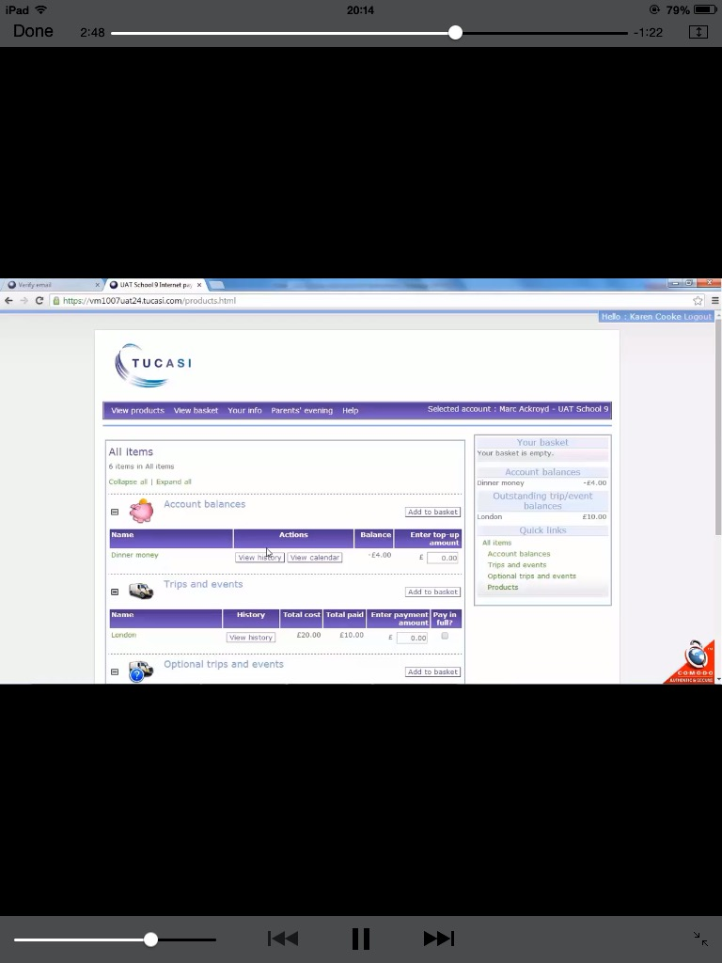Tucasi is an online system which schools can subscribe to, to enable them to manage income effectively (Tucasi, 2016). Figure 1 illustrates the Tucasi member’s area. Tucasi allows for parents to make payments for school activities such as trips and events, and view transaction history. The cost to schools is in the region of £3,000 for a ‘school fund’ module, with a ‘dinner money’ module available at an extra cost (Admin.org, 2016). There is an additional annual management fee, and a cost to the cost per transaction for online payments.

Figure 1 - Tucasi Website - Members Area (Scopay.com, 2016)

**2.2.2.2 eSchoolMeals**

eSchoolMeals is an online service for schools, where parents can book and pay online for school meals. It allows bookings for the month/term ahead, and has an order history area where parents can review purchases. Figure 2 illustrates the registration page for parents. eSchoolMeals aims to significantly reduce the administration burden for schools, of school meal management (Eschoolmeals.com, 2016).

However the system has limitations in that, there is no functionality to order from a menu - parents can only purchase ‘credits’. The system only deals with school meals, it does not extend to other school activities. There is a cost to the school to subscribe to the system.

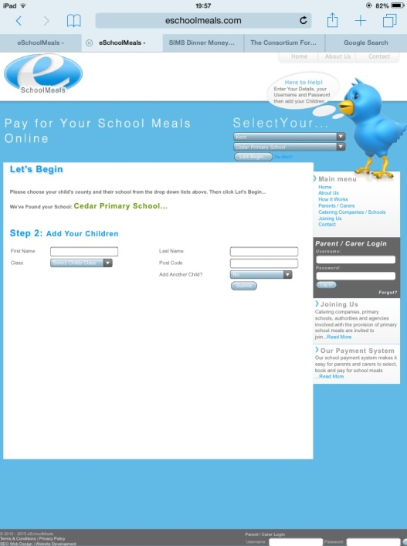

Figure 2 -eSchoolMeals Website – Registration Page

(eSchoolMeals.com, 2016)

**2.2.2.3 School Gateway**

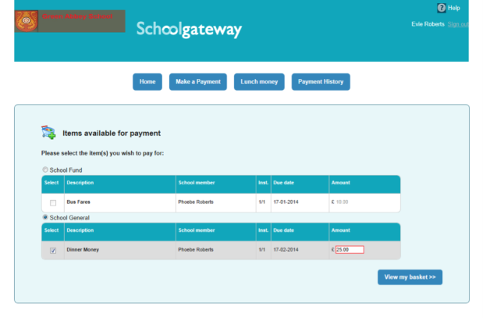School Gateway is an online system for schools and parents, offering a fast easy way for the two to communicate (Schoolgateway.com, 2016). It offers parents the functionality to pay for school meals and other school activities such as trips and music tuition. Parents can review their purchases. Figure 3 illustrates the purchase page. The system has some limitations in that a general lunch payment could be made but not for specific days, and again this is a paid subscription service, which school must subscribe to in order to use.

Figure 3 - School Gateway Website – Purchase Page

(Login.schoolgateway.com, 2016)

**2.2.3 Comparison of School Payment Solutions**

Now that the systems have been evaluated, a comparison of the system features can be conducted. Table 1 presents the comparisons:

|  |  |  |  |  |
| --- | --- | --- | --- | --- |
| Comparisons | Paper-based Solution | Tucasi | eSchool Meals | School Gateway |
| Subscription Service | No | Yes | Yes | Yes |
| Purchase meals from menu | Yes – on Mondays only | Yes | No – purchase credits only | No – purchase credits only |
| Covers other school activities | Yes | Yes | No | Yes |
| View Transaction History | No | Yes | Yes | Yes |
| Admin Reporting | No | Yes | Yes | Yes |

Table 1 - Comparison of School Payment Solutions

**2.2.4 Conclusion – Current Payment Solutions**

An online system, offers major benefits over a manual paper-based system, in that data is collected and can be examined immediately. It will also provide an efficient way to receive and record meal choices and other school activities.

With all of the open market solutions, there is an initial fee as well as a subscription service. This could present a problem for schools with a tight budget.

Although each of the systems is able to meet the requirements at some level, they do not provide a complete solution which meets the needs of the school. For example, some of the systems only allow meal credits to be purchased and do not allow purchases from a set menu. In addition to this, not all of the systems provide functionality to accept payment for other school activities such as clubs or trips. Bearing all this in mind, the proposed system can apply/avoid most of these points.

The new system will need to be developed with the capabilities of the target users in mind which range from basic to competent users. This will be addressed in Chapter 3 – System Requirements.

**2.3 Software Implementation Options**

**2.3.1 Introduction**

The system will require both a website interface and a database in order to provide all of the required functionality and to ensure that the final production of the software is robust, reliable and easy to modify and edit for future use. The main technologies which could be implemented in the development of the system were reviewed:

**2.3.2 Software Development Languages**

A number of characteristics of possible programming languages and environments were assessed, including:

**2.3.2.1 ASP.NET**

ASP.NET is a development framework for building web pages and web sites with HTML, CSS, JavaScript and server scripting (W3schools.com, 2016). It is a server side technology developed by Microsoft to allow programmers and developers to build dynamic websites and web applications. It has the disadvantage that its upkeep is resource intensive.

**2.3.2.2 HTML**

HTML – Hypertext Mark-up Language (HTML) is the programming specification for how web pages can be written and structured so they can be understood and properly displayed by computers or other internet capable devices (DeBolt, 2007). It is the standard mark-up, forms the base of almost all websites and has the benefit of being supported by every browser.

**2.3.2.3 jQuery (Javascript)**

jQuery provides a general purpose abstraction layer for common web scripting and is therefore useful in almost every scripting language (Chaffer and Swedberg, 2013). It aims to increase the simplicity of document traversing, event-handling, animation and HTML manipulation.

**2.3.2.4 CSS**

CSS – Cascading Style Sheet (CSS) is the language for describing the presentation of web pages, including colours, layout, and fonts (W3.org, 2014). It offers a powerful method of influencing the way a document is rendered. It is often used in conjunction with HTML to produce aesthetically pleasing websites, as it is compatible across all major browsers.

**2.3.2.5 PHP**

PHP is a simple, fast, portable scripting language well suited for development of database-enabled websites (Quigley and Gargenta, 2007). PHP code can be embedded with HTML, so that whenever the page is loaded, PHP can execute its code and display dynamic elements. It makes processing forms easier by providing automatic interpretation of form variables.

**2.3.3 Database Options**

**2.3.3.1 MySQL**

MySQL is an open source database management system, offering relational database stores. The logical model, with objects such as databases, tables, views, rows, and columns, offers a flexible programming environment (Dev.mysql.com, 2016). Data can be stored, access and maintained easily. MySQL uses Structured Query Language (SQL) to insert, retrieve and query information held within a database.

**2.3.3.2 Microsoft SQL Server**

Microsoft SQL Server is Microsoft’s enterprise-class database server. It allows for the storage, retrieving and manipulation of data to meet an organisation’s business objectives (Chapple, 2008). It supports the standard SQL language, as well as having its own SQL implementation, and works across a variety of devices.

**2.3.3.3 Microsoft Access**

Microsoft Access, part of the Microsoft Office suite, is a relational database. It features seven components – tables, relationships, queries, forms, reports, macros and modules (Simply-acess.com, 2016), which the user can easily create. However, it has the disadvantage that the total storage available is limited to 2GB. Additionally, in terms of functionality it is not as robust in comparison to MySQL when dealing with SQL. Another downside is that the whole database is stored into one file which means that as data increases performance may decrease.

**2.3.3.4 phpMyAdmin**

phpMyAdmin is a free package written in PHP, which provides the user with a simple, graphical maintenance environment making it easy to perform routine database functions (Ellwood, 2011). It can perform various tasks such as creating, modifying or deleting databases, tables, fields or rows, executing SQL statements, and managing users and permissions. It has the added advantage of being open source, with a web based interface that can be accessed via any web browser.

**2.3.4 Development Environments**

**2.3.4.1 Visual Studio**

Visual Studio 2015 is a rich, integrated development environment for creating stunning applications for Windows, Android, and iOS, as well as modern web applications and cloud services (Visualstudio.com, 2016). Currently, developers can develop apps with Visual Basic, C#, PHP, Objective-C, JavaScript and Visual C++.

**2.3.4.2 Notepad++**

Notepad++ is a free source code editor that was designed to be used with the Microsoft windows environment. It allows code developers to produce and edit code in several different scripting, programming and mark-up languages including HTML, CSS, ASP, Javascript and PHP. It offers features such as, line numbering, search and replace, syntax highlighting and detection of modified files (Mah, 2010).

**2.3.4.3 Eclipse**

Eclipse is an extensible development platform, runtimes, and application frameworks for building, deploying and managing software across the entire software lifecycle (Abbott, 2009). It is the most widely adopted IDE for   
Java development, and includes features such as code completion, refactoring and syntax checking.

**2.3.5 Conclusion – Software Implementation**

After research into the available technologies, a conclusion has been reached as to which technologies will be used in order to create a robust well functioning system. The basic appearance and structure of the project web pages will be coded in HTML using Notepad++, with PHP used to add dynamic, interactive content. CSS and Javascript will be incorporated to style and enhance the design features. phpMyAdmin will be used to create a functioning database, with PHP code to link this to the user interface in order to add, delete, modify and query data in the database.

**2.4 Usability and Human Computer Interaction**

In designing the project, it is important to consider usability and human computer interaction (HCI) principles, including the removal of barriers that would otherwise exclude some people from using the system at all, such as avoiding segregating or stigmatizing any users and accommodating a wide range of literacy and language skills. Taking this into account, there are a number of guidelines which can be followed such as Benyon and Turner’s 12 Principles (Benyon, Turner et al, 2005) Nielsen’s 10 Heuristics (Nielsen and Molich, 1990) and Shneiderman’s 8 Golden Rules (Shneiderman and Plaisant, 2010). Rather than requiring users to adapt their attitudes and behaviours in order to learn and use a system, a system can be designed to support its intended users’ existing beliefs, attitudes, and behaviours (Authority and Design, 2016). Eberts (1994) describes four HCI design approaches that may be applied to user interface designs to develop user-friendly, efficient, and intuitive user experiences. One or more of these approaches may be used in a single user interface design.

The approaches are:

* The Anthropomorphic Approach – this involves designing a user interface to possess human-like qualities.
* The Cognitive Approach – this considers the abilities of the human brain and sensory-perception in order to develop a user interface that will support the end user.
* The Predictive Modelling Approach - this examines the individual components of a user experience in terms of the time it takes a user to most efficiently complete a goal.
* The Empirical Approach – this is useful for examining and comparing the usability of multiple conceptual designs.

The principles of universal design (Authority and Design, 2016) will also be taken into consideration. The purpose of the principles is to guide the design of environments, products and communications. There are seven principles:

* Equitable use
* Flexibility in use
* Simple, intuitive use
* Perceptible information
* Tolerance for error
* Low physical effort
* Size and space for approach and use

**2.5 Software Development Lifecycles**

A system development methodology refers to the framework that is used to structure, plan, and control the process of developing an application (Itinfo.am, 2016). One key area of project planning is selecting an appropriate lifecycle methodology. There are several methodologies which could be applied to the given project, each with their own advantages and disadvantages. DuPaul (2014) explains that the intent of a software development life cycle process is to help produce a product that is cost-efficient, effective and of high quality. Taking this into account, a number of possible life cycles which could be used in the development of this project were reviewed:

**2.5.1 Waterfall Model**

The waterfall model (Figure 4 representation) presents a software development model as a flow through individual stages (phases) of work:

* Requirements Definition
* System and Software Design
* Implementation and Unit Testing
* Integration and System Testing
* Operation and Maintenance - Recommendations are made for further development and errors that may not have been detected are fixed

**Advantages**: Simple to understand and use. Easy to follow requirements

**Disadvantages**: Does not allow for changes as each phase must be fully completed before the next phase can begin. No prototype is produced until

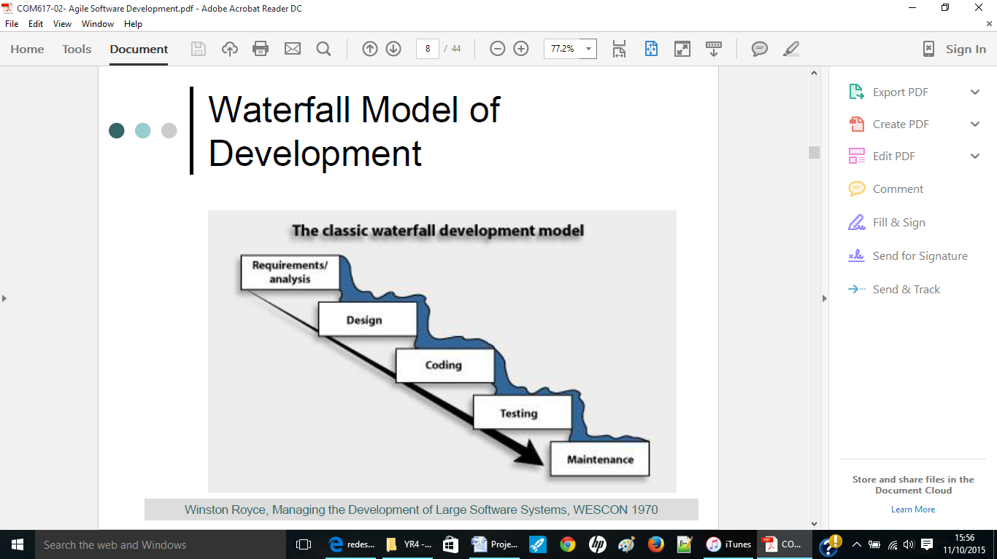late in the cycle.

Figure 4 - Waterfall Method

(RaillsHorde, 2015)

**2.5.2 Agile Model**

The agile model (Figure 5 representation) is a style of software development that emphasises customer satisfaction through continuous delivery of functional software. It was created by twelve software developers who wanted to create an adaptable modern approach. Scrum is an agile framework for completing complex projects. Scrumalliance.org, 2015 explains the approach:

* A product owner creates a prioritised wish list called a product backlog.
* During sprint planning, the team pulls a small chunk from the top of that wish list, a sprint backlog, and decides how to implement those pieces.
* The team has a certain amount of time — a sprint (usually two to four weeks) — to complete its work, but it meets each day to assess its progress (daily Scrum).
* Along the way, the scrum master keeps the team focused on its goal.
* At the end of the sprint, the work should be potentially shippable: ready to hand to a customer, put on a store shelf, or show to a stakeholder.
* The sprint ends with a sprint review and retrospective.
* As the next sprint begins, the team chooses another chunk of the product backlog and begins working again.

**Advantages**: Rapid, frequent delivery of software. Customers, developers and testers constantly interact with each other. Easy update of design and requirements.

**Disadvantages**: Continuous communication required with all stakeholders. Lack of emphasis on necessary deign and documentation.

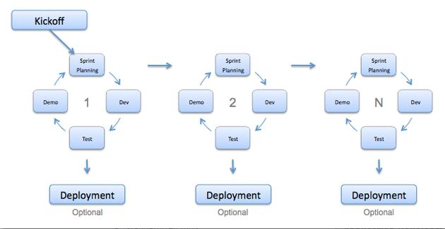

Figure 5 - Agile Method

(Jahan, 2013)

**2.5.3 Iterative Model**

Problems with the waterfall method led to the development of the iterative model (Figure 6 representation). In the iterative model, cycles are divided into smaller easily managed iterations, with each iteration passing through a series of design, development and testing phases in repeated cycles. This allows for results earlier in the process and feedback from system users.

**Advantages**: Allows more flexibility for changes. Defects can be tracked at early stages as the system is built and improved step by step.

**Disadvantages**: Each phase of iteration is rigid with no overlaps. Design issues may arise and not all requirements are specified at the beginning.

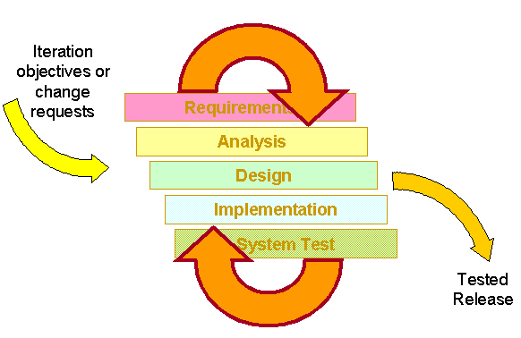

Figure 6 -Iterative Model

(IBM, 2015)

**2.5.4 Spiral Model**

The spiral model (Figure 7 representation) takes an iterative approach, with emphasis on risk analysis. The steps involved can be generalised as:

* High level requirements are defined
* A prototype system is created using preliminary designs to allow for testing
* A new enhanced requirements specification is created
* Enhancements are made to the prototype system
* Planning and design of the new prototype system begins
* Developing and testing of the new prototype is carried out

This process continues until all stakeholders are happy with the system.

**Advantages**: Very effective for large and critical projects. Prototype is produced early in the lifecycle. Large amount of risk analysis.

**Disadvantages**: Not suitable for smaller projects. High costs involved.

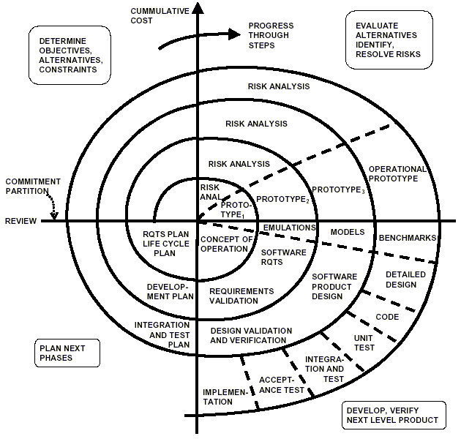

Figure 7 -Spiral Model

(Boehm, 1988)

**2.5.5 Life Cycle Comparisons**

Table 2 presents a comparison of the life cycle methodologies:

|  |  |  |  |  |
| --- | --- | --- | --- | --- |
| Requirement | Waterfall | Agile | Iterative | Spiral |
| Suitable for small projects | ✓ | 🗶 | 🗶 | 🗶 |
| Suitable for low risk project | ✓ | ✓ | ✓ | ✓ |
| Easy to follow requirements | ✓ | ✓ | 🗶 | 🗶 |
| User involvement throughout cycle | 🗶 | ✓ | ✓ | ✓ |
| Overlapping stages | 🗶 | 🗶 | 🗶 | 🗶 |
| Flexible - Allows for changes to be made | 🗶 | ✓ | ✓ | ✓ |
| Permits prototyping | 🗶 | ✓ | ✓ | ✓ |
| Allows for verification and validation | ✓ | ✓ | ✓ | 🗶 |
| Guarantee of success | Low | High | Moderate | High |
| Suitable for individual project | ✓ | 🗶 | 🗶 | 🗶 |

Table 2 - Comparison of Life Cycle Methodologies

**2.5.6 Conclusion - Chosen Life Cycle Methodology**

Having understood and compared different software development models, it is clear to seen there are advantages and disadvantages with each depending on the type of work to be carried out. Traditional software lifecycles put significant effort in analysis, design, and implementation before their results can be tested (Turpin, 1996). The start of testing late in the lifecycle often uncovers flaws from these early phases that require significant rework of analysis and design, causing cost overruns and schedule slippages, making the models compared above unsuitable choices for this project.

The chosen life cycle for this project is the modified waterfall method. The modified waterfall method is a derivative of the traditional waterfall method. It uses the same phases as the waterfall model but is not based on a discontinuous basis. This enables the phases to overlap when needed.

This will allow for flexibility in requirements management including updating project requirements as necessary, and for prototyping, verification and validation to be carried out at each stage of the development process.

System Requirements



**3.1 Introduction**

This chapter presents the requirements gathering and analysis process. A requirement is a statement about an intended product that specifies what it should do or how it should perform. They should be as specific, unambiguous and clear as possible. Kroenke (2008) states that the primary aim of the requirements gathering stage is to determine and document the specific features and functions of the new system. It is imperative to have a robust requirements document in place in order to avoid feature creep which could impact on project costs, schedule and quality therefore it is imperative to define them accurately. The easiest and cheapest time to alter the system is in the requirements stage.

Device Inspections Guide (2003) identifies the following common problems which occur with requirements elicitation and specification:

* 1. Requirements do not represent the actual needs of the customer.
  2. Requirements are incomplete or conflicting.
  3. Requirements are difficult and expensive to update after they have been agreed upon.
  4. Customers, requirements analysts, and software engineers who develop the system have difficulties understanding each other.

Somerville (2016) advises there are three types of requirements which must be addressed during the requirements development phase (illustrated in Figure 8):

1. Business Requirements
2. User Requirements
3. Functional/Non-functional Requirements

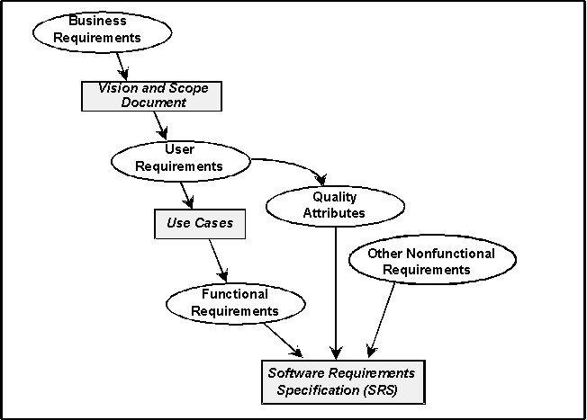

Figure 8 - Levels of Software Requirements

(Sommerville and Sawyer, 1999)

**3.2 Requirements Gathering**

The requirements for this project were obtained over a period of time. This project has a varied number of end users therefore not all could be questioned as to what they required from the system; however requirements were collected from a sample of end users, who differed on levels of background, skill, knowledge and status. Requirements were categorised into functional and non-functional and a list of requirements created. It was agreed that as this was a small project, the requirements would be structured using Microsoft Word.

An initial meeting was conducted with the developer, Marlene Hilditch and the project supervisor Dr Glenn Hawe in which the project to be undertaken was discussed. An initial project plan was created.

Three methods were used to elicit requirements from end users at St. MacNissi’s Primary School:

**3.2.1 Questionnaires**

As input was required from a large sample of end users, it was decided that a questionnaire would be the best method of collecting information. The advantage of using a questionnaire for parents was that they could be honest in their responses as they were anonymous. When creating the questionnaire, care was taken to ensure that the questions were easily understood, and that the respondents were given the opportunity to express concerns or make suggestions on topics not covered by the questions. The results from the questionnaires were very useful in understanding what potential end users of the system would require and what features were important to them. The questionnaire and findings can be found in Appendix B.

**3.2.2 Observation/Shadowing**

There has to be an understanding of the problem area (which includes the users, the work context and the wider organisation in which the problem area is situated) and how the new technology can be applied (Atwood et al, 1995). To further understand the problem area, observations were carried out at St. MacNissi’s Primary School on several occasions over a four week period to understand the current processes, and to build a clear picture of what the company would require from the system. Observable behaviours such as practices, methods, steps and objects were focused on. The Georgia Tech of Computing (2007) advises it is important to learn what users do, why they do it, how they do it, when they do it, with what tools or people they do it. Observations were chosen as people often find it hard to describe what they do because it is so natural to them, and sometimes actual work processes often differ from formal, prescribed processes.

**3.2.3 Interviews**

Semi structured fact gathering interviews were held with the system administrators of St. MacNissi’s Primary School, to get the best possible understanding of their needs during the cash receiving and recording process, whilst also allowing the opportunity to capture or clarify critical information. The interviews were informal and were varied out simultaneously with the observations/shadowing, with the interviewees answering a set of predefined set of questions, as well as having the opportunity to express their views through open ended questions. The use of interviews has several advantages including providing an opportunity for end users to participate and contribute to the design and development of a system, as well as helping break down the barriers of user resistance by allowing the user to assume a vested interest in the process (Abdelhak et al, n.d.). Interviews notes can be found in Appendix C.

**3.2.3 Literature Review**

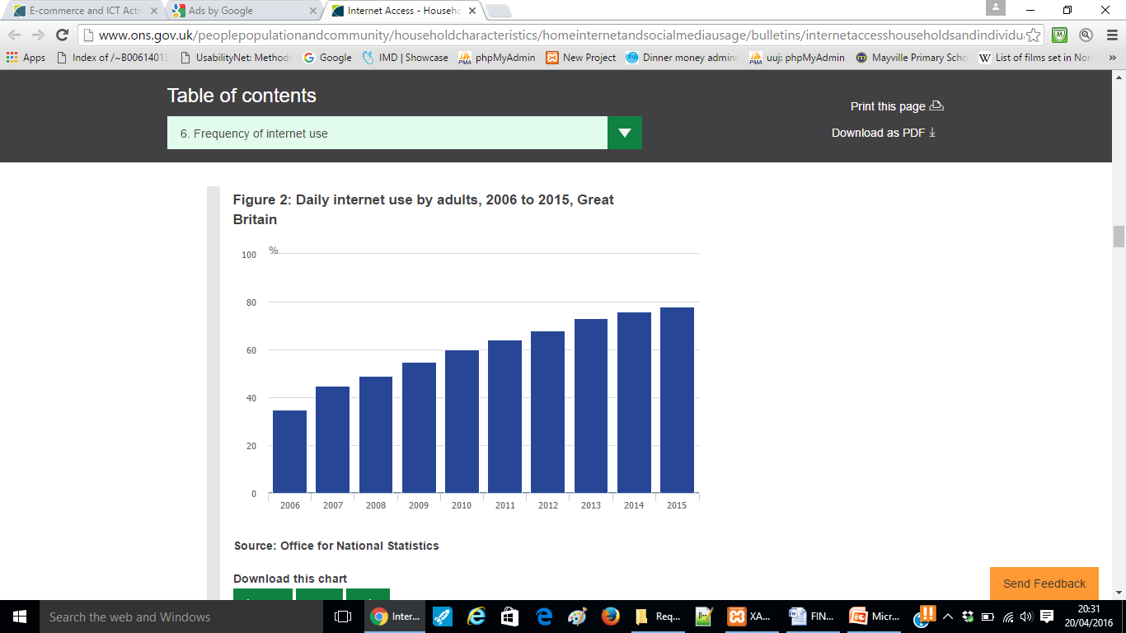As previously discussed in Chapter 2, the literature review compared four payment solutions. There are multiple issues with the current solution currently in place. The paper-based solution is outdated, inconvenient and an inefficient use of time. In today’s tech heavy environment, where globalisation and internet have transformed many aspects of our lives, and where 78% of people use the internet everyday (ONS.gov.uk, 2016), an online system accessible to all seems to be the best solution. Figure 9 shows the growth of internet use in the UK over last decade.

Figure 9 – The Growth of Internet Use in the UK

(ONS.gov.uk, 2016)

**3.2.4 End Users**

There will be two types of visitor to the site. The first is parents/guardians of pupils at St. MacNissi’s Primary School, who wish to view and purchase school meals and select and pay for other school activities, such as school trips and after school clubs. They will be able to register and log in to the site. They will be able to view and select school meals for the coming week, as well as select and purchase additional school activities.

The other users of the site will be system administrator(s), who will be able to access the password protected admin area to perform a number of admin related tasks and functions, such as adding new meals to the menu, adding after school clubs, checking meal purchases, and the viewing of various reports.

**3.3 Requirements**

Having completed the necessary requirements elicitation techniques as described above, a complete list of requirements were drawn up.

**3.3.1 Functional Requirements**

Table 3 presents the functional requirements. These represent the essential requirements from a front end user (parent and administrator) view of the website. They reflect the tasks the user will require the website to do.

| No. | Requirement |
| --- | --- |
| F01 | Parent should be able to register as a new user on the site |
| F02 | Registered users should be able to log into the system |
| F03 | Registered users should be able to log out of the system |
| F04 | Registered users should be able to view (displayed by date) and purchase meal choices |
| F05 | Registered users should be able to view and purchase school trips |
| F06 | Registered users should be able to view and purchase after school clubs |
| F07 | Registered users should be able to print a personalised barcode |
| F08 | Registered users should be able to change password |
| F09 | Registered user should be able to view transaction history |
| F10 | Admin should be able to delete a parent user |
| F11 | Admin should be able to able to change a user’s password |
| F12 | Admin should be able to add new meals to the menu |
| F13 | Admin should be able to delete meals from the menu |
| F14 | Admin should be able to amend a menu entry |
| F15 | Admin should be able to view menu |
| F16 | Admin should be delete master meals |
| F17 | Admin should be add new master meals |
| F18 | Admin should be amend master meal details |
| F19 | Admin should be able to check if a pupil has purchased a meal today |
| F20 | Admin should be able to view the number of daily meals purchased |
| F21 | Admin should be delete an after school club |
| F22 | Admin should be add a new after school club |
| F23 | Admin should be amend after school club details |
| F24 | Admin should be delete a category |
| F25 | Admin should be add a new category |
| F26 | Admin should be amend a category |
| F27 | Admin should be delete a school trip |
| F28 | Admin should be add a new school trip |
| F29 | Admin should be amend trip details |
| F30 | Admin users should be able to log into the system |
| F31 | Admin users should be able to log out of the system |

Table 3 – Functional Requirements

**3.3.2 Non-functional Requirements**

Table 4 present the non-functional requirements. These non-functional requirements are not concerned specifically with the functionality of the system but relate to the efficiency and compatibility of the system.

|  |  |
| --- | --- |
| No. | Requirement |
| NF01 | The website theme should remain consistent throughout |
| NF02 | The website should display correctly on all major web browsers |
| NF03 | The application should be accessible from PC, tablet and smart phone |
| NF04 | The website should be easily navigated |
| NF05 | Users should not be able to view content without logging in |
| NF06 | Passwords should be securely stored by the database |
| NF07 | The website should confirm to HCI and usability principles |

Table 4 – Non-functional Requirements

**3.3.3 Business Requirements**

Table 5 presents the business requirements of the system.

|  |  |
| --- | --- |
| No. | Requirement |
| B01 | The finished system should be completed by 22 April 2016 |

Table 5 – Business Requirements

**3.3.4 Risk Analysis**

Schwalbe (2000) defines project risk management as the art and science of identifying, analyzing, and responding to risk throughout the life of a project and in the best interests of meeting project objectives. Risk management, including performing a risk assessment is an important step in being prepared for potential problems that can occur within any software project.

Figure 10 identifies several benefits from software risk management practices including the ability to anticipate/avoid problems and prevent surprises.

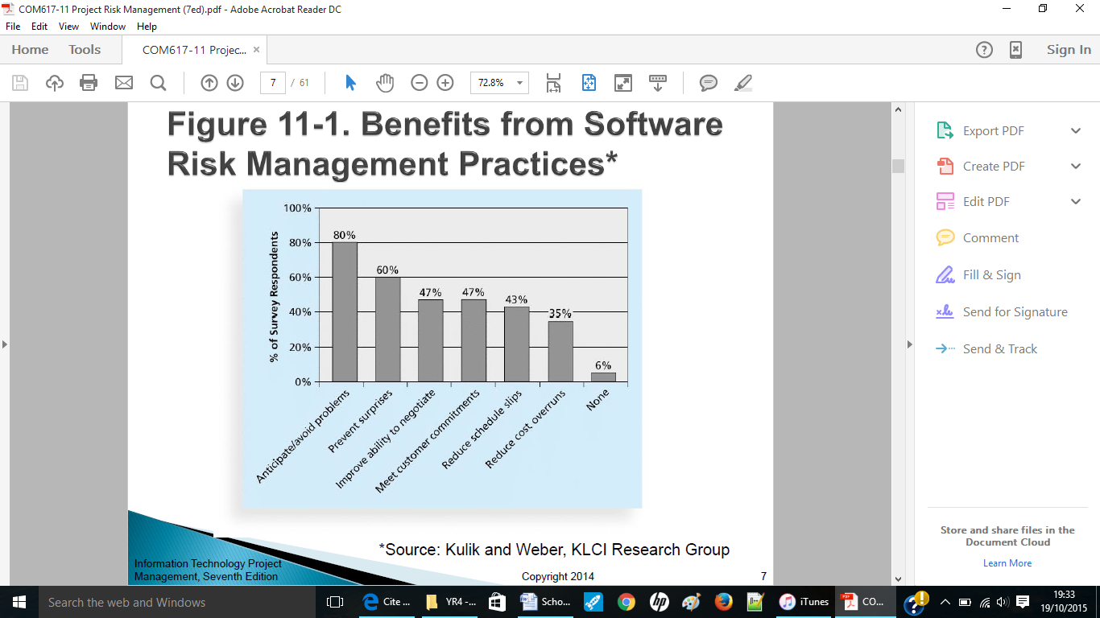

Figure 10 - Benefits from Software Risk Management Practices

(Kulik and Weber, 2001)

Where a potential risk was identified, a resolution or plan of action was developed. Due to the nature of this project, limited risks were identified, however, Table 6 represents some of the risks that have been identified and the resolution that will be taken in the event that they occur.

| No. | Risk | Impact | Resolution |
| --- | --- | --- | --- |
| 1 | Data Loss | Result in having to do work over again. Hinder the delivery of the project. | Regular backup processes and back-up plan in place. |
| 2 | Change in requirements / Feature creep | Project costs, schedule and quality could all be affected. | Robust product requirements document in place. Regular contact with St. MacNissi’s P.S |
| 3 | Fall behind schedule | Failure to meet deadlines and deliver project on time. Unhappy stakeholders. Additional unnecessary costs. | Use and follow tools such as work breakdown structure and Gantt chart to manage time effectively and monitor progress. |
| 4 | Resources not identified/available | Project timescale, schedule and quality will be affected. | Understand what resources are required and identify all necessary resources at an early stage. |
| 5 | Change in personal circumstances | Project costs, schedule and quality could all be affected as this project is being developed by a one person working on their own | Planning is essential to reduce this risk. Build buffers into the schedule to allow for superficial delays. Full documentation maintained in the event someone has to take over. |
| 6 | Inaccurately defined requirements | Requirements that are incomplete, ambiguous, or untestable will cause problems at some point during the life of the project. | Eliciting requirements from stakeholders using a variety of techniques to create a clearly defined requirements analysis document. |
| 7 | First time assignment for project manager | First time project management is a risk because some of the learning about project management only comes through time and experience. Project scope, schedule and quality could all be affected. | Communicate with stakeholders, Use tools such as project plan, requirements spec, WBS, Gantt charts and techniques such as time management to succeed. Understand the aims and objectives of the project and establish clear milestones. |

Table 6 – Identified Risks

**3.3.4.1 Probability/Impact Matrix**

Table 7 present these risks in a probability/impact matrix table.

|  |  |  |  |  |
| --- | --- | --- | --- | --- |
| Probability | High |  |  |  |
| Medium |  | Risk 2 | Risk 1 |
| Low |  | Risk 4  Risk 7 | Risk 3  Risk 5  Risk 6 |
|  | Low | Medium | High |
|  |  | Impact | | |

Table 7 – Probability/Impact Matrix

**3.3.5 Conclusion – Requirements Gathering**

Now that the requirements have been outlined and requirements specified, the design and implementation of the system can now begin. Although requirements have been thoroughly discussed and prioritised during the requirements gathering stage, due to the flexible nature of the development methodology chosen, they may be subject to change throughout. Therefore requirements and their progress will be closely monitored and managed throughout the duration of the project.

Design

**4.1 Introduction**

The goal of software design is to build a model that meets all customer requirements and leads to successful implementation (Qian, 2010). This chapter contains a design plan based around a back end database, user interfaces for both parents and administrators, and queries to link the website with the database. The designs are based on the list of requirements. It is imperative that the design stage is completed accurately as a poor design may result in a deficient product that does not meet system requirements, is not adaptive to future requirement changes, exhibits unpredictable behaviour or performs badly (Qian, 2010). Following usability guidelines, including those discussed in Chapter 2.4, embodies good practice in interface design and will improve the quality of the interface.

**4.2 High Level Design**

As specified in the requirements, there are three areas that parent users should be able to view and purchase from – school meals, school trips and after school clubs. An overview of the system was produced, using use case diagrams, to provide a picture of how users will perform tasks on the website, related to these three areas. A use case diagram has the benefit of outlining from a user’s point of view, a system’s behaviour as it responds to a request (Affairs, A, 2016).

Bell (2013) identifies the main purpose of the use case diagram as to help visualise the functional requirements of the system, including the relationship of the users who will interact with the system, to essential processes, as well as the relationships among different use cases. The use case is represented as a sequence of simple steps, beginning with a user's goal and ending when that goal is fulfilled.

Figure 11 presents an overview of how a parent will interact with the system.

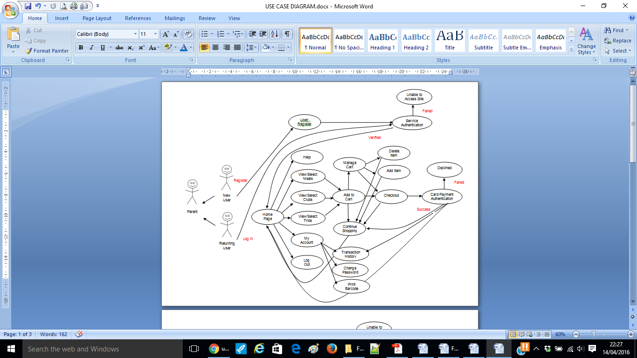

Figure 11 – Use Case Diagram – Parent User Interaction

Figures 12, 13 and 14, delve deeper and show the relationship between a parent user and the system administrator, when purchasing trips, clubs and meals respectively.

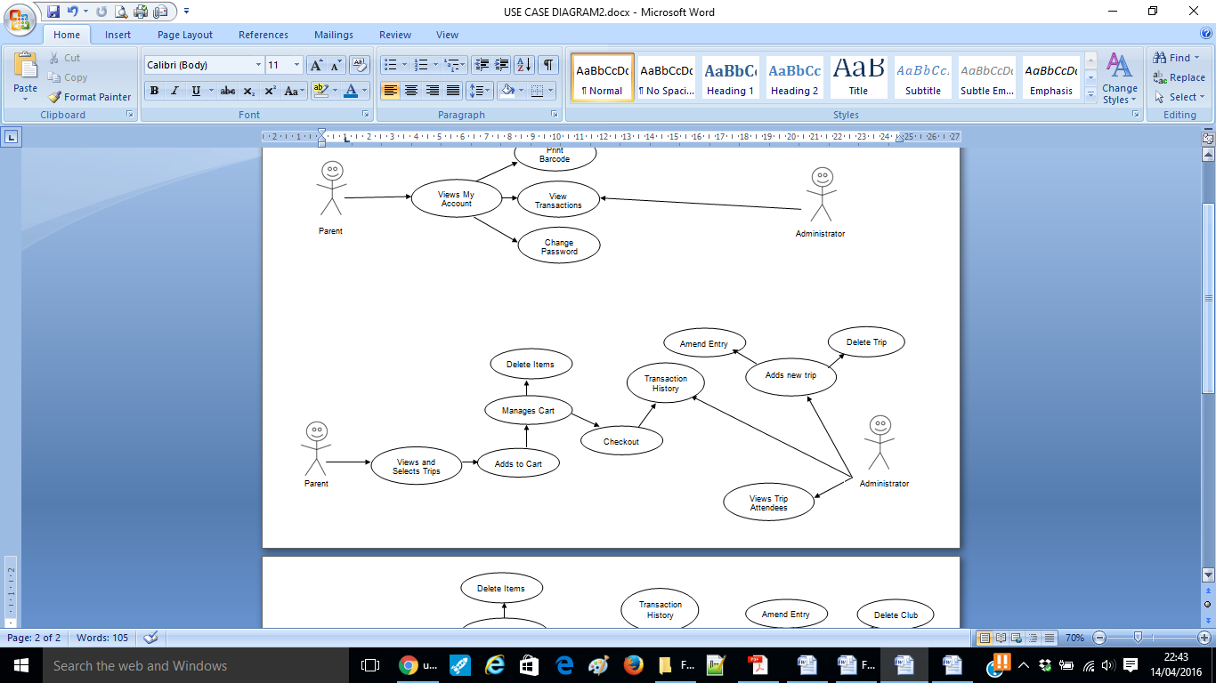

Figure 12 – Use Case Diagram – Trips

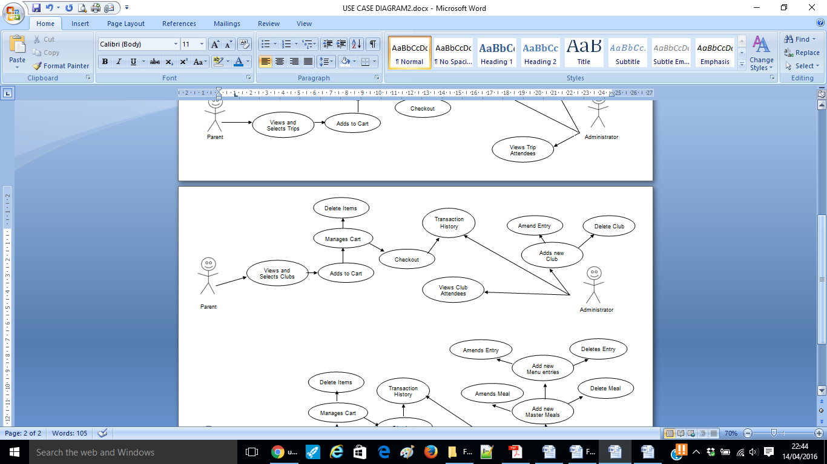

Figure 13 – Use Case Diagram – After School Clubs

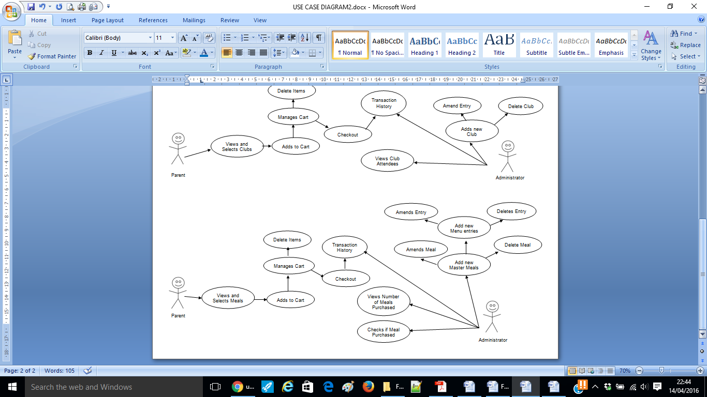

Figure 14 – Use Case Diagram – Meals

Figure 15, shows the relationship between a parent user and the system administrator, when using the ‘My Account’ facility.

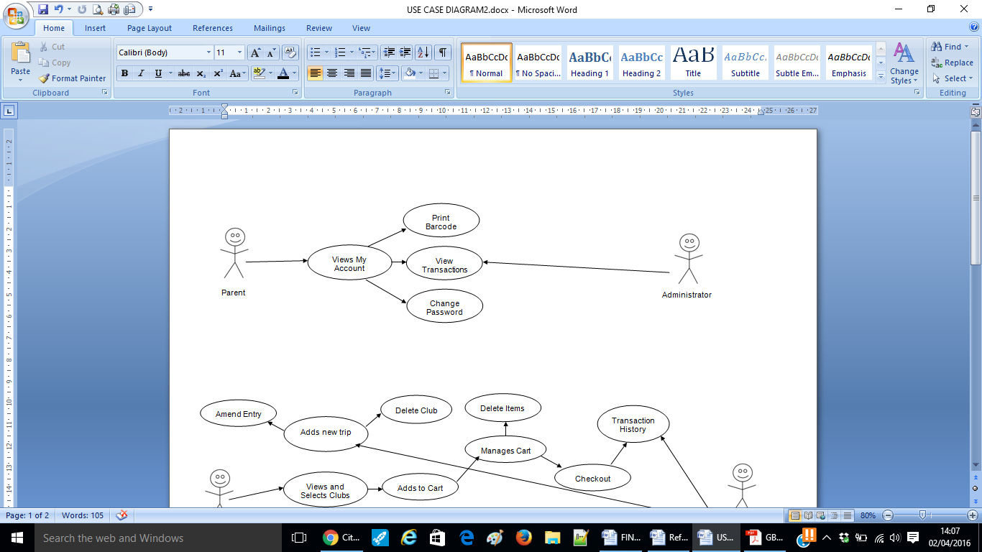

Figure 15 – Use Case Diagram – My Account

Figure 16, gives an overview of how the administrator will interact with the system.

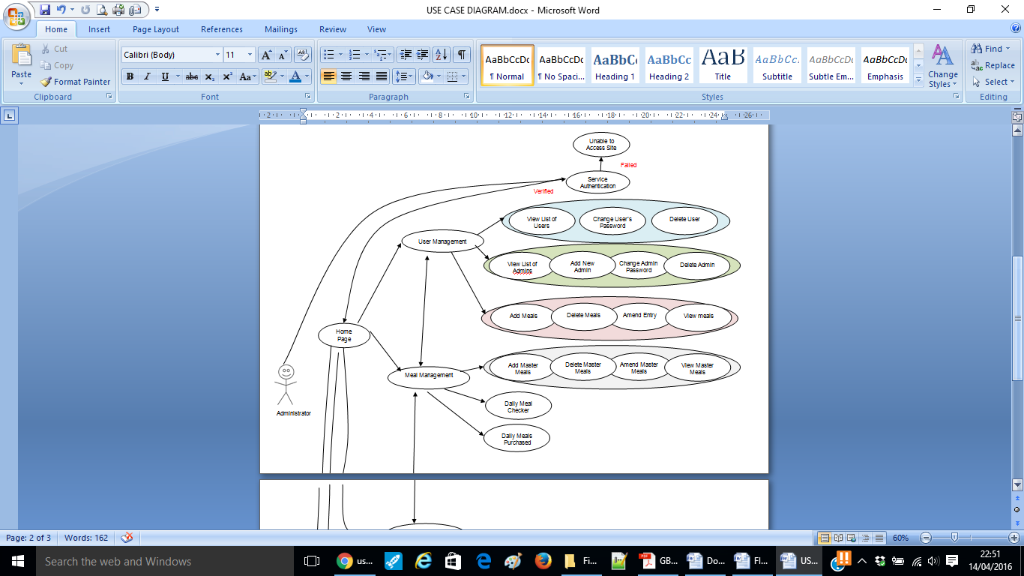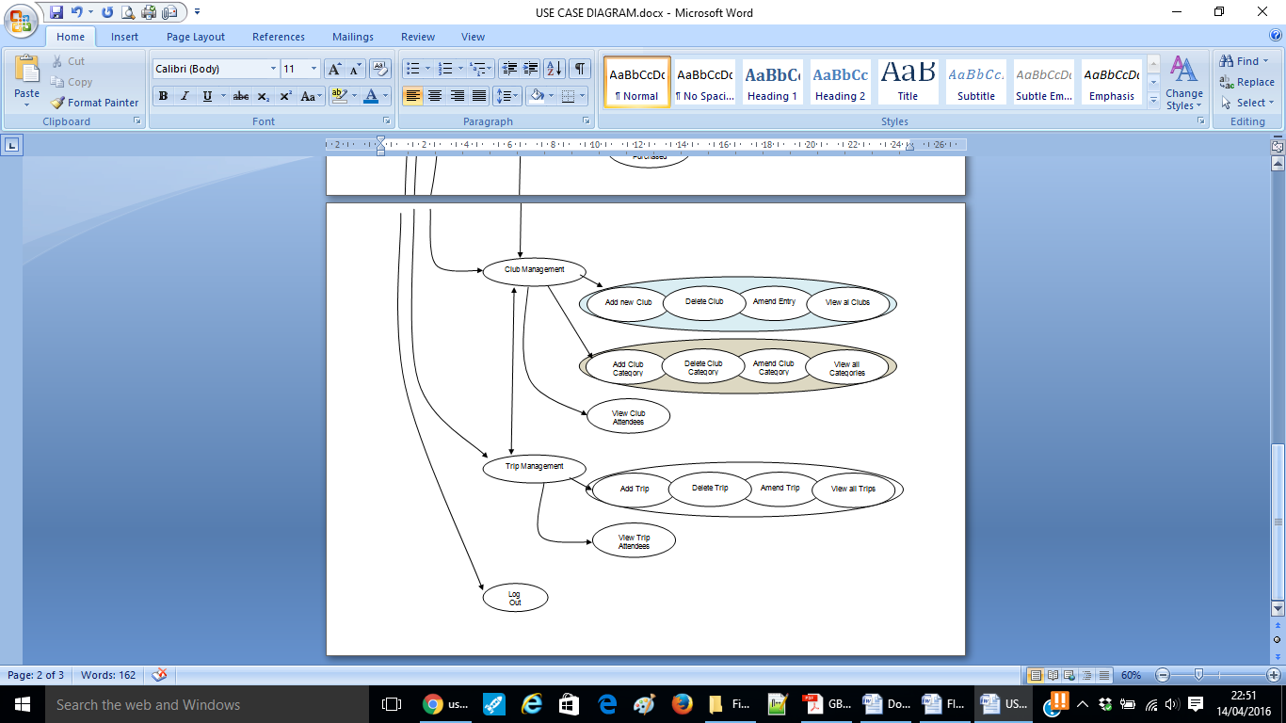

Figure 16 – Use Case Diagram – Administrator Interaction

**4.3 Detailed Design – User Interface**

Paper prototypes and site sketches were used to clarify requirements and enable draft interaction designs and screen designs to be simulated and tested. They included four stages of prototyping - concept design, interaction design, screen design and screen testing, and provided the benefit of allowing potential usability problems to be detected at an early stage before any code had been written. Example prototypes can be found in Appendix D.

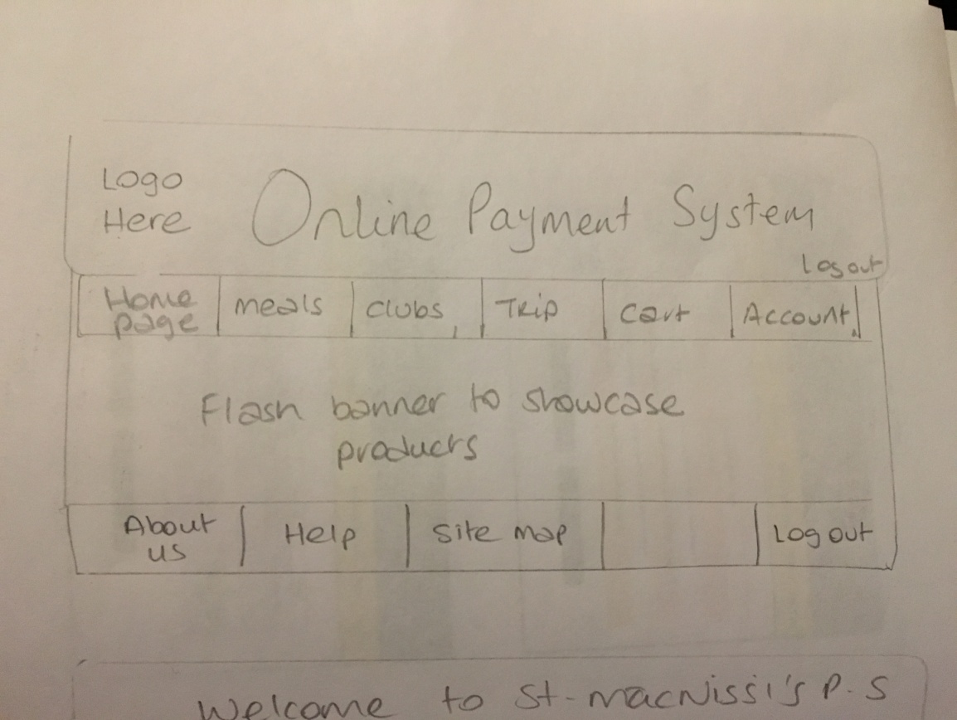

Figure 17 – Paper Prototype Example

A site plan providing an overview of the proposed navigation, for a parent user (Figure 18) and an administrator (Figure 19), through the system were produced focusing on site layout and site content. 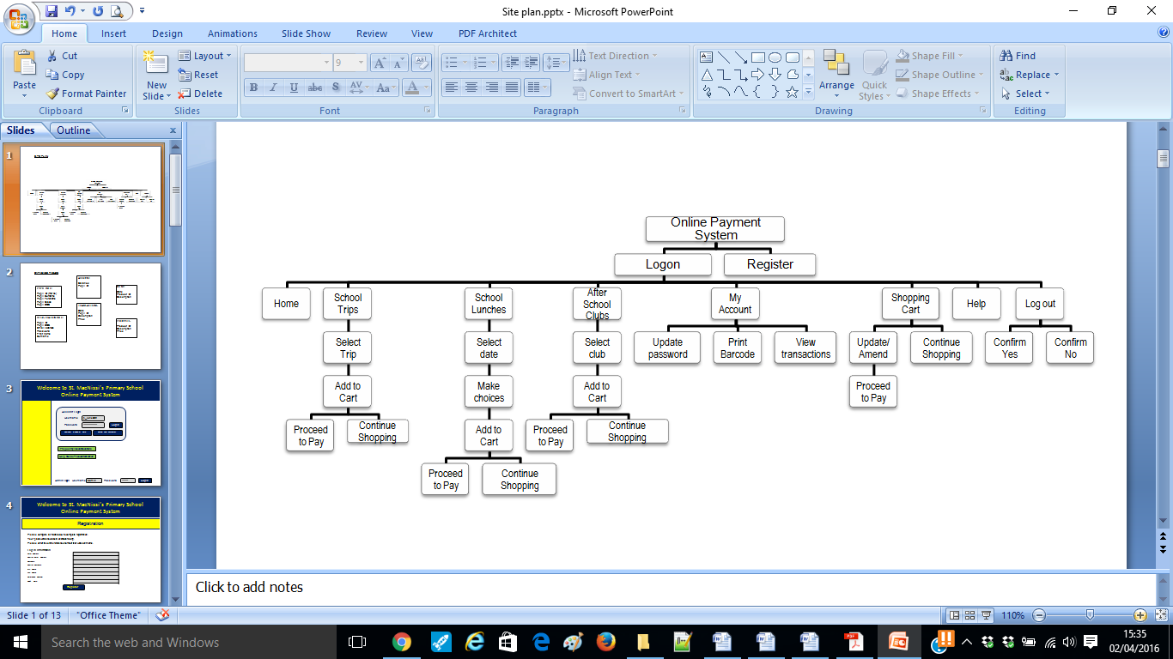

Figure 18 – Site Layout – Parent User

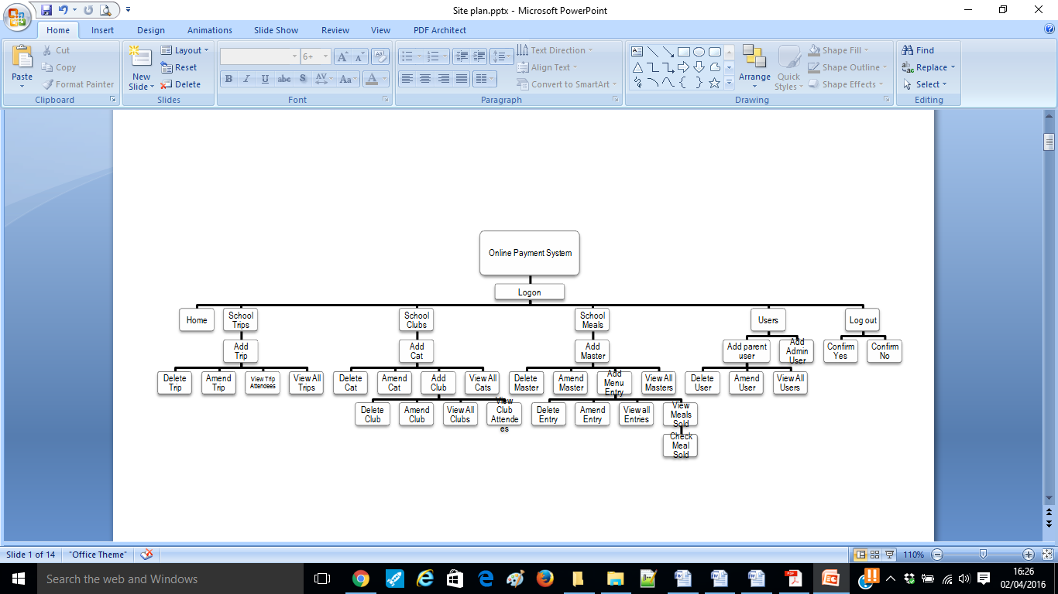

Figure 19 – Site Layout – Administrator

Figure 20 illustrates some of the mock site designs which were created after site navigation and strucure had been confirmed:

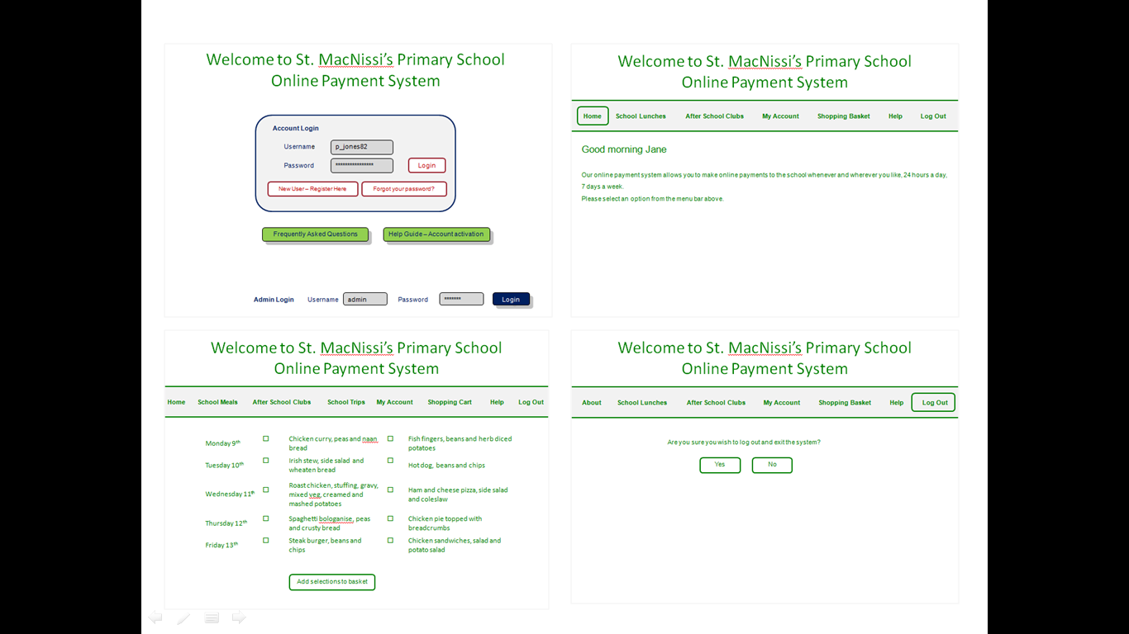Figure 20 – Mock Site Designs

There is a colour convention associated with St. MacNissi’s Primary School – specifically bottle green and red – therefore it was requested that designs included this colour in some form.

**4.3.1 Home Page**

The home page will display a welcome to the system and provide parents with an option to either register or log into the system. There will also be a seperate login section for the school administrator. The login form features a user name field and password field. The password field will be set as ‘password’ to ensure the password being entered is not visible to others present.

**4.3.2 New User Registration - Parents**

The registration page will display a registration form, which the user will need to complete in order to access the member’s area. In order for the administrator to easily identify pupil transactions, parents are asked to enter their child’s name as the user name in the format ‘First Name.Last Name’. The password field will be restricted to a character length of 6-16 characters, and the user will be asked to confirm the password to ensure it has been entered correctly. The password will be encrypted before it is stored in the database. The user is asked to select from file, an image of their child. The image will be used later in the meal collection process by the site administrator to confirm meal choice. There will be a success alert, error alert or failure alert depending on whether or not the user has completed the form correctly.

**4.3.3 Member’s Area - Parents**

Following login/registration validation checks, the ‘member’s’ area will present the user with a personalised greeting depending on the time of day, and will display their log in name. The user will be presented with a menu bar with options for school meals, after school clubs and school trips, as well as a ‘my account’ page, ‘shopping cart’, ‘help’ page and ‘log out’. In the top right hand corner the user can easily see at any stage the number of items in the shopping cart and the total price of the items.

**4.3.4 School Meals Purchasing**

The school has two set meals to choose from each day.

The school meals page will present users with these set meals options for the next 7 days, along with an image of the meal and the price.

Users will select their choices and add to the shopping cart. Meals are restricted to 7 days in case of menu changes, and to encourage parents to use the site regularly.

**4.3.5 After School Clubs Purchasing**

Due to the number of after school clubs available, it was decided to assign them to a particular category in order to classify them and make it easier for users to find a club of their choice. Users will be presented with a list of categories, and can click on any category to view the clubs available.

**4.3.6 School Trips Purchasing**

Users will be presented with a list of active school trips. They can click on any trip to get further details and add to the shopping cart.

**4.3.7 My Account - Parents**

The ‘my account’ area will present users with options to change their password, view all transactions on their account, and print a personalised barcode. The barcode will use a PHP library to generate a barcode based on their username. Parents are asked to print this barcode. The barcode will be scanned by the school administrator when the pupil collects their meal to verify that he/she has purchased a meal for that day, and to confirm meal choice. St. MacNissi’s Primary School specifically requested that the meal choice be verified as there is a problem with children ordering one meal and actually choosing another.

**4.3.8 Shopping Cart/Checkout**

Purchases from ‘meals’, ‘trips’ or ‘clubs’ will be added to the shopping cart. The total items and total cost will be displayed. Users can continue shopping or proceed to checkout. The checkout process will ask the user to enter their personal details, as well as payment information. The system will simply check that a 16 digit card has been entered, and that the card is valid. There will be a success alert or error alert depending on whether or not the user has completed the form correctly, and a failure alert if the card is not valid.

**4.3.9 Log Out - Parents**

Upon clicking ‘log out’, users will be reminded to print their barcode from the ‘my account’ section. They will be asked to confirm log out, upon which their session will end.

**4.3.10 Member’s Area - Admin**

Following login/registration validation checks, the ‘member’s’ area will present the user with a personalised greeting depending on the time of day, and will display their log in name. The user will be presented with a menu bar with options for ‘user management’, ‘school meals management’, ‘after school club management’ and ‘school trip management’, as well ‘log out’. These options will allow the admin user to perform a variety of admin related tasks and functions on the website and the database.

**4.3.11 User Management - Admin**

In the ‘user management’ area, the administrator can view parent users, change a parent user’s password and delete parent users. They can also view, add, and delete admin users.

**4.3.12 Meal Management**

The database will hold a list of ‘master meals’, upon which the daily menu will be based. The administrator can add, edit, delete and view the master meals.

They can also add meals entries to the daily menu by selecting meals from the master meal list. Daily entries will also be able to be edited, deleted and viewed.

There will be a ‘meal checker’ where the administrator can scan a pupil’s barcode to confirm that they have purchased a meal for that day. If they have, the pupil’s photo and meal choice will be displayed, so that the school can confirm the pupil has made the right choice. This should minimise instances where the canteen runs out of food due to a pupil taking a different meal from the meal ordered. The administrator can also run a report showing the number of meals purchased for that day. This report can be given to the school kitchen so that they know how many pupils to cater for and how many meals to make.

**4.3.13 After School Club Management**

In the ‘after school club management’ area, the administrator can add, edit, delete and view club categories.

They can also add new clubs and assign them to the relevant category.

They will also be able to view the number of pupils who have registered to attend each club.

**4.3.14 School Trip Management**

In the ‘school trip management’ area, the administrator can view, add, edit and delete school trips. They will also be able to view the number of pupils who have purchased each trip.

**4.4 Database Design**

The system greatly depends on the database and its ability to retrieve and maintain relevant information. Both the parent users and administrator will need to store and retrieve data from the database. This will include data such as usernames, passwords, meals, clubs, trips and their associated images. phpMyAdmin will be the database management system in use.

The tables within the database, along with their descriptions and purpose are presented below.

**4.4.1 Admin Table**

The ‘admin’ table holds the details of the administrator users of the system, including their username, password and email address. This table is required to control access to the system. The administrator can log in and perform administrative tasks such as those described above. Table 8 presents the structure of the admin table.

|  |  |  |  |  |
| --- | --- | --- | --- | --- |
| **Column** | **Type** | **Null** | **Attributes** | **Description** |
| username | varchar(16) | No | Primary Key | The administrator’s username |
| passwd | char (40) | No |  | The administrator’s password |
| email | varchar(100) | No |  | The administrator’s email address |

Table 8 – Admin Table

**4.4.2 User Table**

The ‘user’ table holds the details of the parent users of the system, including their username, password, email address and path to image. This table is required to control access to the system. Parents need to log in to the system in order to purchase meals and other schools activities such as trips and after school clubs. The user’s password will be encrypted before it is saved in the database. Table 9 presents the structure of the user’s table.

|  |  |  |  |  |
| --- | --- | --- | --- | --- |
| **Column** | **Type** | **Null** | **Attributes** | **Description** |
| username | varchar(16) | No | Primary Key | The user’s username |
| passwd | char (40) | No |  | The user’s password |
| email | varchar(100) | No |  | The user’s email address |
| picture | varchar(255) | Yes |  | Path to where image is stored |

Table 9 – Users Table

**4.4.3 Categories Table**

The ‘categories’ table holds information which will populate the categories in the online system. Examples of categories will include Sport, Music, Academic, Creative, ICT, Other, Trips and Meals. The administrator can add, edit and delete from the categories table. Table 10 presents the structure of the admin table.

|  |  |  |  |  |
| --- | --- | --- | --- | --- |
| **Column** | **Type** | **Null** | **Attributes** | **Description** |
| cat_id | int (10) | No | Primary key, Auto increment | The category id number |
| cat_name | varchar (30) | No |  | The category name |

Table 10 – Categories Table

**4.4.4 Clubs Table**

The ‘clubs’ table holds information on the various after school clubs available. Each club is assigned to a category, for example Club ‘Football’ would be assigned to Category ‘Sport’. The administrator can add, edit and delete from the clubs table. Table 11 presents the structure of the clubs table.

|  |  |  |  |  |
| --- | --- | --- | --- | --- |
| **Column** | **Type** | **Null** | **Attributes** | **Description** |
| id | int (10) | No | Primary key, Auto increment | The club id number |
| name | varchar (60) | No |  | The club name |
| cat_id | int(10) | No |  | The category id, the club is assigned to |
| description | varchar(500) | Yes |  | A description of the club |
| price | float(4,2) | Yes |  | The price of the club |
| instructor | varchar(100) | Yes |  | The instructor of the club |
| materials | varchar(200) | Yes |  | Any materials pupils are required to bring to the club |

Table 11 – Clubs Table

**4.4.5 Trips Table**

The ‘trips’ table holds information on the various school trips available. Each trip is assigned to the trip category. The administrator can add, edit and delete from the trips table. Table 12 presents the structure of the trips table.

|  |  |  |  |  |
| --- | --- | --- | --- | --- |
| **Column** | **Type** | **Null** | **Attributes** | **Description** |
| Id | int (10) | No | Primary key, Auto increment | The trip id number |
| cat_id | int (10) | No |  | The category id, the club is assigned to |
| date | date | No |  | The date of the trip |
| name | varchar(100) | No |  | The name of the trip |
| description | varchar(200) | No |  | A description of the trip |
| price | float(4,2) | No |  | The price of the trip |

Table 12 – Trips Table

**4.4.6 Meals Table**

The ‘meals’ table holds information on the ‘master meals’. There are twenty master meals, on which the daily menu is based. The administrator can add, edit and delete from the meals table. Table 13 presents the structure of the meals table.

|  |  |  |  |  |
| --- | --- | --- | --- | --- |
| **Column** | **Type** | **Null** | **Attributes** | **Description** |
| Id | int (10) | No | Primary key, Auto increment | The meal id number |
| name | varchar (100) | No |  | The name of the meal |
| price | float(4,2) | No |  | The price of the meal |
| cat_id | int(10) | No |  | The category id the meal is assigned to |
| description | varchar(200) | Yes |  | A description of the meal |
| allergen_info | varchar(100) | Yes |  | Any allergy information the user should be aware of |

Table 13 – Meals Table

**4.4.7 Menu Options Table**

The ‘menu options’ table contains meals populated from the master meal table.

The administrator can edit, delete and view the menu entries. Table 14 presents the structure of the menu entries table.

|  |  |  |  |  |
| --- | --- | --- | --- | --- |
| **Column** | **Type** | **Null** | **Attributes** | **Description** |
| Id | int (10) | No | Primary key, Auto increment | The menu entry id number |
| mealDate | date | No |  | The date of the meal |
| option1 | int(11) | No |  | Set meal option 1 |
| option2 | int(11) | No |  | Set meal option 2 |

Table 14 – Menu Entries Table

**4.4.8 Purchased Clubs Table**

The ‘purchased clubs’ table stores entries about after school clubs purchased by parent users. The user id is stored so that the administrator can tell who made the purchase, and so that the entry displays when the user views their transaction history. The activity id is stored so both the user and administrator can tell what club was purchased. The date is stored so that the user can tell in their transaction history when the purchase was made.

The administrator can query the table and return how many pupils are attending a given club. Table 15 presents the structure of the purchased clubs table.

|  |  |  |  |  |
| --- | --- | --- | --- | --- |
| **Column** | **Type** | **Null** | **Attributes** | **Description** |
| Id | int (11) | No | Primary key, Auto increment | The entry id for the purchased club |
| username | varchar(32) | No |  | The username of the user who purchased the club |
| activity_id | int(11) | No |  | The id number of the club purchased |
| purchase_date | date | No |  | The purchase date |

Table 15 – Purchased Clubs Table

**4.4.9 Purchased Meals Table**

The ‘purchased meal’ table stores entries about meals purchased by parent users. The user id is stored so that the administrator can tell who made the purchase, and so that the entry displays when the user views their transaction history. The meal id is stored so both the user and administrator can tell what meal was purchased. The date is stored so that the user can tell in their transaction history when the purchase was made for. The administrator can query the table and return how many meals have been sold for a given day. Table 16 presents the structure of the purchased meals table.

|  |  |  |  |  |
| --- | --- | --- | --- | --- |
| **Column** | **Type** | **Null** | **Attributes** | **Description** |
| id | int (11) | No | Primary key, Auto increment | The entry id for the purchased meal |
| username | varchar(32) | No |  | The username of the user who purchased the meal |
| meal_id | int(11) | No |  | The id number of the meal purchased |
| for_date | date | No |  | The date the meal was purchased for |

Table 16 – Purchased Meals Table

**4.4.10 Purchased Trips Table**

The ‘purchased trips’ table stores entries about school trips purchased by parent users. The user id is stored so that the administrator can tell who made the purchase, and so that the entry displays when the user views their transaction history. The trip id is stored so both the user and administrator can tell what trip was purchased. The date is stored so that the user can tell in their transaction history when the trip is for. The administrator can query the table and return how many pupils have purchased a given trip. Table 17 presents the structure of the purchased trips table.

|  |  |  |  |  |
| --- | --- | --- | --- | --- |
| **Column** | **Type** | **Null** | **Attributes** | **Description** |
| id | int (11) | No | Primary key, Auto increment | The entry id for the purchased activity |
| username | varchar(32) | No |  | The username of the user who purchased the activity |
| trip_id | int(11) | No |  | The id number of the activity purchased |
| purchase_date | date | No |  | The purchase date |

Table 17 – Purchased Trips Table

**4.5 Query Design**

For the website to be effective and meet its requirements, information needs to be stored, retrieved, updated and deleted from the database.

Table 18 details the queries that will be used in the implementation of the system.

| **No.** | **Query Name** | **Description** |
| --- | --- | --- |
| 01 | Add Category | Administrator is asked to enter new category name. Query checks to see if a category with the same name already exists. New category is added to the database. |
| 02 | Add Club | Administrator is asked to enter new club name. Query checks to see if a club with the same name entered already exists. Administrator selects appropriate category from drop down list. Query checks if all form fields are filled out. New club data is added to the database. |
| 03 | Add Master Meal | Administrator is asked to enter new master meal name. Query checks to see if a master meal with the same name already exists. Query also checks if all form fields are filled out. New master meal data is added to the database. |
| 04 | Add Menu Entry | Administrator is asked to enter menu date. Query checks to see if a menu entry has already been entered for the selected date. Administrator selects meals from drop down list, and query adds it to the database (menu). |
| 05 | Add Trip | Administrator is asked to enter new trip name. Query checks to see if a trip with the same name already exists. Administrator selects appropriate date. Query also checks if all form fields are filled out. New trip data is added to the database. |
| 06 | Amend Category | Administrator is asked to select category to be amended via a drop down list. Query checks name entered by the administrator is unique. Amended data is updated in database. |
| 07 | Amend Club | Administrator is asked to select club to be amended via a drop down list. Query checks name entered by the administrator is unique. Query also checks if all form fields are filled out. Amended data is updated in database. |
| 08 | Amend Master Meal | Administrator is asked to select master meal to be amended via a drop down list. Query checks name entered by the administrator is unique. Query also checks if all form fields are filled out. Amended data is updated in database. |
| 09 | Amend Menu Entry | Administrator is asked to select date to be amended via a drop down list. Administrator selects meals from drop down list. Amended data is updated in database. |
| 10 | Amend Trip | Administrator is asked to select trip to be amended via a drop down list. Query checks name entered by the administrator is unique. Query also checks if all form fields are filled out. Amended data is updated in database. |
| 11 | Amend user password | Administrator is asked to select user whose password is to be amended. Query checks form fields are filled out. Query checks if passwords entered match. User’s password is updated. |
| 12 | Daily meal check | Administrator to enter / scan student username. Query checks if student has purchased a meal for today. If they have purchased a meal, meal choice and student image is displayed. If they have not, message is displayed. |
| 13 | Delete Category | Administrator is asked to select category to be deleted from a drop down list. Category is deleted from database. |
| 14 | Delete Club | Administrator is asked to select club to be deleted from a drop down list. Club is deleted from database. |
| 15 | Delete Master Meal | Administrator is asked to select master meal to be deleted from a drop down list. Master meal is deleted from database. |
| 16 | Delete Menu Entry | Administrator is asked to select menu entry date to be deleted from a drop down list. Menu entry is deleted from database. |
| 17 | Delete Trip | Administrator is asked to select trip to be deleted from a drop down list. Trip is deleted from database. |
| 18 | Delete user | Administrator is asked to select user to be deleted. User data is deleted from database. |
| 19 | Filled out | Query checks that form data is filled out. If it is not an error message is displayed. This query is used as a function on all forms throughout the site. |
| 20 | Get Price | Query tallies the total price of items in the shopping cart. The total price is displayed for the user in the top menu bar, and in the shopping cart and checkout |
| 21 | Get total items | Query tallies the total items in the shopping cart. The number of items is displayed for the user in the top menu bar and in the shopping cart and checkout |
| 22 | Log In | Query checks if username and password are valid and match those stored in the database. Error displayed if data entered is not a match. |
| 23 | Registration | Query checks if username data entered is in correct format. Checks if username is unique. Check if email address entered is valid format. Checks two passwords entered are identical. Checks Image is valid. Error message displayed depending on exception. |
| 24 | Remove from cart | Query removes selected item from the user’s shopping cart. |
| 25 | Student Barcode | Query creates a barcode based on the username. |
| 26 | Transactions | Query displays user’s meals, clubs and trip purchases and displays them as a transaction history. |
| 27 | Valid email | Query checks that data entered is in a valid email format i.e. contains at least @ and ‘.’ |
| 28 | Valid user | Query checks if a user is logged in, if not access to page is denied. This query is used as a function on all pages throughout the site. |
| 29 | Valid username | Query checks that data entered is in a valid format i.e. contains a ‘.’ (format: *first name* ***.*** *last name*) |
| 30 | View club attendees | Query asks administrator to select club. Pupils (and purchase date) that have purchased clubs are displayed. |
| 31 | View clubs | Query returns all clubs stored in the database that are assigned with clubs categories i.e. Sport, Music, Academic, Creative, ICT and other. |
| 32 | View Meals | Query returns all meals stored in the database that are assigned to the meal category. |
| 33 | View meals purchased | Query asks administrator to select date. Pupils and their meal choice are displayed. |
| 34 | View trip attendees | Query asks administrator to select trip. Pupils (and purchase date) who have bought trip are displayed. |
| 35 | View trips | Query returns all trips stored in the database that are assigned to the trip category. |

Table 18 – Database Queries

**4.6 Conclusion - Design**

Although there is the slight possibility that designs may need slight alterations over the course of implementation, the design provides the knowledge, understanding, and pathway for implementation to now begin.

Implementation

**5.1 Introduction**

This chapter documents the implementation of the online payment system website, where an executable version of the software is created. A walk through of the system’s most significant features will be provided, including code snippets. Issues encountered and the related solutions will also be documented.

**5.2 Development Platform Used**

Table 19 presents an overview of the platform used for the implementation of the system.

|  |  |  |  |
| --- | --- | --- | --- |
| **Hardware** | | **Software** | |
| CPU | Intel(R) Core(TM) i5-3230M 2.6ghz | Operating System | Windows 10 |
| RAM | 4.00GB | Local Server | XAMPP |
| Hard Drive | 1TB | Browser(s) | Chrome, Safari, Firefox, Internet Explorer |
| Screen | 1280x1024 | Development Environment | Notepad++  phpMyAdmin |

Table 19 – Development Platforms

**5.3 Development Technologies Used**

The development technologies used in the implementation of the system included:

**5.3.1 Notepad++**

Notepad++ is a free source code editor which supports several programming languages running under the MS Windows environment (Notepad-plus-plus.org, 2016). It has several useful features such as the ability to produce and edit code in over fifty scripting languages, syntax highlighting and folding, auto completion, function completion and function parameters hints. It was compatible and facilitated all of the programming languages used in the creation of the system and therefore suitable for the developer to use.

**5.3.2 phpMyAdmin**

phpMyAdmin is a free software tool written in PHP, intended to handle the administration of MySQL over the Web. phpMyAdmin supports a wide range of operations on MySQL (phpmyadmin.net, 2016).

phpMyAdmin is used for the design, creation and management of the database and tables used in the system - a user interface provide via web browser, with capabilities provided for SQL queries to be executed, allows for this to happen. This database management system supports all database management tasks that the system requires.

**5.3.3 Logomakr**

Logomakr is a free open source program allowing the creation of fully customisable logos, text and graphics (Logomakr.com, 2016). The program was used to create various images throughout the site, such as add to cart, view cart, and continue shopping, as illustrated in Figure 21.

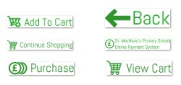

Figure 21 – Example site images

**5.4 Implementation Strategy**

A plan of action, in addition to the Gantt chart, which can be found in Appendix E, and work breakdown schedule, which can be found in Appendix F, was created in order for the system implementation to be met within the given timescale. The tasks were broken down into sequential sections. Figure 22 presents an overview of the order in which they are to be developed:

|  |  |  |  |  |  |
| --- | --- | --- | --- | --- | --- |
| Time | | | | | |
| Website Design | Displaying clubs, meals, trips | Barcode Creation | Help Pages | Administrator Tasks | Site Testing |
| Database Creation | Adding to/Deleting from Cart | | |
| Purchasing | | | Meal Checking |
| Transaction History | | |

Figure 22 – Implementation Plan

The diagram shows the division of tasks has been completed in a logical manner. More complex tasks run for longer periods of time and in parallel with others, to allow the developer to switch between tasks for complex problems. The following sections will look at significant features of the system and how they were implemented. Snippets of code are included. Full code can be found in Appendix G.

**5.5 User Registration**

Functional requirement F01 states that a parent must be able to register as a new user. As specified in the design stage, the registration page will display a registration form, which the user will need to complete in order to access the member’s area – email address, username, password, confirm password, upload student image . The registration page is shown in Figure 23. Form data is gathered by the $_POST array. Once the register button has been clicked, and the form data has been stored in the $_POST variables, validation checks can now take place. Exception handling, using a try catch block is used to deal with a number of possible exceptions, specifically:

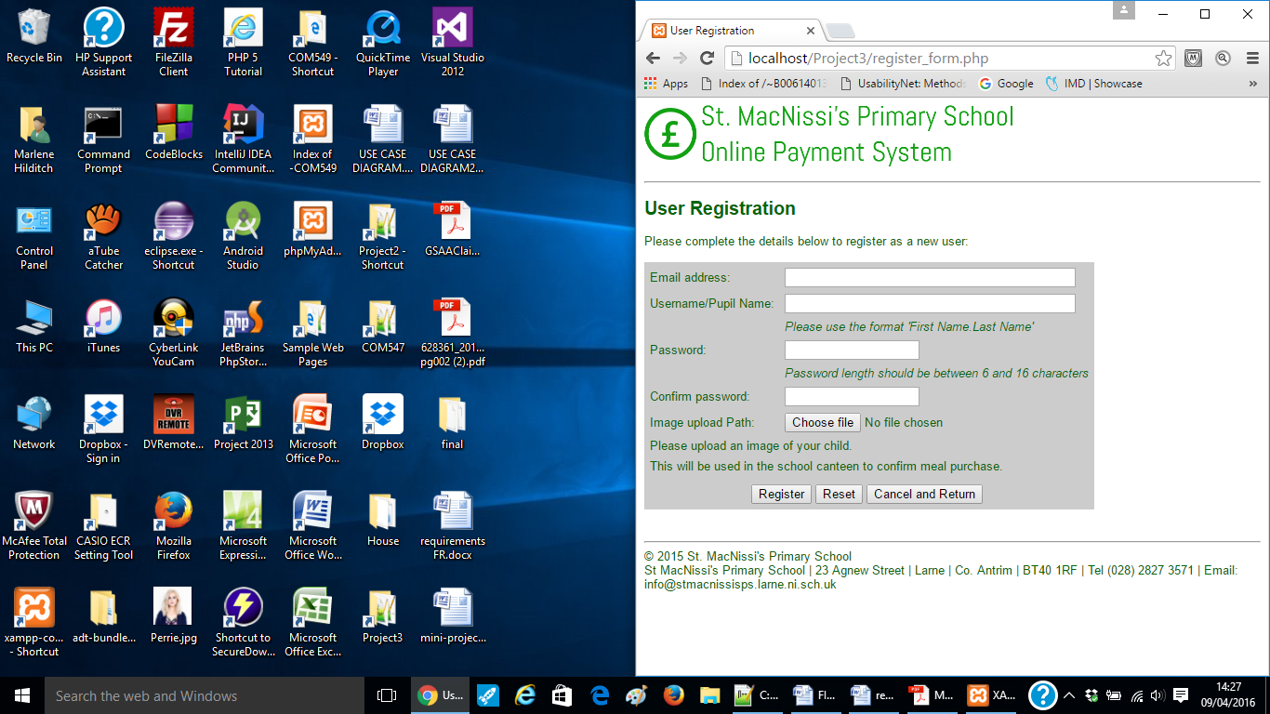

Figure 23 – User Registraton Form

* If all form fields are filled out and are not empty
* If the username is a valid format
* If the email address is in a valid format
* If the two passwords entered are identical, and
* If the password length is between 6 and 16 characters.

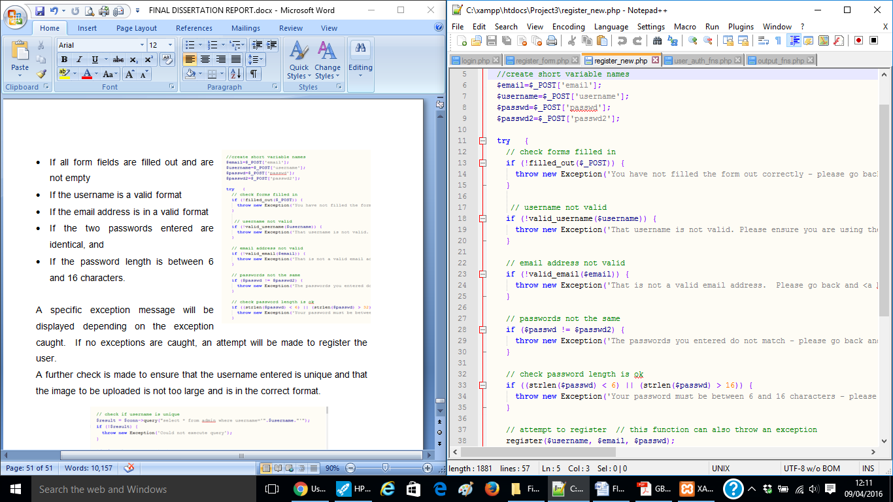

Figure 24 – User Validation Code

A specific exception message will be displayed depending on the exception caught. If no exceptions are caught, an attempt will be made to register the user. Figure 24 displays the user registration validation code.

A further check is made to ensure that the username entered is unique, and checks are done on the image being uploaded – that it is an image file, that the file does not already exist, that the file size is not too large and that the file is in the correct format – jpg, jpeg, png or gif. An error message is displayed to the user depending on what stage the upload fails at. The image itself is not stored in the database, simply its path. Figure 25 displays the image upload validation code.

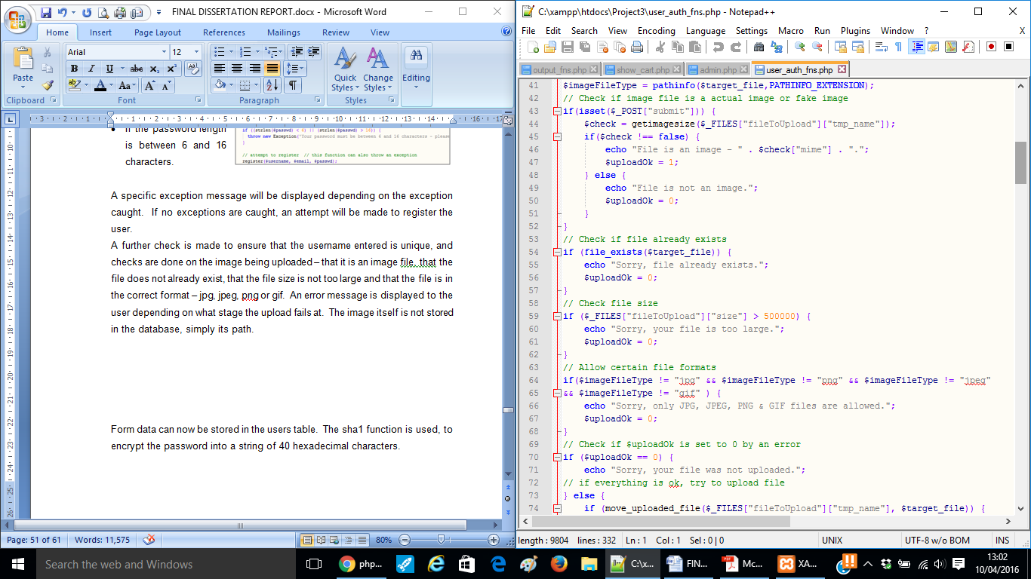

Figure 25 – Image Upload Validation Code

Form data can now be stored in the users table. The ‘sha1’ function is used, to encrypt the password into a string of 40 hexadecimal characters (code illustrated in Figure 26).

The password is now unrecognisable within the database. This is an additional security measure for the user, and as it uses one way encryption cannot be decrypted, making it relevant only to the user who input the password. An example database entry showing the encrypted password is shown in Figure 27.

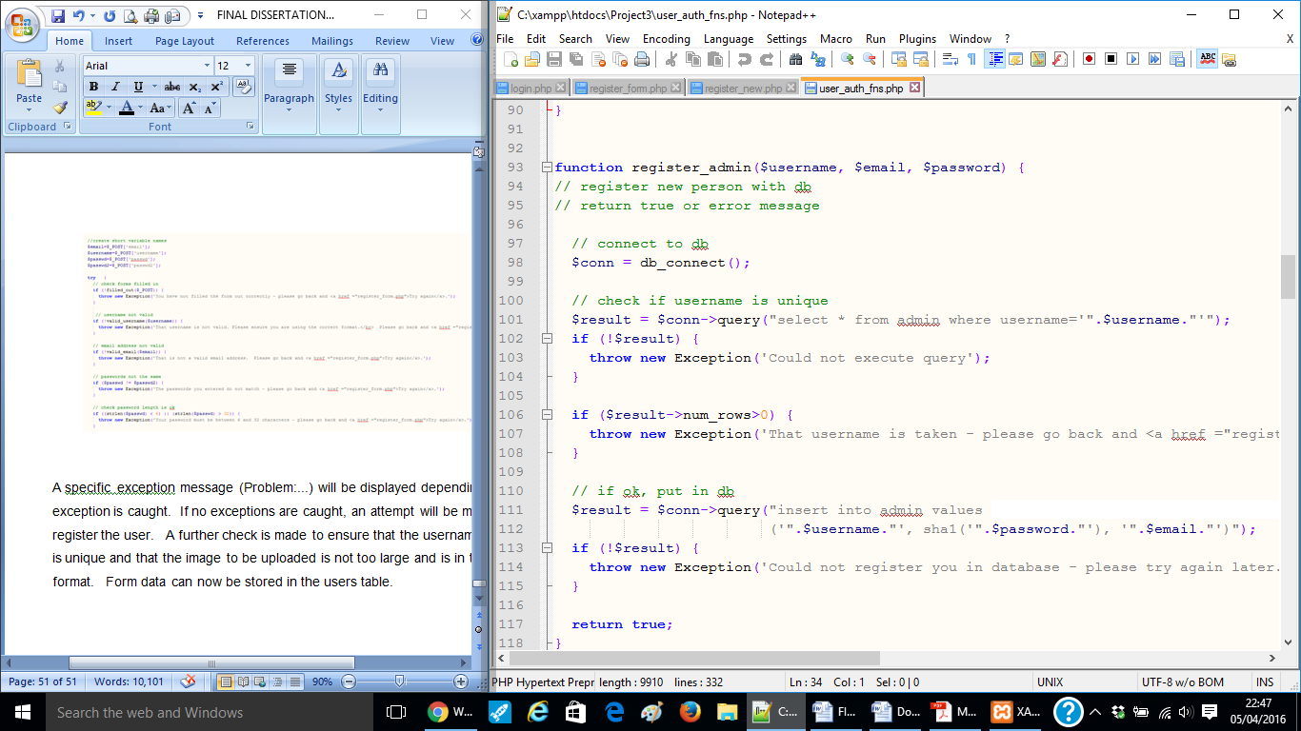

Figure 26 – Password Encryption Code

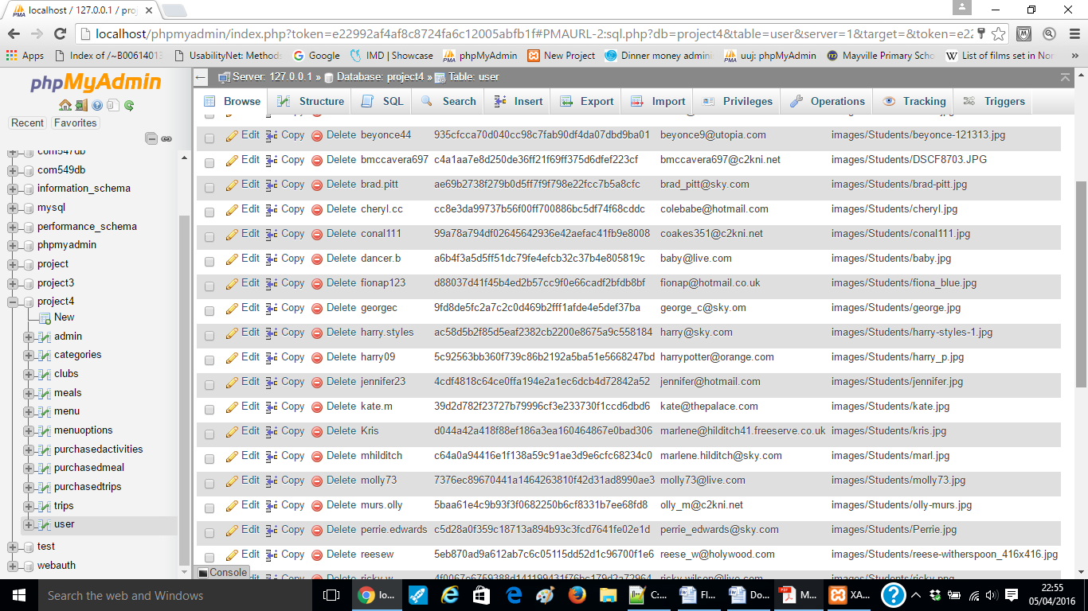

Figure 27 – Database Entry Showing Encrypted Password

**5.6 User Log In/Log Out**

Functional requirements F02 and F03 state that registered users should be able to log in and out of the system. The user is presented with a simple log in form on the home page (Figure 28). When a user attempts to log in, two things need to be checked:

1. That the username entered exists
2. 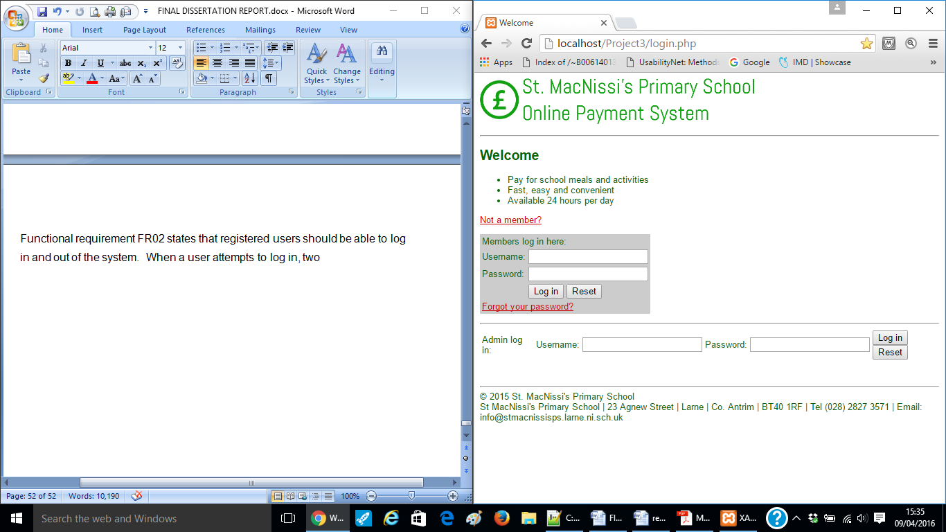That the password entered is correct for that username

Figure 28 – User Log in Form

If the user has tried to log in, the PHP script will attempt to log the user in by connecting to the database and selecting data from the users table that matches the username entered. The code for this query is illustrated in Figure 29. In this case, the query only returns a row should the username and password both match ensuring that there is no unauthorised access to the system. If they log in successfully, a valid user session is registered in the name of the username, and access is granted to the member’s area of the site. If the username and password combination entered do not match, the script detects that this is not a valid user (i.e. not logged in) and access to the member’s area of the site is denied.

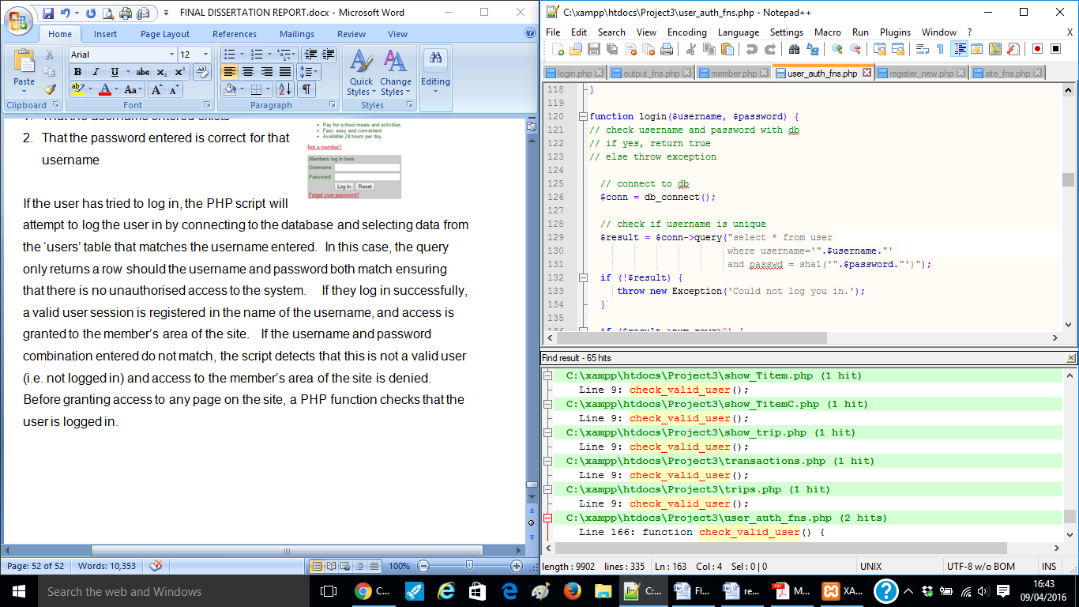

Figure 29 – User Log in Code

Before granting access to any page on the site, a PHP function checks that the user is logged in. This is discussed further in Chapter 4.7.

The member’s area displays a greeting to the user, based on the time of day – morning, afternoon or evening. This was implemented using JavaScript - the date and hour is called, and a series of if statements display a greeting based on the time. The code is illustrated in Figure 30. The user’s log in name is also displayed (example illustrated in Figure 31).

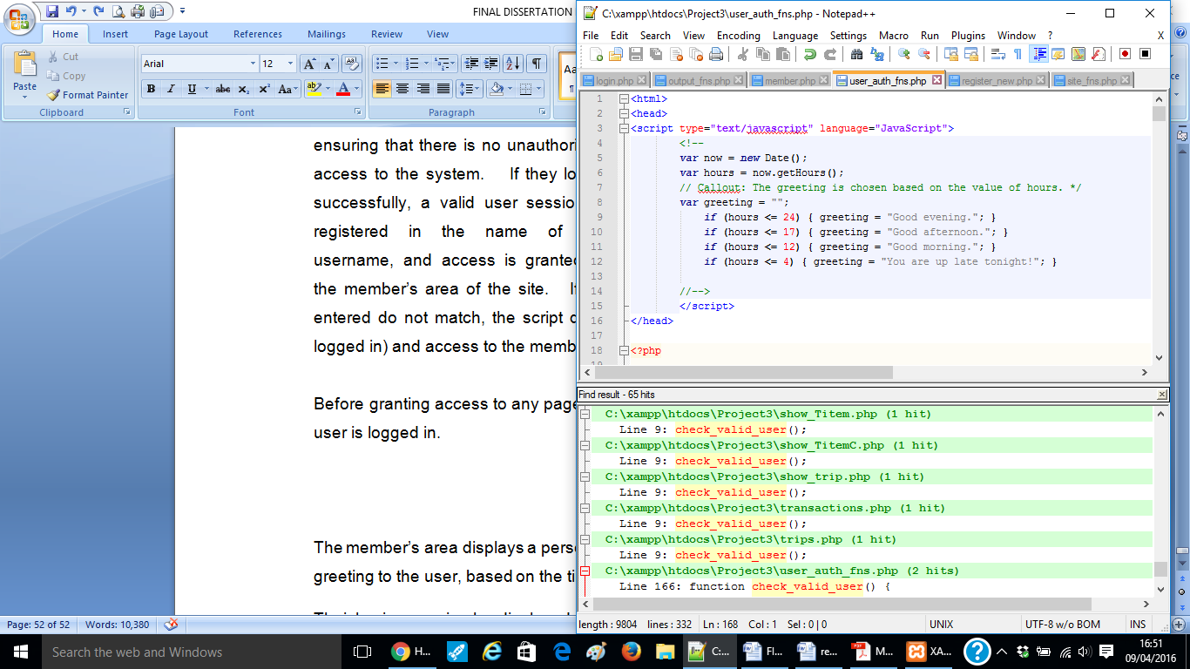

Figure 30 – Time of Day Greeting Code

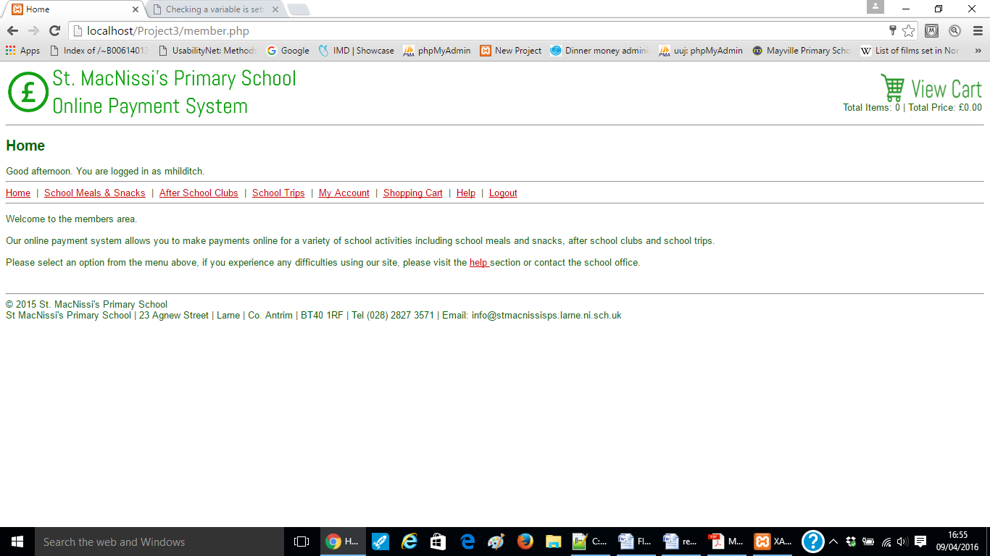

Figure 31 – Example Personalised Greeting

The user should log out of the system when finished to prevent unauthorised use account access via an active logon. The menu bar provides a link for the user to log out of the system. Before the session is ended, the user is asked to confirm that they are sure they wish to log out (illustrated in Figure 32).

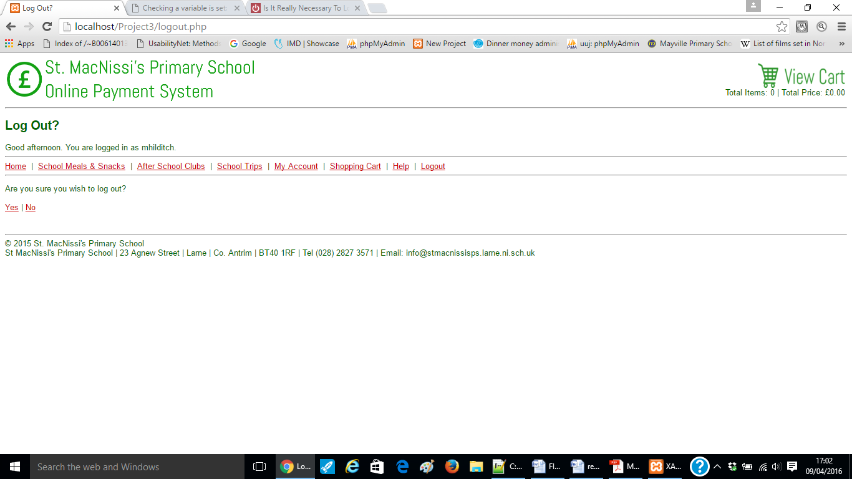

Figure 32 – Example Confirm User Log Out

The PHP scripts tests to see if the user was logged in, and the session _destroy() function is used to end the current session meaning that any variables held by the session array cannot be called during any following code. The code for this is illustrated in Figure 33.

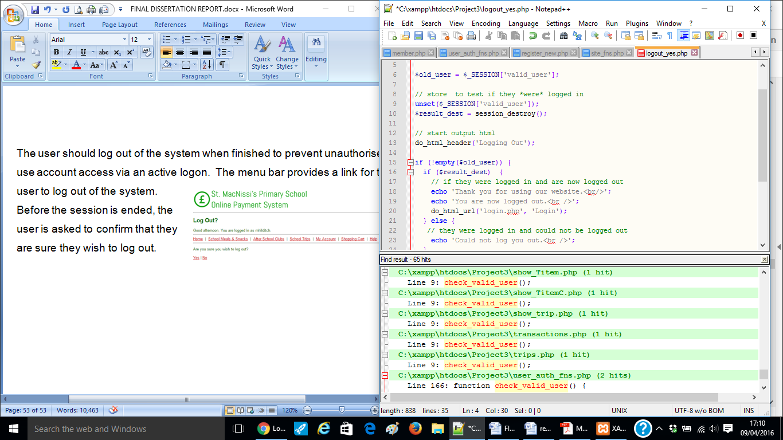

Figure 33 – User Log Out Code

Once the session has ended, and the user is logged out, a message is displayed thanking them for using the system and a link is provided via a url to the homepage should they wish to log in again.

**5.7 Sessions**

As previously discussed, a user needs to be logged in to view pages in the member’s area. Extra code is required to maintain the user’s status as they are transitioning between pages. To solve this issue, sessions are used. $_SESSION is PHP super-global that stores data in an array. The session will last for as long as the user keeps the browser open. Upon success log in, a valid user session is registered in the name of the username. As a user moves between pages, a ‘check_valid_user’ function will be used to check that they are logged in and therefore be granted access to the requested page.

Figure 34 illustrates the code for this.

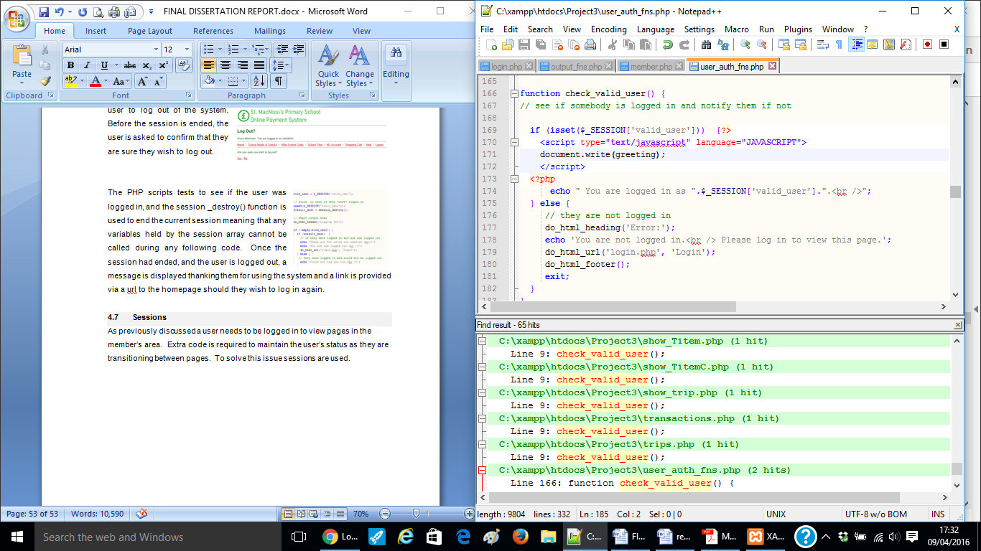

Figure 34– Check Valid User Code

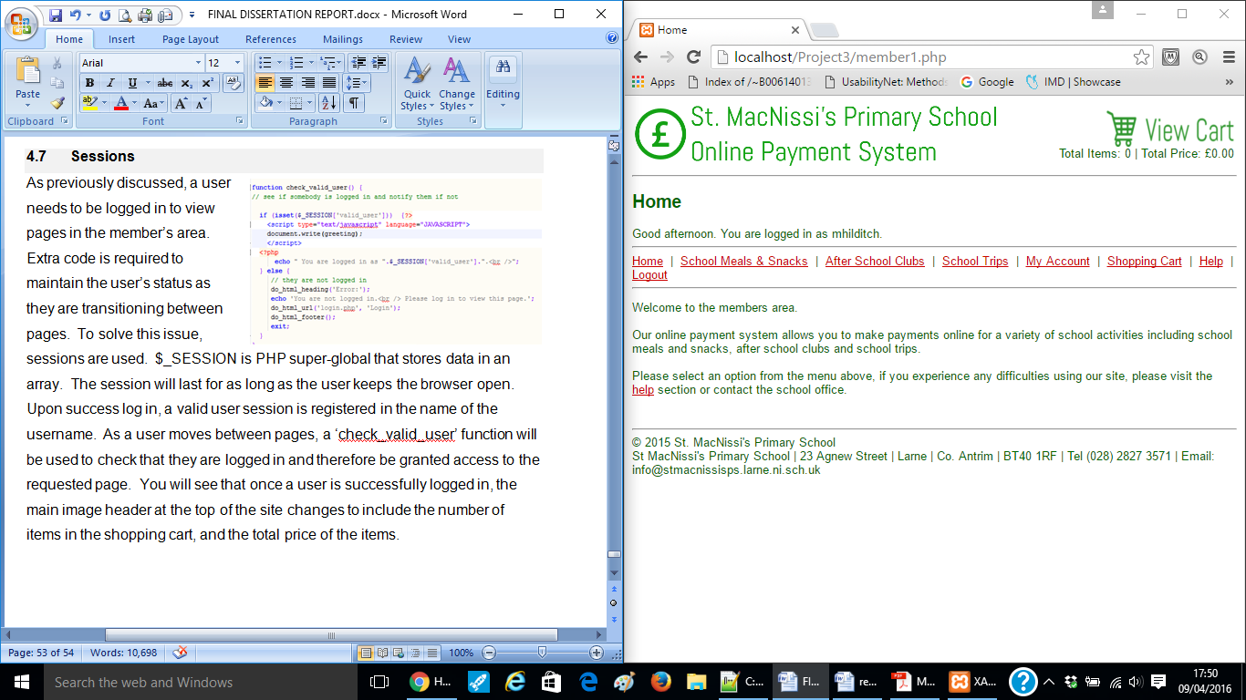You will see that once a user is successfully logged in, the main image header at the top of the site changes to include the number of items in the shopping cart, and the total price of the items. An example of this is shown in Figure 35.

Figure 35 – Header Change Example

**5.7.1 Session Timeout**

As an extra security measure, a session time out has been built into the system. A timeout variable field specifies the number of seconds that the session can remain idle for before the session is terminated. The timeout is set to 600 seconds (20 minutes). The number of seconds since the last visit is checked, and if this time is larger than the timeout period the session is destroyed, meaning the user will have to log in again to proceed. This feature will prevent unauthorised access to unattended sessions. The code is illustrated in Figure 36.

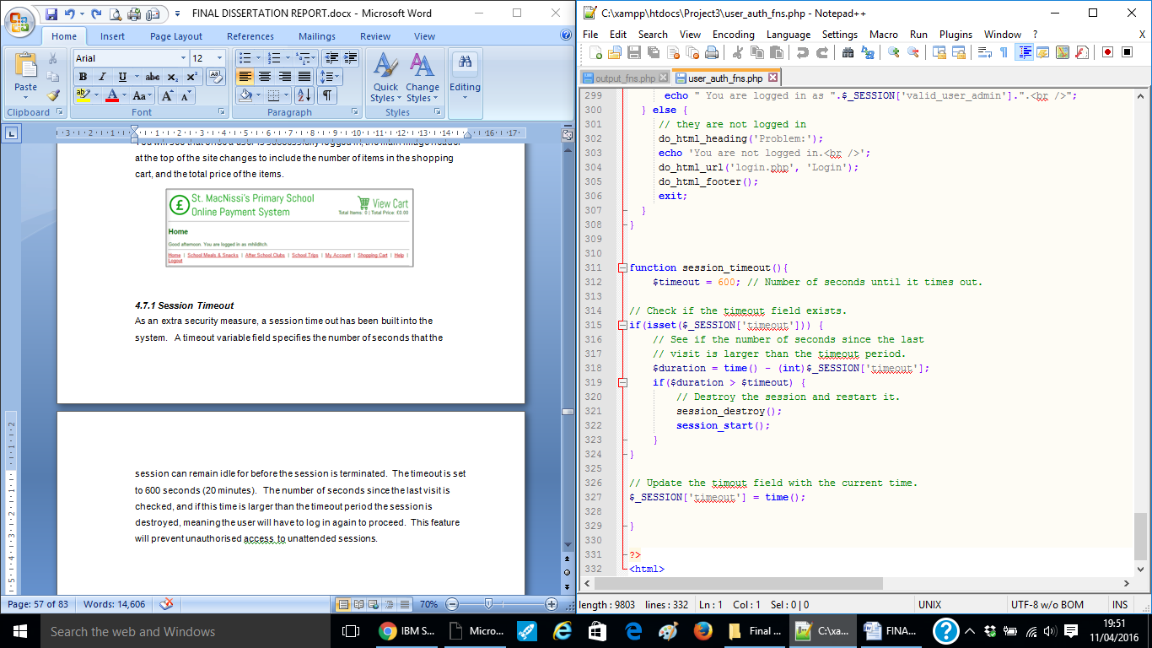

Figure 36 – Session Time Out Code

**5.8 School Meals**

Functional requirement F04 states that registered users should be able to view and purchase meal choices. The user can view the school meal choices by clicking on ‘School Meals & Snacks’ from the menu navigation bar. Users are able to view and purchase meals for the next 7 days.

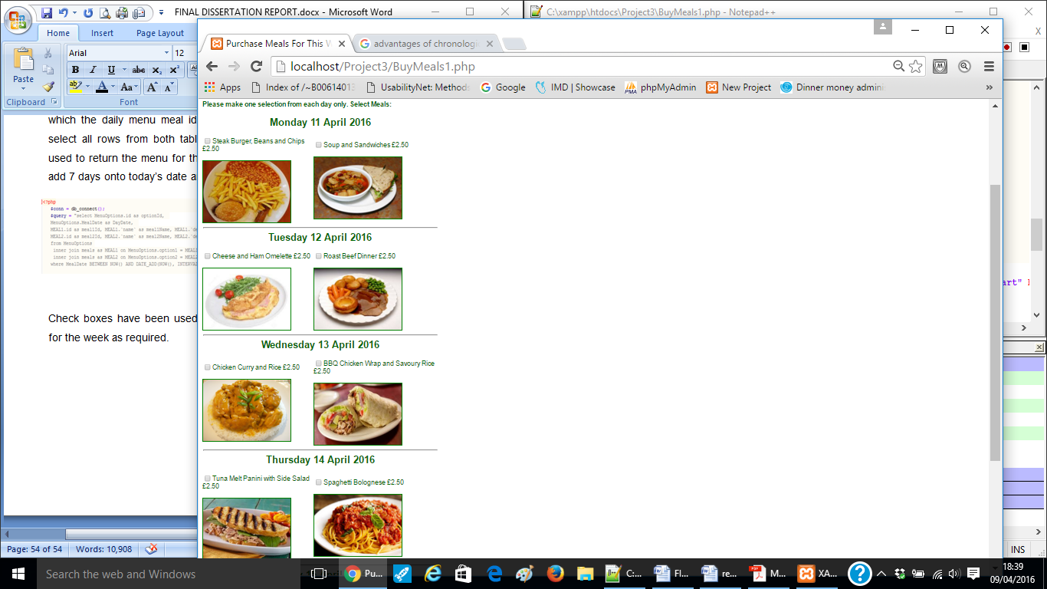As discussed in Chapter 3.6.3.6, there are twenty master meals, and the daily menu offers two set choices from this list of master meals each day. Users are presented with the name, price and image of each set meal for a given date. An example of the view is shown in Figure 37.

Figure 37 – View and Purchase Meals Example

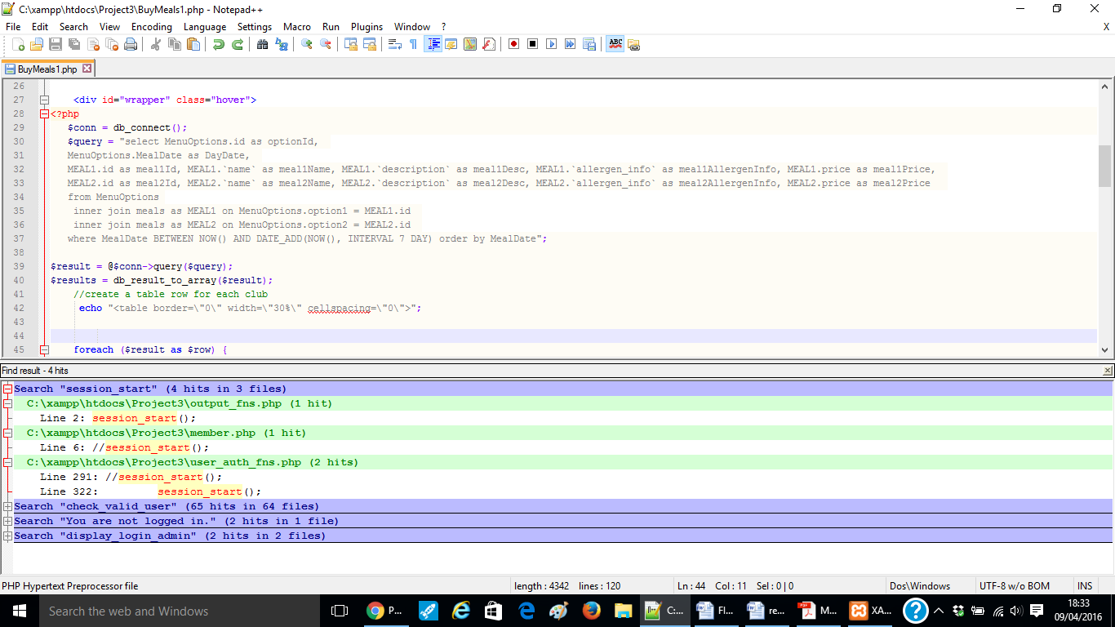An ‘if’ statement is used to check the image folder for an image with a matching id as the meal id. To achieve this, a query selects the meal id and date from the daily menu table, and an inner join is performed on the master meals table, to return the rows in which the daily menu meal id matches the master meal id. The inner join will select all rows from both tables as long as there is a match. A where line is used to return the menu for the next 7 days - the ‘date_add()’ function is used to add 7 days onto today’s date and finally the meals are ordered by date. This code for this is illustrated in Figure 38.

Figure 38 – Viewing Meals Code

Check boxes have been used to allow parents to select one or as many meals for the week as required. An ‘add to cart’ button is displayed to allow users to easily add their selection to the shopping cart.

**5.9 School Trips**

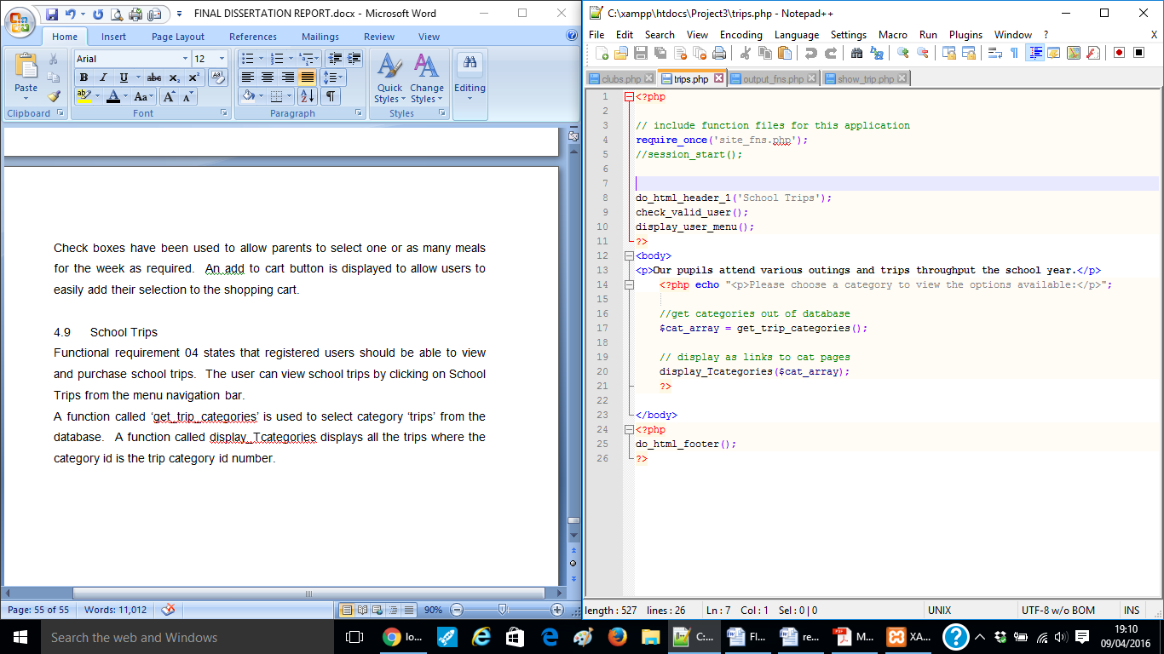Functional requirement 05 states that registered users should be able to view and purchase school trips. The user can view school trips by clicking on ‘School Trips’ from the menu navigation bar. As discussed in Chapter 3 there is a table named ‘categories’ and a table named ‘trips’. A function named ‘get_trip_categories’ selects the category named ‘trips’ from the categories table. The code used for this is displayed in Figure 39.

Figure 39 – Get Trip Categories Code

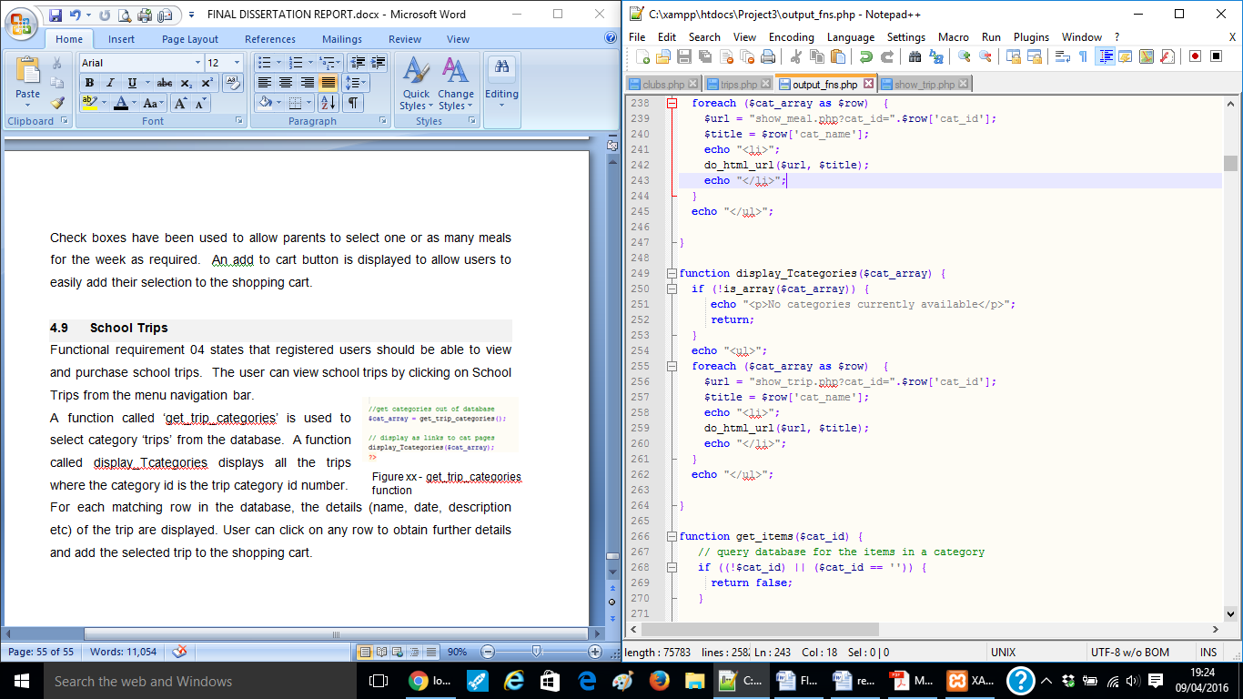A further function named ‘display_Tcategories()’ displays all trips from the trips table where the category id matches the ‘trips’ category id in the categories table. The code to achieve this is displayed in Figure 40.

Figure 40 – Display Trip Categories Code

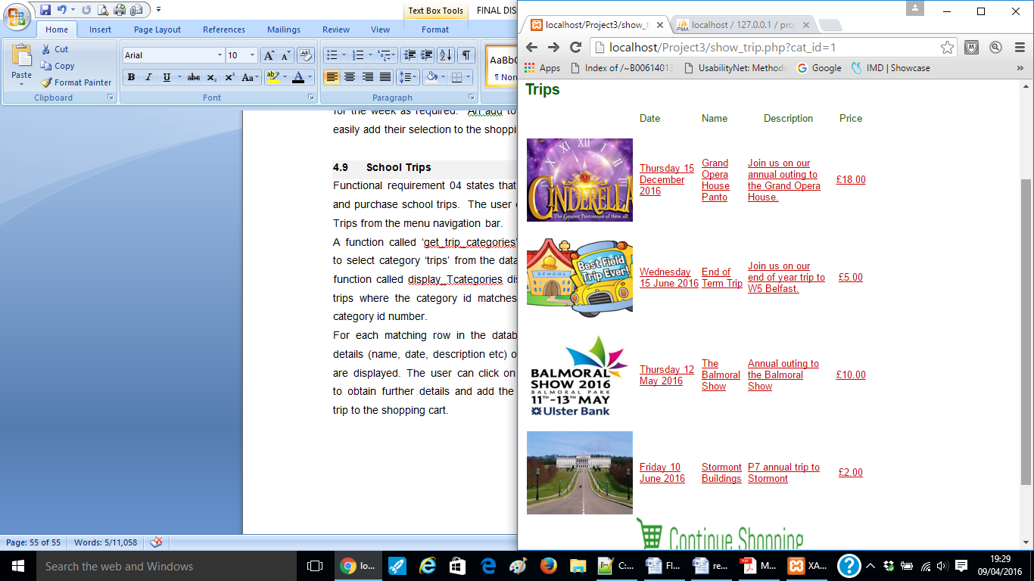For each matching row in the database, the details (name, date, description etc) of the trip are displayed. The user can click on any row to obtain further details and add the selected trip to the shopping cart. This is illustrated in Figure 41.

Figure 41 – Viewing School Trips Example

**5.10 After School Clubs**

Functional requirement 06 states that registered users should be able to view and purchase after school clubs.

The user can view after school clubs by clicking on ‘After School Clubs’ from the menu navigation bar. This is illustarted in Figure 42. The functions and code involved in viewing clubs is very similar to that of school trips, as discussed in Chapter 4.9.

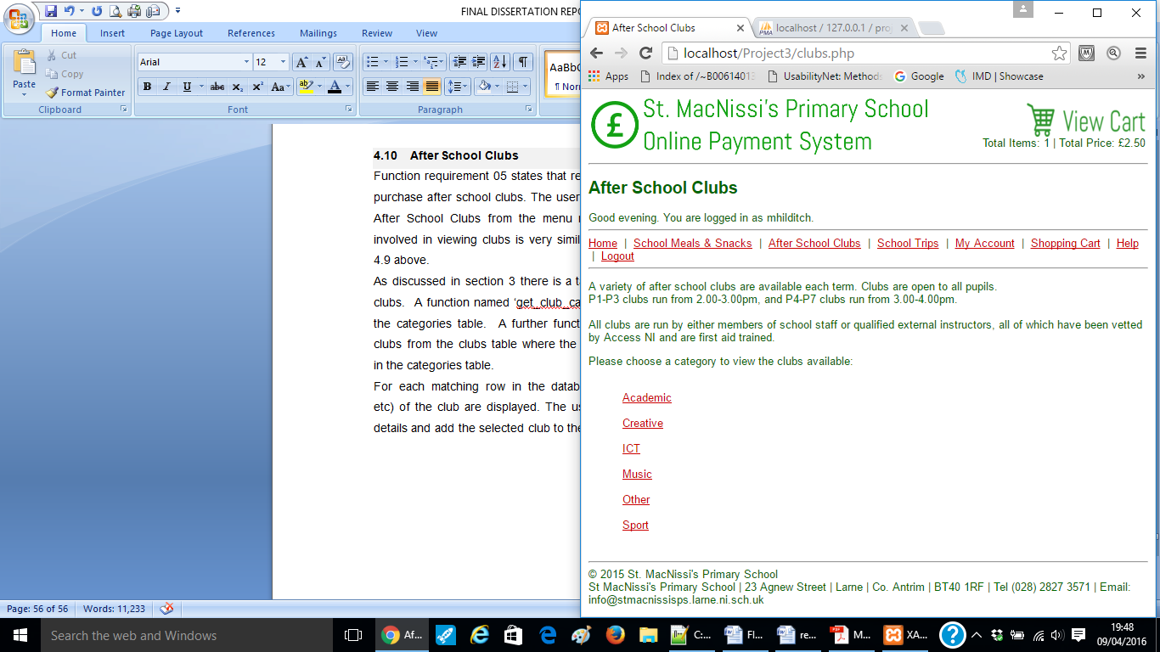

Figure 42 – Viewing After School Clubs Example

As discussed in Chapter 3 there is a table named ‘categories’ and a table named ‘clubs’. A function named ‘get_club_categories()’ selects the club categories from the categories table. The code used to achieve this is illustrated in Figure 43.

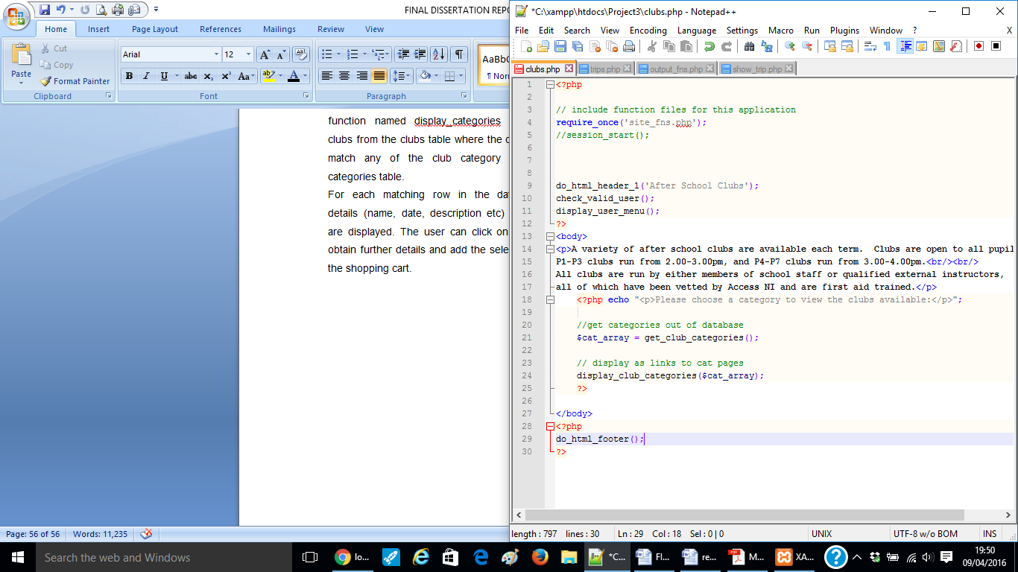

Figure 43 – Get Club Categories Code

A further function named ‘display_categories()’ displays all clubs from the clubs table where the category ids match any of the ‘club’ category ids in the categories table. The code used to achieve this is illustrated in Figure 44.

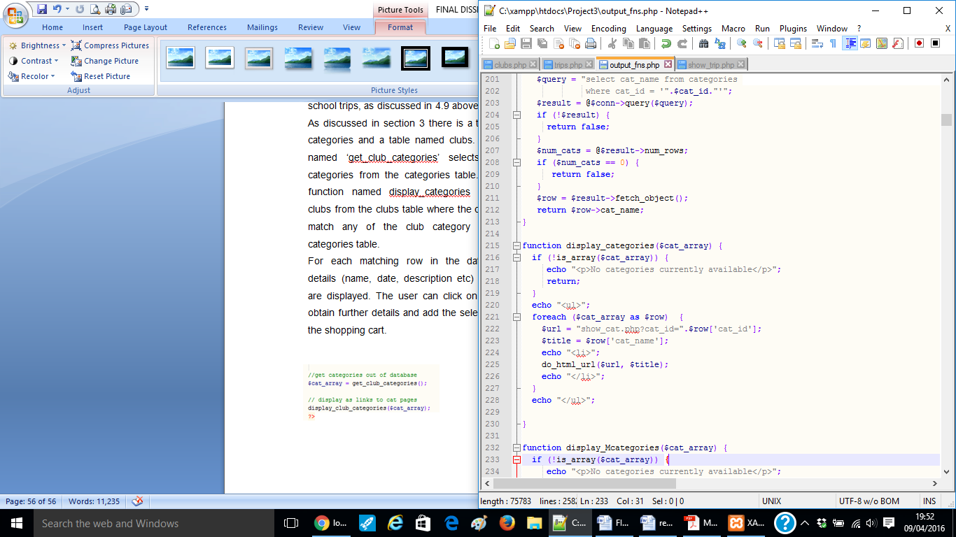

Figure 44 – Display Trip Categories Code

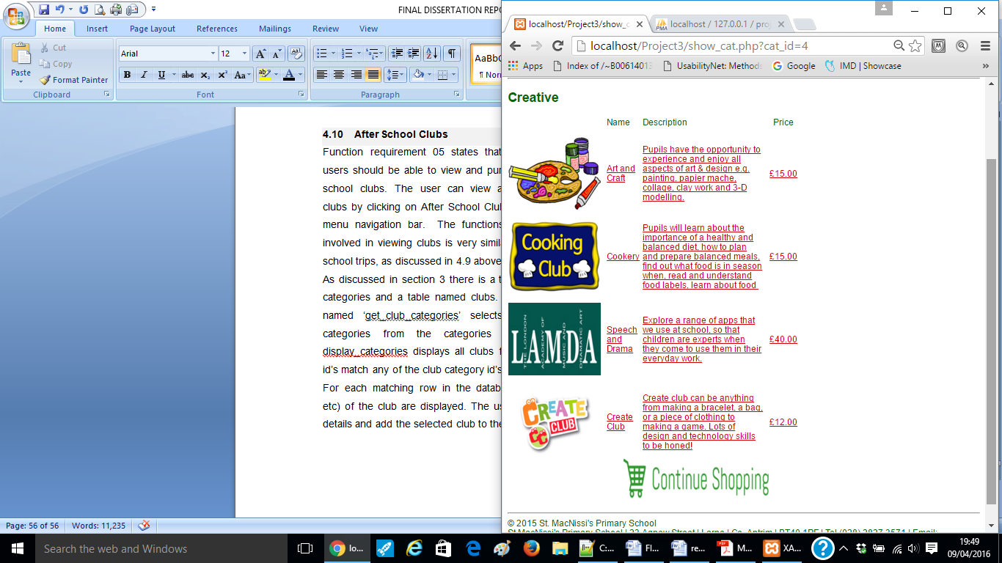For each matching row in the database, the details (name, date, description etc) of the club are displayed. The user can click on any row to obtain further details and add the selected club to the shopping cart. An example is illustrated in Figure 45.

Figure 45 – Viewing Trips Example

**5.11 Barcode**

Functional requirement 07 states that registered users should be able to print a personalised barcode.

The school meals section reminds users to visit the ‘My Account’ area to do this. On logging out, a windows alert is also displayed reminding the user to print their barcode. An example of this is illustrated in Figure 46.

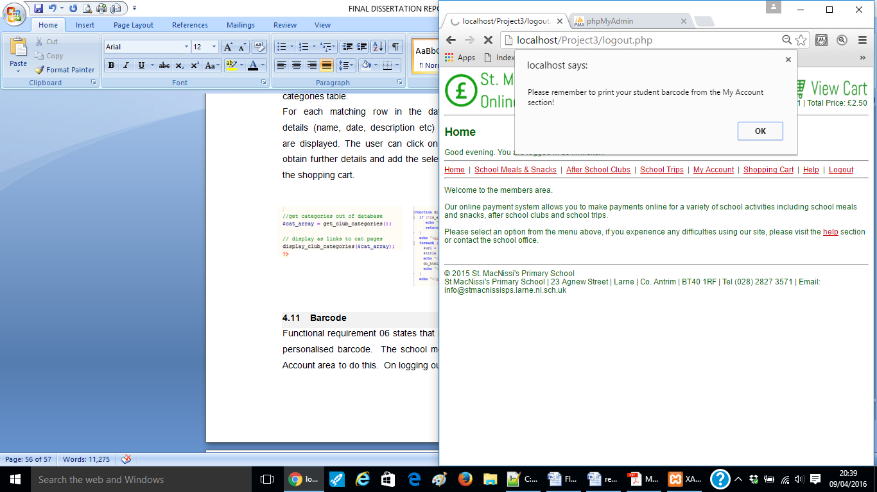

Figure 46 – Windows Alert Example

This was achieved using a simple windows alert function. The code used to achieve this is displayed in Figure 47.

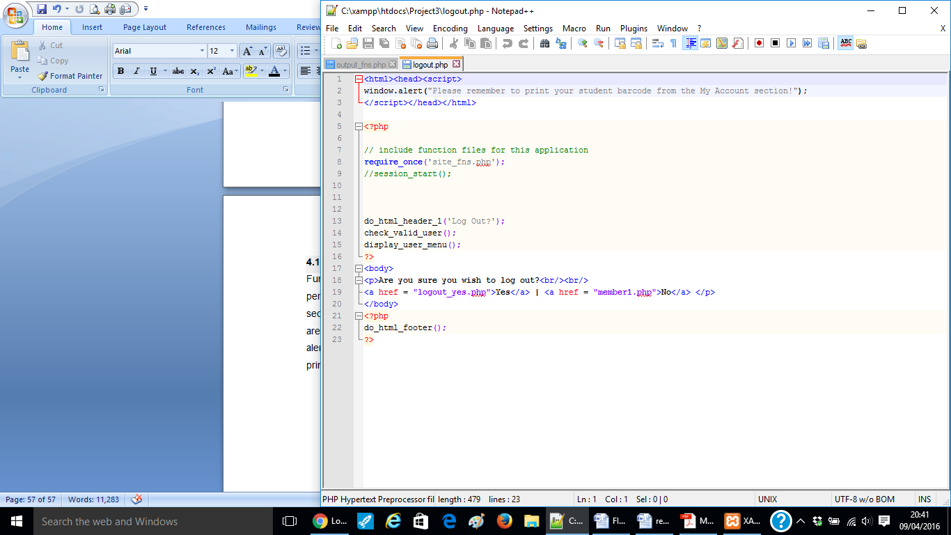

Figure 47 – Windows Alert Code

The barcode functionality uses the PHP technology BCGcode39.barcode.php library to generate a barcode for the user.

Code 39 is a common barcode type used for various labels such as name badges so it was felt that this would be the most suitable. It can pass in a string variable. The required classes were included. The barcode scale, thickness, colour, font etc were set, and a new barcode drawing called, passing in the username using the valid user session data.

When the user runs clicks to view their own personalised barcode it is displayed as an image, meaning they can save or print it easily. An example of a user barcode is illustrated in Figure 48. The code to achieve this is illustrated in Figure 49.

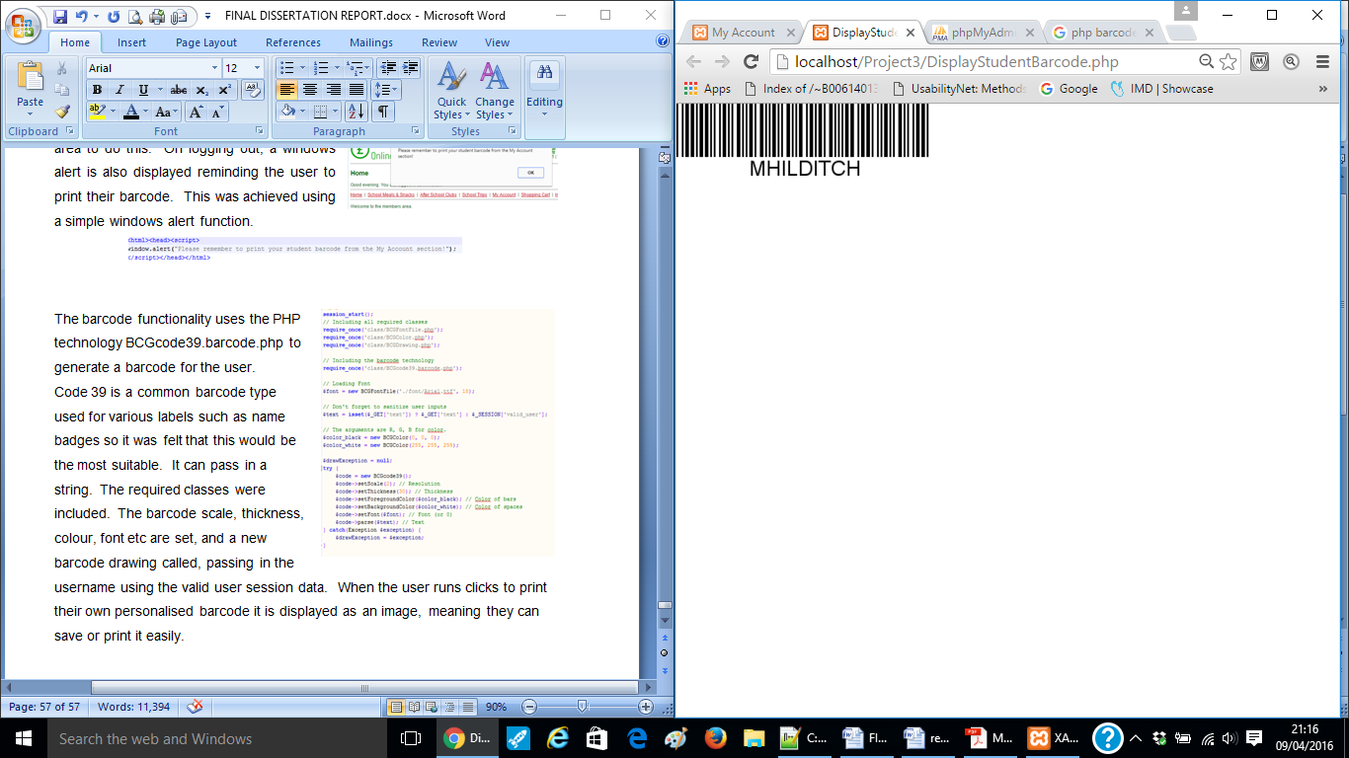

Figure 48 – Personalised User Barcode

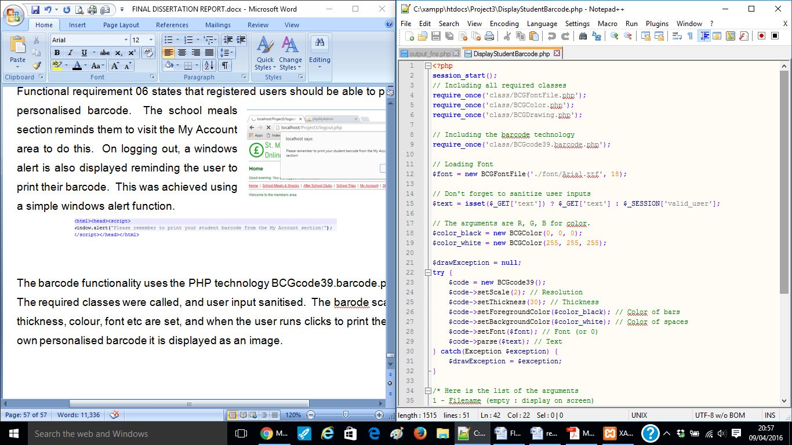

Figure 49 – Barcode Implementation Code

**5.12 Shopping Cart**

As part of the meals, trips and after school club purchasing process, users should be able to view and edit the shopping cart. A large amount of time was spent on this area, ensuring that the data displayed correctly and in order from each of the three purchase areas- meals, trips and clubs.

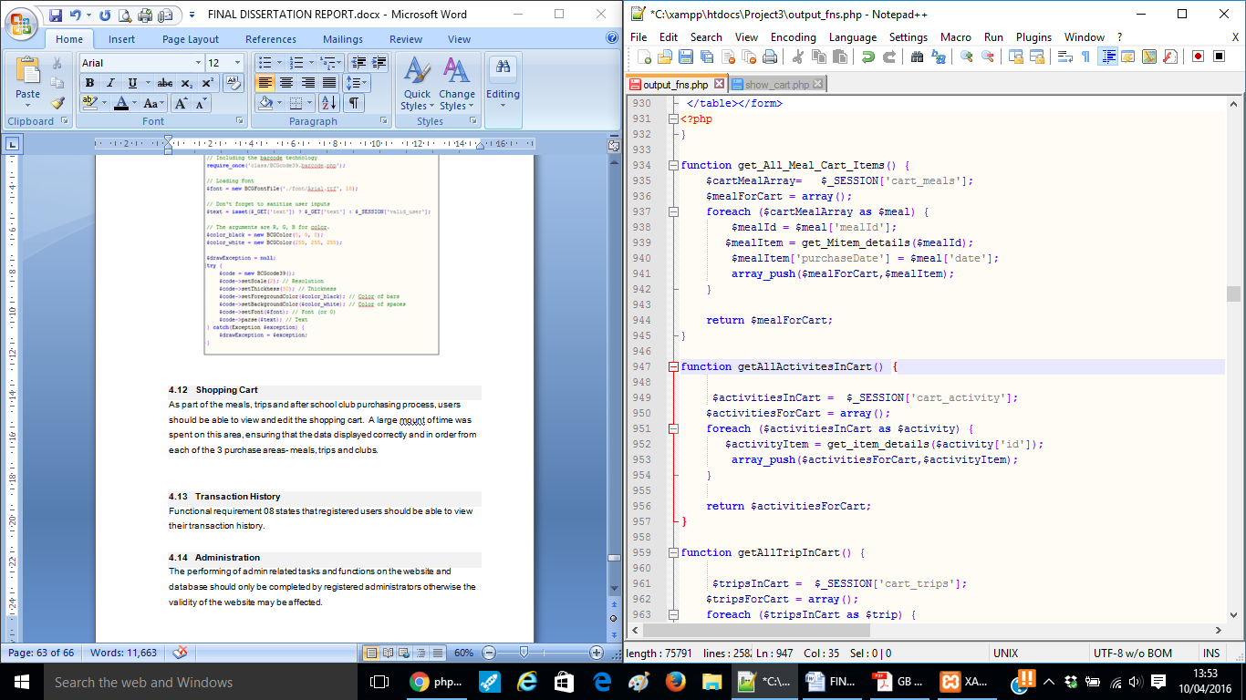Three separate functions were created – ‘get_All_Meal_Cart_Items’, ‘get_All_Trip_Cart_Items’ and ‘get_All_Club_Cart_Items’ and the items from each, placed in an array. An example of the code used to achieve getting the meal items is illustrated in Figure 50.

Figure 50 – Get Meal Items Code

Each of these functions was called, and items in each array were displayed as a table in the shopping cart. The code used to achieve this is illustrated in Figure 51.

Figure 51 – Display Shopping Cart as a Table

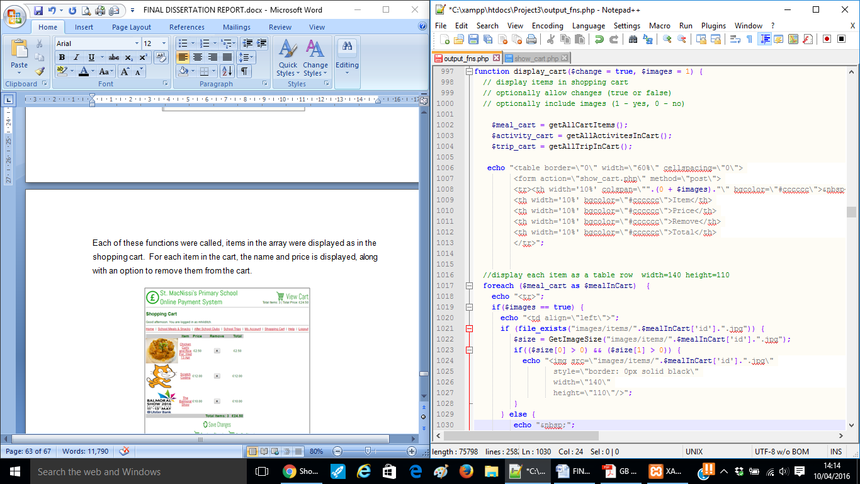

Figure 51 –Shopping Cart Code

For each item in the cart, the name and price is displayed, along with an option to remove the item from the cart. An example of the shopping cart is illustrated in Figure 52.

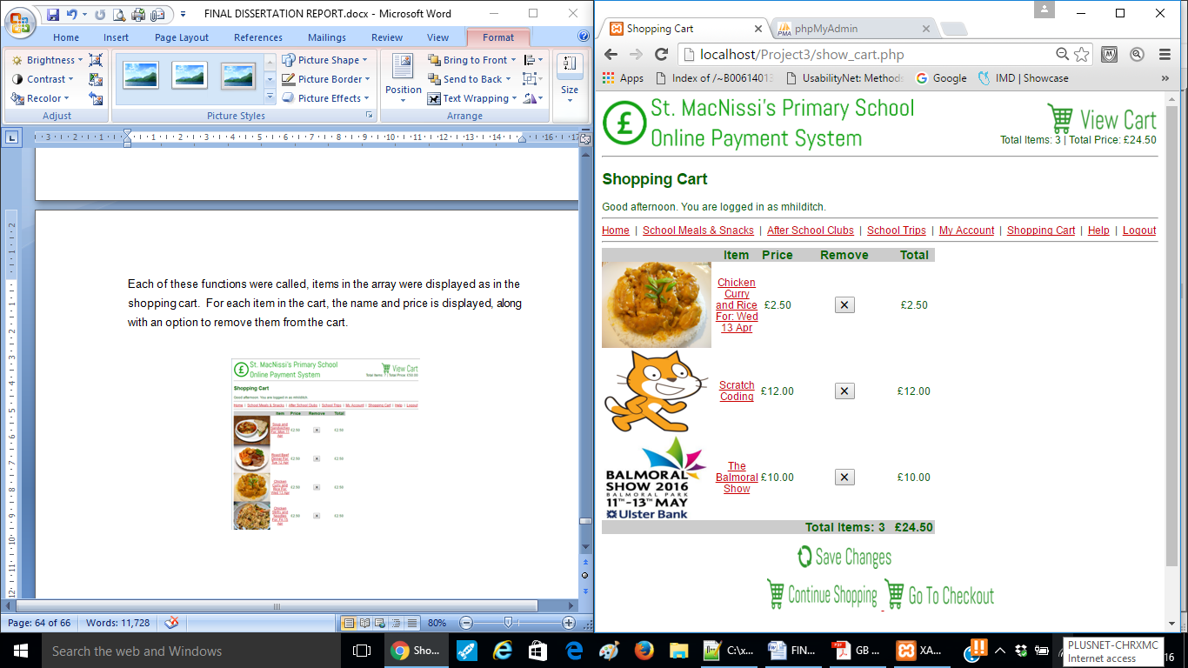

Figure 52 – Example Shopping Cart

If there are no items in the shopping cart, a message is displayed advising the user that the shopping cart is empty.

**5.13 Purchasing**

Once the user is happy with their purchases in the shopping cart, they may proceed to ‘purchase’. The user can only proceed to the purchase stage if they have items in the shopping cart.

At the purchase stage a summary of their items and cost is displayed. A simple form asks the user to fill out their personal details and their credit/debit details.

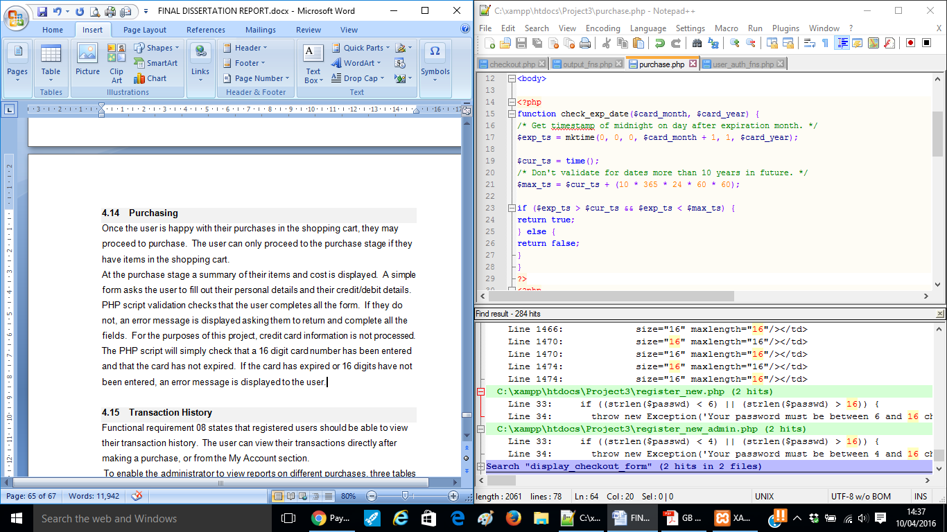PHP script validation checks that the user completes all the form. If they do not complete all form fields, an error message is displayed asking them to go back and complete all the fields. For the purposes of this project, credit card information is not processed. The PHP script will simply check that a 16 digit card number has been entered and that the card has not expired. The code used to check the expiry date is sown in Figure 53.

Figure 53 – Checking Expiry Date Code

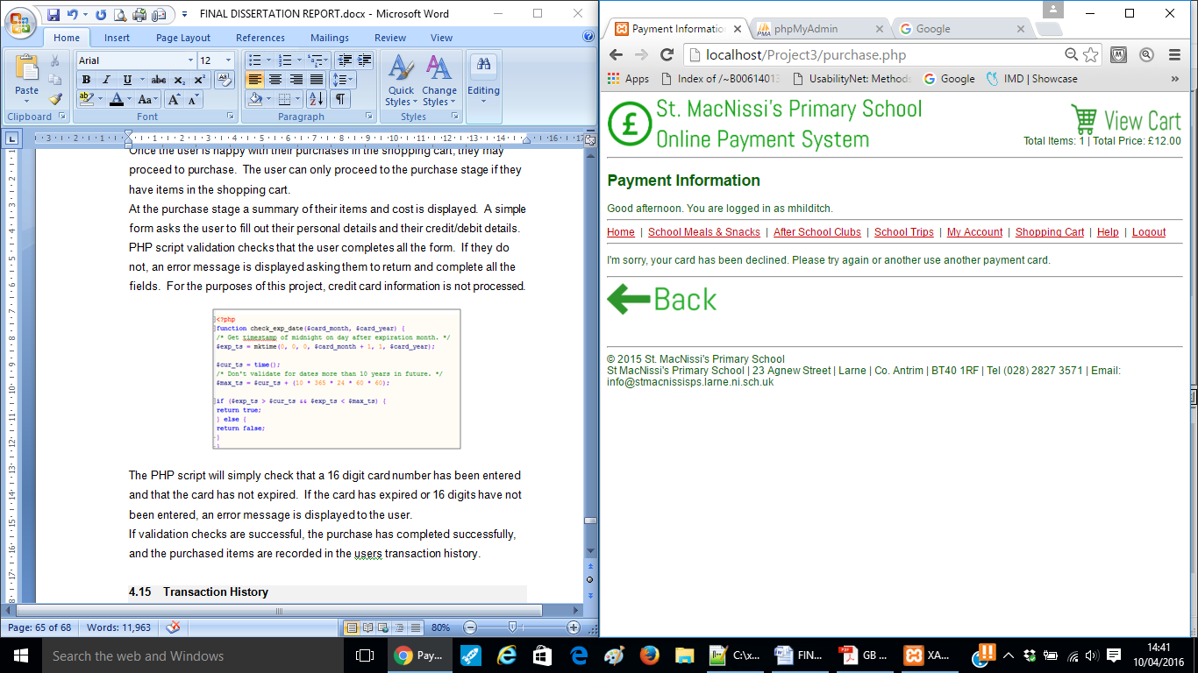 If the card has expired or 16 digits have not been entered, an error message is displayed to the user. An example of this is shown in Figure 54.

Figure 54 – Purchase Error Message Example

If validation checks are successful, the purchase has completed successfully, and the purchased items are recorded in the user’s transaction history.

**5.14 Transaction History**

Functional requirement 09 states that registered users should be able to view their transaction history. The user can view their transactions directly after making a purchase, or from the ‘My Account’ section.

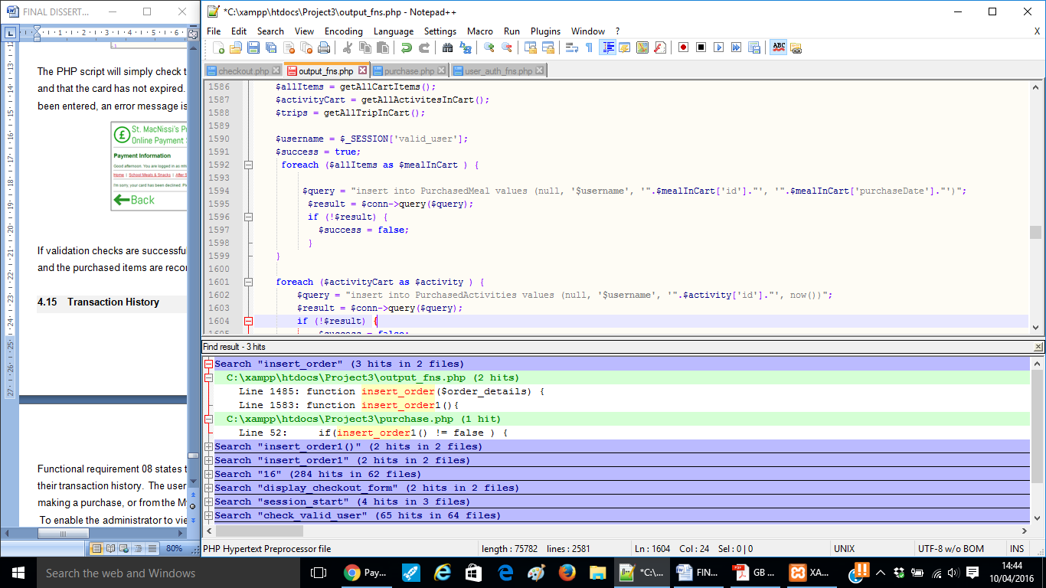 To enable the administrator to view reports on different purchases, three tables were created in the database to hold purchased meals, purchased trips and purchased clubs.

Figure 55 – Transaction History Code

For each meal, trip, or club purchased, the item id and date along with the username of the purchaser is placed in each respective table. The code used to achieve this is shown in Figure 55.

This allows the administrator to query who has purchased what and when, when they run a query report.

**5.15 Administration**

The performing of administration related tasks and functions on the website and database should only be completed by registered administrators otherwise the validity of the website may be affected. There is an area on the home page for the administrator to log in. Login functionality is similar to that of a parent user; only the PHP script will be checking the username and password is a match in the ‘admin’ table (as opposed to the user table). When logged in, you will see that the main image header is different to that of a parent user.

There are different types of data the administrator can add to, delete from, or amend in the database. Each of these are applied similarly and stored in their respective tables. Figure 16 as illustrated in Chapter 4 displays the different interactions the administrator has with the system.

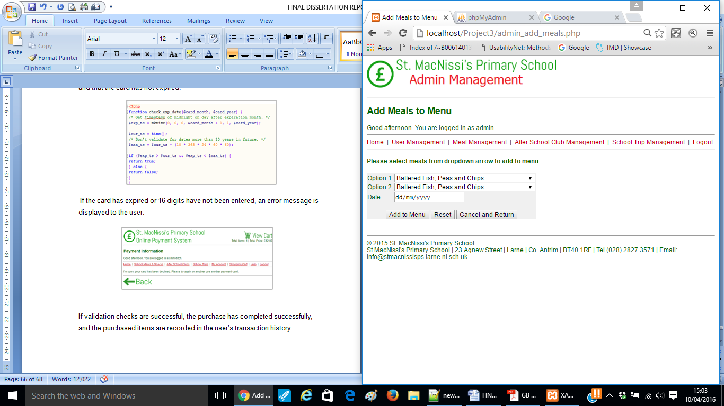An example of which is adding menu entries. The administrator is presented with an interface asking them to select set meal 1 and set meal 2 from a drop down list, and to select the date. An example of the administrator interface for adding menu entries is shown in Figure 56.

Figure 56 – Adding Menu Entries Example

When the administrator clicks the ‘Add to Menu’ button a PHP script checks that a menu entry has not already been entered for that date. It does this by selecting any matching rows in the database that match the date the administrator has selected. If there is a match, an error message is displayed advising that a menu entry already exists for that date. An example of the code used to achieve this is shown in Figure 57.

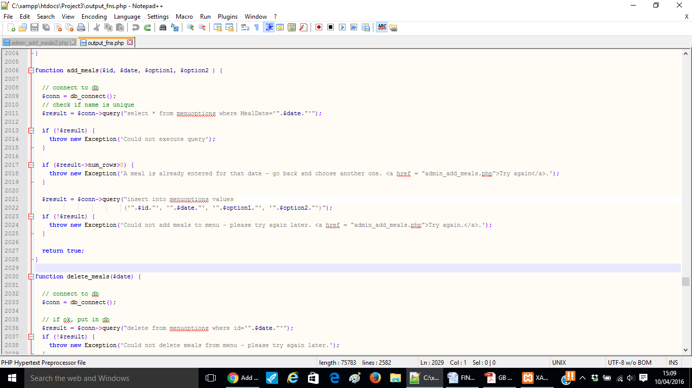

Figure 57 – Adding Menu Entries Code

If no date already exists, the selections are added as a menu entry, which the parent user can view for that date.

The other ‘add’ functions such as add master meal, add trip, add club, add category work in a similar way, the PHP script will check that an entry in the database does not already exist.

Amending and deleting meals, master meals, trips, and clubs work in a similar way again. The administrator selects from a drop down list the item they would to amend or delete (i.e. club, category, master meal, menu entry, trip).

If the item is being amended a PHP script ( for each item), checks that an entry does not already exist in the database to that of the amended information entered by the administrator. An error message is displayed if there is an item already existing with the same name/id.

Figure 58 displays the code used to amend a master meal.

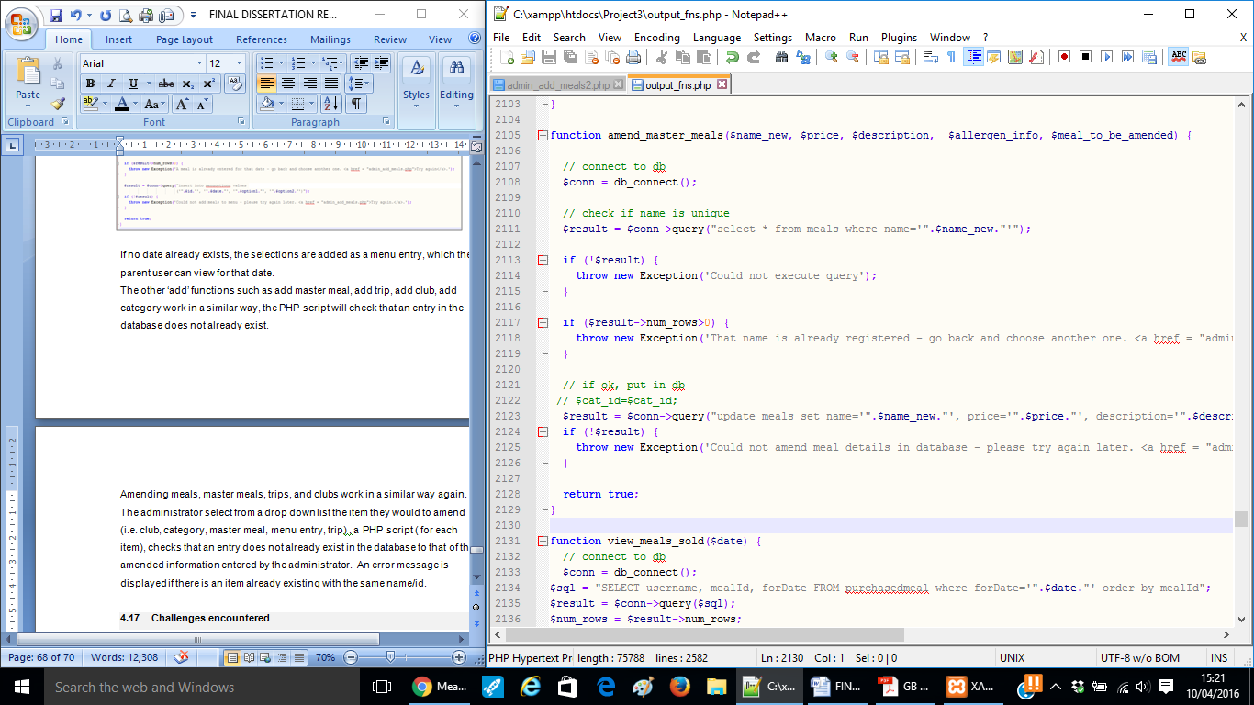

Figure 58 – Amend Master Meal Code

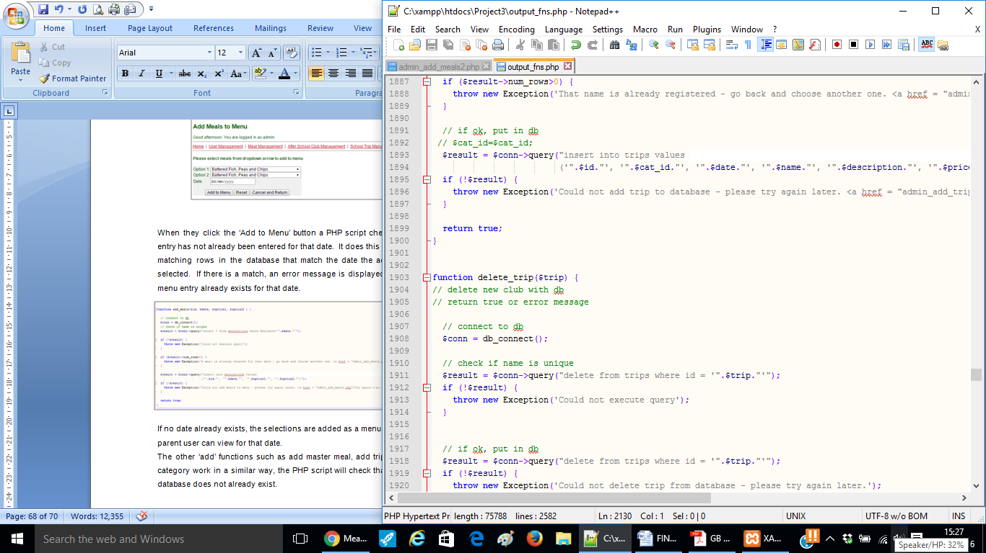If an item is being deleted, the administrator navigates to the appropriate area of the site, clicks to delete an item, and selects the item to be deleted from a drop down list. The PHP script selects the item from the database, where there is a match, and deletes it. An example of the code used to delete a trip is shown in Figure 59.

Figure 59 – Delete Trip Code

**5.16 Checking Meal Purchases**

Within the administration area, there is an option called ‘Daily Meal Checker’. Chapter 2.2.1 discussed a problem arising with the current paper-based solution, when pupils collect come to collect their meal at lunch time, and chose a different meal to the one they raised their hand for that morning. As there are no records kept, it presents a problem. The Daily Meal Checker allows the administrator to check that a student has purchased a meal for today, and also to confirm what the meal choice was. There is a simple form for the administrator to either type in or scan the pupil’s barcode. An example of the interface is shown in Figure 60.

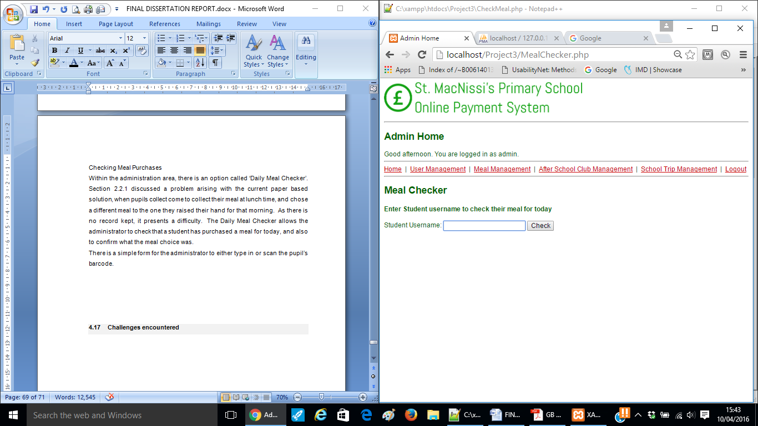

Figure 60 – Daily Meal Checker Example

A PHP script checks the purchased meal table for a match for the username and today’s date. If there is no match, a message is displayed to the administrator advising that a meal has not been purchased for today.

If a match is found, the pupil’s picture (which the parent uploaded when registering) and their meal choice is displayed, allowing the administrator to verify that the pupil has purchased a meal and therefore entitled to collect a meal from the school kitchen, AND to verify that the pupil is selecting the correct choice. This should minimise incidences of the cook running out of food, as children will be required to collect the meal choice purchased.

An example of a verified purchase is shown in Figure 61. The code to achieve this is displayed in Figure 62.

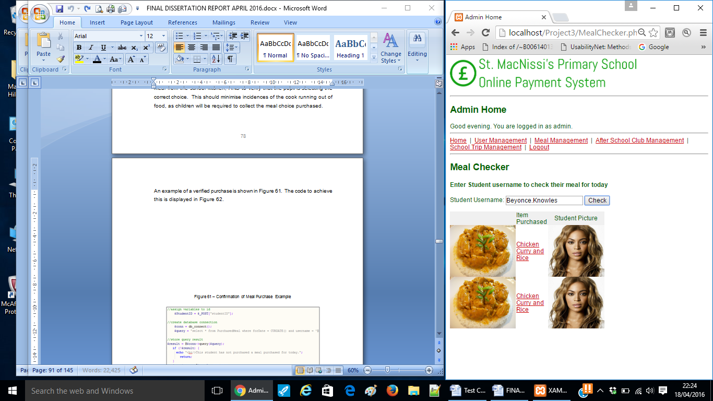

Figure 61 – Confirmation of Meal Purchase Example

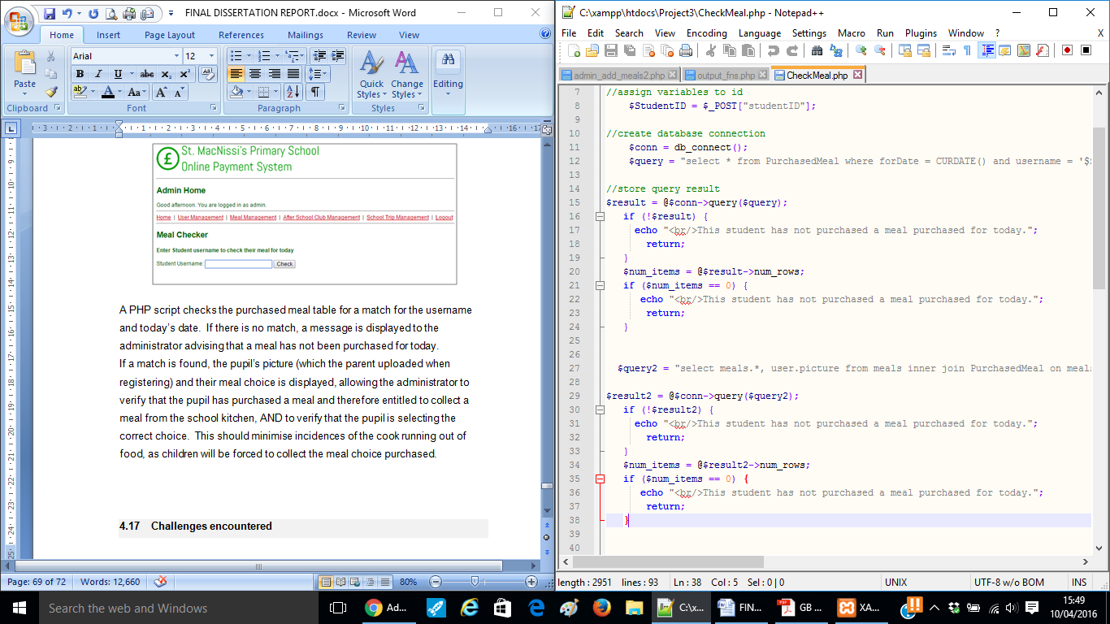

Figure 62 – Checking Meal Purchase Code

There is also functionality for the administrator to view and print reports, as to who has purchased what item. Each of the queries is applied similarly. In the case of school meals, the administrator selects the day from a drop down arrow and clicks to view who has purchased what meal. A PHP script selects the username and meal choice from the purchased meals table where the date matches the date selected by the administrator.

This report can then be shared with the school kitchen, so that the correct number of meals can be prepared. The code used to achieve this is shown in Figure 63. An example meal purchase report is shown in Figure 64.

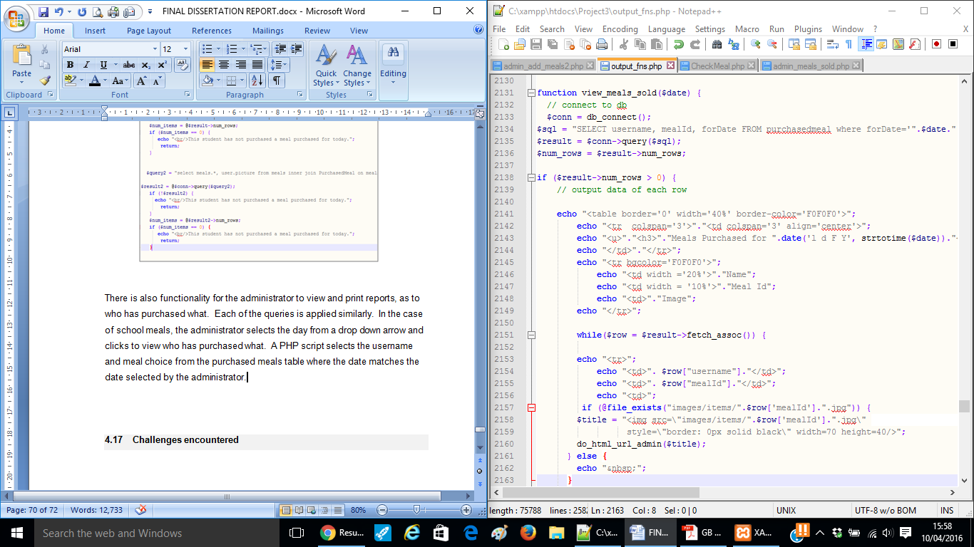

Figure 63 – Number of Meals Sold Code

Figure 63 – View Meals Sold Code

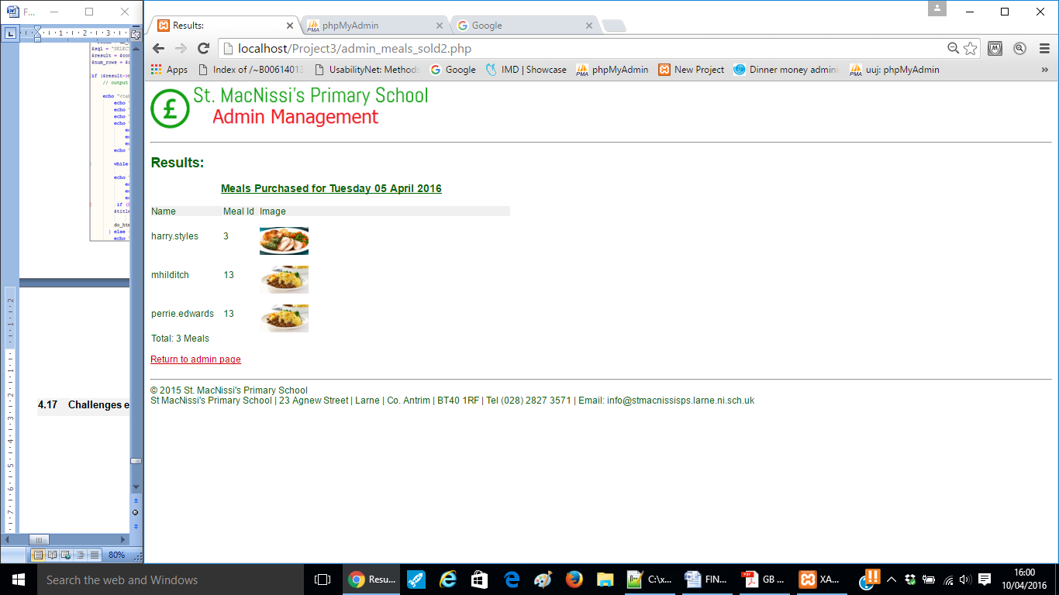

Figure 64 –Meals Sold Report Example

Trip attendees and club attendees are applied in a similar way. In these cases, the administrator clicks the trip/club (as opposed to date in the case of meals) from a drop down arrow, and selects to view who has purchased them i.e. the attendees.

**5.17 Error Handling**

Error handling has been incorporated at every stage throughout the implementation. This relieves the need for end users to encounter frustration in not knowing why something hasn’t happened as they thought it would. It also will aid the developer in the testing stages. Examples of error messages displayed have been discussed throughout the implementation stage.

**5.18 Challenges Encountered**

One of the most significant challenges encountered by the developer was getting the shopping cart functionality completed and working correctly without errors. In addition to this, getting the meals displayed correctly with the use of checkboxes/radio buttons proved another great difficulty. These tasks took a little longer than expected however tools such as the work breakdown structure and Gantt chart which had been created in the initial stages were used to manage time effectively and monitor progress.

 Testing

**6.1 Introduction**

This chapter presents the testing phase of the project. The purpose of this section is to report the various techniques that were applied to ensure that the system was robust and could meet the expectations of the end users. Weaver (2004) states that testing is critically important to the success of any project which aims to deliver working software.

Verification aims to ensure that the product is being built according to the requirements and design specifications (Softwaretestingfundamentals.com, 2011), i.e. to ensure that work products meet their specified requirements. Verification took place regularly, as the developer carefully checked the requirements and designs after it was felt a requirement had been met to ensure that this was the case. Furthermore, the Gantt chart was regularly consulted to ensure that the project was in keeping with the expected timescales.

Validation aims to ensure that the product actually meets the user’s needs, and that the specifications were correct in the first place (Softwaretestingfundamentals.com, 2011), i.e. to demonstrate that the product fulfils its intended use when placed in its intended environment. Validation was carried out for this project in the implementation stage. Various form of testing were carried out on the system - unit testing was carried out through the implementation of the system, system testing was completed as the final testing strategy for the project, navigation testing focused solely on user navigation and browser testing ensured cross browser functionality.

**6.2 Unit Testing**

McFarlin (2012) explains that unit testing refers to the practice of testing certain functions and areas – or units – of code. Throughout the implementation process, each unit of code was tested as it was being applied, to ensure it functioned as expected.

Errors found at this stage were resolved immediately, before the developer moved on to the next feature or requirement. This testing technique proved efficient, as discovering errors at an early stage allowed them to be detected more easily and at an early stage rather than in the final stages of testing with the end users. It identified and thus removed several system deficiencies.

**6.3 System Testing**

System testing is the type of testing to check the behaviour of a complete and fully integrated software product based on the software requirements (Softwaretestingclass.com, 2016). The main focus of this testing is to evaluate business, functional and end-user requirements. It is therefore based on the requirements specified in Chapter 3. This is black box type of testing where external working of the software is evaluated with the help of requirement documents and it is totally based on the user’s point of view. To document this testing technique the test itself is broken down into multiple test cases that can be examined and decision made on the outcome, whether the test passed or failed.

Table 20 presents an example test case.

Full system test case results can be found in Appendix H.

|  |  |
| --- | --- |
| **Test Id.** | **Description** |
| **1** | Parent should be able to register as a new user on the site |
| **Input** |  |
| **Expected Output** | User will be able to view and complete registration form. Successful registration provide user with a link to the members area. |
| **Actual Output** | As expected. |
| **Pass/Fail** | Pass |

Table 20 – Test Case Example

**6.4 Navigation Testing**

Navigation testing is undertaken to ensure that external and internal links are working properly (Tempson, 2016). It was carried out to ensure that users can successfully navigate from one page to another, and that all buttons and links are navigating the user to the correct page. This will include testing whether unregistered users can access the member’s area pages. Full navigation test case results can be found in Appendix I.

**6.5 Cross Browser Testing**

As not all users will be accessing the system using the same browser, it is the responsibility of the developer to ensure the website is built to perform adequately, across multiple browsers. Apperfect.com (2016) explains that cross browser testing involves checking the compatibility of the application across multiple web browsers and ensures that the web application works correctly across different web browsers. To thoroughly test this, the four main browsers – Safari, Mozilla Firefox, Microsoft Internet Explorer and Google chrome, were checked to ensure that the system displayed similarly on all. No issues were detected during this testing.

**6.6 User Acceptance Testing**

User acceptance testing is the last phase of software testing. The goal of user acceptance testing is to validate that a system of products is of sufficient quality to be accepted by the users, an ultimately, the stakeholders (Cimperman, 2006).

During the testing, actual end users test the software to make sure it can handle required tasks in real-world scenarios, according to specifications. User acceptance testing for this system was carried out in an informal manner. A potential end user (parent) was identified, and given a trial run with the website. They were asked to identify any issues they felt were a concern. The developer observed the user as they interacted and moved through the website, taking notes of issues or missed functionality. No major issues were detected and the user was happy with the system.

**6.7 Conclusion – Testing**

This chapter documented all of the testing strategies applied to ensure that the system was robust and also verified that the system met all of the requirements set out in Chapter 3. Without testing, errors, defects and bugs would have remained significantly reducing the user’s experience and system functionality. The various testing phases showed the developer that the system was developed and implemented right. In addition, testing validated that the system developed is what the user needed - to satisfy that the developer built the right system.

Excluding system maintenance this testing phase is the last developer input before the system is delivered. Thanks to the various testing methods applied a successful end product can be delivered.

 Evaluation and Results

**7.1 Introduction**

This Chapter documents the evaluation and results of the implemented online payment system. This chapter will focus on evaluating the project planning phases and the end user feedback compared to chapter ten that will provide a designer/ developer retrospective of the completed system.

**7.2 Reflection of Technologies Used**

**7.2.1 Notepad++**

The developer had previous experience with this script editor, and was able to draw on this experience when implementing the system. It ran well within the Windows environment and the auto complete function proved very useful. It’s compatibility with all of the development languages used, in particular phpMyAdmin, and ease of use made it the ideal editor. It had the added benefit of being cost free. It was used to develop all of the webpages and queries within the system.

**7.2.2 phpMyAdmin**

phpMyAdmin provided a secure and reliable environment to store, access and maintain data. It was easily incorporated with the programming languages used. Information was easily retrieved from the database through the use of SQL queries. phpMyAdmin was used to develop all of the database tables, some of which contained highly sensitive data. The system would not be functional without the database and associated tables.

**7.2.3 Development Languages**

HTML, CSS, Javascript and PHP were combined by the developer to produce the system. The result was a professional, modern website that had a consistent theme throughout. PHP was applied to add functionality to the site. It allowed data to be executed on the server, allowing the result to be returned to the browser.

It also allowed form data to be collected and processed, and data to be added, deleted and modified in the database. The languages were easy to read and write.

**7.3 Requirements Evaluation**

Chapter 3 presented the system requirements. In order to make the implemented system a success, both the functional, non-functional and business requirements needed to be met. Opfro.org (2016) specifies that the typical objectives of a requirements evaluation task are to determine if all specified requirements are:

* Correct
* Complete
* Consistent
* Feasible
* Mandatory
* Unambiguous
* Verifiable
* Validatable

**7.3.1 Functional Requirements**

Functional requirements were made up of both user (parent) and administrator requirements. They included all tasks that the user will require the website to complete. All the functional requirements have been met, and the test case results all produced a pass.

Users are able to register, log in and log out of the system. They are able to view and purchase school meals, trips and after school clubs. They are also able to view transaction history, and print a personalised barcode.

Admin users can log in and perform tasks and queries on data, such as adding new data, modifying data and deleting data. They can also perform specific queries on data. All of these functional requirements are suitable and precise, and required in order to make the system function correctly and as expected. Table 21 measures the functional requirements against the Opfro.org (2016) recommended objectives.

|  |  |  |  |  |  |  |  |  |
| --- | --- | --- | --- | --- | --- | --- | --- | --- |
| No. | Correct | Complete | Consistent | Feasible | Mandatory | Unambiguous | Verifiable | Validatable |
| F01 | ✓ | ✓ | ✓ | ✓ | ✓ | ✓ | ✓ | ✓ |
| F02 | ✓ | ✓ | ✓ | ✓ | ✓ | ✓ | ✓ | ✓ |
| F03 | ✓ | ✓ | ✓ | ✓ | ✓ | ✓ | ✓ | ✓ |
| F04 | ✓ | ✓ | ✓ | ✓ | ✓ | ✓ | ✓ | ✓ |
| F05 | ✓ | ✓ | ✓ | ✓ | ✓ | ✓ | ✓ | ✓ |
| F06 | ✓ | ✓ | ✓ | ✓ | ✓ | ✓ | ✓ | ✓ |
| F07 | ✓ | ✓ | ✓ | ✓ | ✓ | ✓ | ✓ | ✓ |
| F08 | ✓ | ✓ | ✓ | ✓ | ✓ | ✓ | ✓ | ✓ |
| F09 | ✓ | ✓ | ✓ | ✓ | ✓ | ✓ | ✓ | ✓ |
| F10 | ✓ | ✓ | ✓ | ✓ | ✓ | ✓ | ✓ | ✓ |
| F11 | ✓ | ✓ | ✓ | ✓ | ✓ | ✓ | ✓ | ✓ |
| F12 | ✓ | ✓ | ✓ | ✓ | ✓ | ✓ | ✓ | ✓ |
| F13 | ✓ | ✓ | ✓ | ✓ | ✓ | ✓ | ✓ | ✓ |
| F14 | ✓ | ✓ | ✓ | ✓ | ✓ | ✓ | ✓ | ✓ |
| F15 | ✓ | ✓ | ✓ | ✓ | ✓ | ✓ | ✓ | ✓ |
| F16 | ✓ | ✓ | ✓ | ✓ | ✓ | ✓ | ✓ | ✓ |
| F17 | ✓ | ✓ | ✓ | ✓ | ✓ | ✓ | ✓ | ✓ |
| F18 | ✓ | ✓ | ✓ | ✓ | ✓ | ✓ | ✓ | ✓ |
| F19 | ✓ | ✓ | ✓ | ✓ | ✓ | ✓ | ✓ | ✓ |
| F20 | ✓ | ✓ | ✓ | ✓ | ✓ | ✓ | ✓ | ✓ |
| F21 | ✓ | ✓ | ✓ | ✓ | ✓ | ✓ | ✓ | ✓ |
| F22 | ✓ | ✓ | ✓ | ✓ | ✓ | ✓ | ✓ | ✓ |
| F23 | ✓ | ✓ | ✓ | ✓ | ✓ | ✓ | ✓ | ✓ |
| F24 | ✓ | ✓ | ✓ | ✓ | ✓ | ✓ | ✓ | ✓ |
| F25 | ✓ | ✓ | ✓ | ✓ | ✓ | ✓ | ✓ | ✓ |
| F26 | ✓ | ✓ | ✓ | ✓ | ✓ | ✓ | ✓ | ✓ |
| F27 | ✓ | ✓ | ✓ | ✓ | ✓ | ✓ | ✓ | ✓ |
| F28 | ✓ | ✓ | ✓ | ✓ | ✓ | ✓ | ✓ | ✓ |
| F29 | ✓ | ✓ | ✓ | ✓ | ✓ | ✓ | ✓ | ✓ |
| F30 | ✓ | ✓ | ✓ | ✓ | ✓ | ✓ | ✓ | ✓ |
| F31 | ✓ | ✓ | ✓ | ✓ | ✓ | ✓ | ✓ | ✓ |

Table 21 – Functional Requirements Evaluation

**7.3.2 Non-functional requirements**

The non-functional requirements were concerned with the efficiency and compatibility of the system. All of the non-functional requirements have been met. The theme is consistent throughout the system and is also in keeping with colour conventions. The website displays correctly on all major browsers as verified by testing. The website is accessible from a range of devices and displays correctly. The website is easily navigated and should present as such to end users, who differ on levels of background, skill, knowledge and status for example. End user feedback presented in Chapter 7.4 shows all users agreed or strongly agreed that they found the system easy to use and navigate. The system is secure in that users need to either register or log in to view content in the member’s area. The implementation chapter showed that passwords are stored securely in the system.

NF07 requirement ‘The website should confirm to HCI and usability principles’, could perhaps be less ambiguous. Although various HCI and usability principles were researched as part of the Literature Review and Research in Chapter 2, the requirement omitted to specify which principles exactly. Table 22 measures the non-functional requirements against the Opfro.org (2016) recommended objectives.

|  |  |  |  |  |  |  |  |  |
| --- | --- | --- | --- | --- | --- | --- | --- | --- |
| No. | Correct | Complete | Consistent | Feasible | Mandatory | Unambiguous | Verifiable | Validatable |
| NF01 | ✓ | ✓ | ✓ | ✓ | ✓ | ✓ | ✓ | ✓ |
| NF02 | ✓ | ✓ | ✓ | ✓ | ✓ | ✓ | ✓ | ✓ |
| NF03 | ✓ | ✓ | ✓ | ✓ | ✓ | ✓ | ✓ | ✓ |
| NF04 | ✓ | ✓ | ✓ | ✓ | ✓ | ✓ | ✓ | ✓ |
| NF05 | ✓ | ✓ | ✓ | ✓ | ✓ | ✓ | ✓ | ✓ |
| NF06 | ✓ | ✓ | ✓ | ✓ | ✓ | ✓ | ✓ | ✓ |
| NF07 | ✓ | ✓ | ✓ | ✓ | ✓ | 🗶 | ✓ | ✓ |

Table 22 – Functional Requirements Evaluation

**7.3.3 Business Requirements**

Business requirement B01 specified that the finished system should be completed by 22April 2016. This requirement has been met in full. The Gantt chart and work breakdown schedule proved useful tools in helping to manage time effectively and monitor progress, to ensure the project was completed within the required timescale.

**7.4 End User Evaluation**

***7.4.1 Parents***

A sample of end users (parents) was asked to give their opinion on the use, functionality and user experience of the final system.

Sixty six parents (representing 30% of potential end users) completed end user questionnaires. The completed questionnaires can be found in Appendix J, a summary of the responses are analysed and evaluated below.

Question 1: *I found the system easy to use and navigate*

90% of respondents strongly agreed that they found the system easy to use and navigate. Figure 65 presents the results as a bar chart.

These results are very encouraging indeed, and would suggest that the system conforms to project objective no.4 of ‘creating a user friendly front end website for parents with consideration for usability and HCI principles’.

Figure 65 – Results: I found the system easy to use and navigate

Question 3: *Did you find the online system an improvement to the current manual process*?

91% of respondents strongly agreed that they found the new online payment system an improvement to the current manual process. This is a very successful outcome, and would suggest that if they feel it is an improvement they would therefore be more inclined to use the system rather than the current manual approach. Figure 66 presents the results in a bar chart.

Figure 66 – Results: Did you find the online system an improvement to the current manual process

Question 4: *How is it an improvement?*

92% of respondents said as the system was more convenient,

86% of respondents said as the system was less time consuming,

78% of respondents said as the system was accessible 24 hours,

61% of respondents said as the system the system gave them peace of mind,

47% of respondents said as the system was instantaneous,

12% of parents commented that they felt assured that their child would receive the correct meal choice.

These results are very positive, and highlight the fact that it is a much more up to date and current way of paying for school activities. If it is more convenient than the current method, parents would be more likely to use it.

Figure 67 presents the results in a bar chart.

Figure 67 – Results: How is it an improvement?

Question 5: *How frequently would you use the new system?*

9% of respondents would use the new system daily

69% of respondents would use it weekly

18% of respondents would use it as and when required

These results are excellent, and show that parents would use the new system on a regular basis. Parents paying for school activities using the new online system cuts down the workload for the school administrator and means that school meals, trips, and club purchases can be easily viewed and tracked. Figure 68 presents the results as a bar chart.

Figure 68 – Results: How frequently would you use the new system?

Question 10: *I would recommend the system to other parents*

97% of respondents strongly agreed that they would recommend the system to other parents.

This is an excellent result for the system, and would therefore indicate that parents are very happy to engage with the new system. Figure 69 presents the results in a bar chart.

Figure 69 – Results: I would recommend the system to other parents

**7.4.2 Admin**

The administrators who participated in the requirements gathering phase, were asked to provide feedback on the final system. Results can be found in Appendix K.

They reported that having parents pay for school meals and activities using the online system was a much more efficient way of managing the whole cash receipt and recording process. Their workload has been significantly reduced, and they have particularly found the meal checker and daily meal report very useful and practical. It has helped reduced instances of incorrect meal choices, and children taking meals they have not paid for.

It would seem that the system has achieved its aim by streamlining the school cash receiving process and helping to reduce workload.

**7.5 Reflection on Project Aims and Objectives**

The aim of the project was ‘*To create an online payment system incorporating a canteen management scheme for St. MacNissi’s Primary School, which streamlines the school cash receiving process and helps reduce workload’*. This aim perfectly summarises the intentions of the project. To meet this aim, the following project objectives were set:

* **Identify and evaluate existing school cash/canteen management systems** – This was completed in Chapter 2. The Literature Review and Research compared several different existing solutions, and advantages and disadvantages of each highlighted.
* **Compile a list of system requirements** – A number of methods were used to elicit requirements including questionnaires, observations and interviews. This enabled the requirements to be determined and documented. The functional, non-functional and business requirements specifying the features and functions of the new system were presented in Chapter 3. A robust list of requirements helped prevent feature creep.
* **Create a back end database to hold account, school activity and purchase information** – This was completed during the implementation stage. Chapter 4 presented the design of the database tables and Chapter 5 documented the implementation.
* **Create a user friendly front end website for parents with consideration for usability and HCI principles** – Chapter 4 presented the design of the website and Chapter 5 documented the implementation. The back end database and front end website work together to present a fully functional system.
* **Create a simple, user friendly interface for the school administrator to perform a variety of admin related tasks and functions, on the website and database** – Chapter 4 presented the design of the website and Chapter 5 documented the implementation. The administrator can easily perform a number of admin related tasks such as adding new data, editing data and deleting data as well as running a number of queries and reports.
* **Conduct a complete test of the website to ensure that the system is robust** – this was completed in Chapter 6. Multiple testing strategies including unit, system, navigation, cross browser and user acceptance testing were carried out in order to eliminate errors and bugs, demonstrate that the system fulfils its intended use, and that the product is being built according to the requirements and design specifications.

**7.6 Evaluation and Results – Conclusion**

This chapter has provided a reflection of the technologies and languages used to implement the system. An evaluation of the system requirements has been conducted to determine if all requirements had been met. Feedback from end users was analysed and presented. An evaluation of the project aims and objectives, assessing each one to see if it they were met was also completed.

Conclusion and Suggestions for Further Enhancements

**8.1 Introduction**

This chapter concludes the report and presents a reflection on the success of the project as a whole. Potential shortfalls and possible future developments will also be presented.

**8.2 Shortfalls and Potential Future Enhncements**

Increased functionality could be incorporated in the future in the following areas:

1. Free School Meals

The ability for children who are entitled to free school meals, to use the system to select meal choices. These children do not need to pay for school meals, but are required to select a meal choice. This could potentially save the administrator time, as the child could be added to the ‘number of meals sold’ report which is passed to the school cook. The system could be updated in the future to include this enhancement.

1. Sibling Purchases

Currently the system does not include functionality for parents to make purchases for siblings. This could potentially save parents time as, at present they would need to register an account for each separate child. The system could be updated in the future to include this enhancement.

These suggestions could be attainable given a larger timescale. No system is perfect; however it is felt that the system which has been developed thus far provides an excellent foundation for these enhancements to be based upon.

1. Data Mining

As the system continues to be used by parents and data is built up, data analysis and behavioural profiling could take place. Examples of ways this can be used for the benefit of St. MacNissi’s Primary School include predictions on future purchases, sales forecasting, database marketing and information on customer loyalty.

1. Email Meal Choices

Automatic emailing of the menu could be implemented in the future. For example every Monday morning, the menu choices for the week could be sent to parents in an email. The email address is collected at registration so no additional information would be required.

**8.3 Project Reflection and Conclusion**

Overall, the developer is very pleased with the outcome of the project. It has not been without its difficulties and challenges at times, but the final software is of a high standard and all project aims and objectives have been met. Although the developer had moderate experience with the technologies used in the implementation of this system, this was the largest and most complex project the developer had undertaken. The Gantt chart and work breakdown schedule helped to manage time effectively and monitor progress, with buffers being built in to the completion dates to add safety time and guarantee completion of each task. Steps were taken to minimise and control risks by following the actions documented in Chapter 3.3.4.

The experience and the complexity of the project enhanced the developer’s sense of achievement. The feedback received has been very encouraging and it is a joy and with a great sense of accomplishment to see the final system in use and functioning as expected. The system is a vast improvement to the current system in place, and fills a market gap. The system can continue to be used well into the future, as well as having the functionality for data to be updated as necessary. It is clear that the project has been a success. The knowledge obtained during the project can now be looked back upon as experienced gained and as the stepping stone for future endeavours.

References

Affairs, A. (2016). *Use Cases*. [online] Usability.gov. Available at: <http://www.usability.gov/how-to-and-tools/methods/use-cases.html> [Accessed 1 November 2015].

Authority, N. and Design, C. (2016). *The 7 Principles | Centre for Excellence in Universal Design*. [online] Universaldesign.ie. Available at: <http://universaldesign.ie/What-is-Universal-Design/The-7-Principles/> [Accessed 30 October 2015].

Abbott, D. (2009). *Embedded Linux development using Eclipse*. Burlington, MA: Newnes/Elsevier.A

Abdelhak, M., Grostick, S. and Hanken, M. (n.d.). *Health information*.

Admin.org.uk. (2016). The School of Educational Administration. [online] Available at: <http://www.admin.org.uk/adminfaqs.html> [Accessed 14 November 2015].

Appperfect.com. (2016). *Cross Browser Testing*. [online] Available at: <http://www.appperfect.com/products/web-testing/cross-browser-testing.html> [Accessed 10 November 2015].

Atwood ME, Burns B, Gairing D, Girgensohn. (1995). *A. Facilitating communication in software development. In: Symposium on designing interactive systems* pp 65- 73

Authority, N. and Design, C. (2016). *The 7 Principles | Centre for Excellence in Universal Design*. [online] Universaldesign.ie. Available at: <http://universaldesign.ie/What-is-Universal-Design/The-7-Principles/> [Accessed 30 October 2015].

Bell, D. (2013). *An introduction to the Unified Modeling Language*. [online] Ibm.com. Available at: <http://www.ibm.com/developerworks/rational/library/769.html> [Accessed 2 November 2015].

Benyon, D., Turner, P. and Turner, S. (2005). *Designing interactive systems*. Harlow, England: Addison-Wesley.

Boehm, B. (1988), "A Spiral Model of Software Development and Enhancement," *IEEE Computer 21*, 5, 61-72.

Chaffer, J. and Swedberg, K. (2013). *Learning jQuery*. Birmingham: Packt Publishing.

Chapple, M. (2008). *Microsoft SQL Server 2008 for dummies*. Hoboken, NJ: Wiley.

Cimperman, R. (2006). *UAT defined*. Upper Saddle River, N.J.: Addison Wesley Professional.

DeBolt, V. (2007). *Mastering integrated HTML and CSS*. Indianapolis, Ind.: Wiley Pub.

Dev.mysql.com. (2016). *MySQL :: MySQL 5.7 Reference Manual :: 1.3.1 What is MySQL?*. [online] Available at: <https://dev.mysql.com/doc/refman/5.7/en/what-is-mysql.html> [Accessed 13 November 2015].

Device inspections guide. (2003). Falls Church, VA: FDA News/Washington Business Information, Inc.

DuPaul, N. (2014). Software Development Lifecycle (SDLC). [online] Veracode. Available at: <http://www.veracode.co.uk/security/software-development-lifecycle> [Accessed 17 Oct. 2015].

*Eberts, R. E. (1994). User interface design. Englewood Cliffs, NJ: Prentice Hall.*

Ellwood, R. (2011). *Build a home webserver using fedora 12*. [S.l.]: Lulu Com.

Eschoolmeals.com. (2016). eSchoolMeals - Cashless Catering for Primary Schools in the UK. [online] Available at: http://www.eschoolmeals.com/ [Accessed 14 November 2015].

[falseTurpin, Russell. (1996). The 1996 2nd IEEE International Conference on Engineering of Complex Computer Systems; Montreal; Can; 21-25 Oct. 1996. (Oct 21, 1996).](http://search.proquest.com/computerinfo/pubidlinkhandler/sng/pubtitle/The+1996+2nd+IEEE+International+Conference+on+Engineering+of+Complex+Computer+Systems$3b+Montreal$3b+Can$3b+21-25+Oct.+1996/$N?accountid=14775)

Georgia Tech College of Computing. (2007). *Requirements Gathering & Requirements Gathering & Understanding Users Understanding Users*. [online] Available at: <http://www.cc.gatech.edu/~stasko/6750/Talks/06-reqts-gather.pdf> [Accessed 31 October 2015]

Somerville, I. (2016). *What is Iterative Development*. [online] Available at: http://www.software-engin.com/ [Accessed 30 October 2015].

IMB, (2015). What is iterative development?. [online] Available at: http://www.ibm.com/developerworks/rational/library/apr05/bittner-spence/ [Accessed 24 Oct. 2015].

Itinfo.am. (2016). *Software Development Methodologies*. [online] Available at: <http://www.itinfo.am/eng/software-development-methodologies/> [Accessed 30 October 2015].

Jahan, K. (2013). *Advantages of Agile Testing - Optimus Information Inc*. [online] Optimus Information Inc. Available at: <http://www.optimusinfo.com/blog/advantages-agile-testing/> [Accessed 14 November 2015].

Kroenke, D. (2008). *Experiencing MIS*. Upper Saddle River, N.J.: Pearson Prentice Hall.

Kulik, Peter and Catherine Weber, (2001). “Software Risk Management Practices – 2001,” KLCI Research Group (August 2001).

Login.schoolgateway.com. (2016). *School Gateway*. [online] Available at: <http://login.schoolgateway.com> [Accessed 14 November 2015].

Logomakr.com. (2016). *Free Logo Maker | Create a custom logo for free*. [online] Available at: <https://logomakr.com/> [Accessed 5 November 2015].

Mah, P. (2010). *Review: Notepad++ text editor - TechRepublic*. [online]

TechRepublic. Available at: <http://www.techrepublic.com/blog/product-spotlight/review-notepad-plus-plus-text-editor/> [Accessed 13 November 2015].

McFarlin, T. (2012). *The Beginner’s Guide to Unit Testing: What Is Unit Testing?*. [online] Code Envato Tuts+. Available at: <http://code.tutsplus.com/articles/the-beginners-guide-to-unit-testing-what-is-unit-testing--wp-25728> [Accessed 20 January 2016].

Neelb.org.uk. (2016). Disposal of Records Schedule. [online] Available at: <http://www.neelb.org.uk/_resources/assets/attachment/full/0/20421.doc> [Accessed 14 November 2015].

Nielsen, J., and Molich, R. (1990). Heuristic evaluation of user interfaces, *Proc. ACM CHI'90 Conf.*(Seattle, WA, 1-5 April), 249-256.

Notepad-plus-plus.org. (2016). *Notepad++ Home*. [online] Available at: <https://notepad-plus-plus.org/> [Accessed 5 November 2015].

ONS.gov.uk. (2016). *Internet Access - Households and Individuals- Office for National Statistics*. [online] Available at: <http://www.ons.gov.uk/peoplepopulationandcommunity/householdcharacteristics/homeinternetandsocialmediausage/bulletins/internetaccesshouseholdsandindividuals/2015-08-06> [Accessed 31 October 2015].

Opfro.org. (2016). *OPEN Process Framework (OPF) Repository Organization (OPFRO) Website*. [online] Available at: <http://www.opfro.org/index.html?Components/WorkUnits/Tasks/QualityEngineering/QualityControl/RequirementsEvaluation.html~Contents> [Accessed 16 November 2015]

phpmyadmin.net. (2016). *phpMyAdmin*. [online] phpMyAdmin. Available at: <https://www.phpmyadmin.net/> [Accessed 5 November 2015].

Qian, K. (2010). *Software architecture and design illuminated*. Sudbury, Mass.: Jones and Bartlett Publishers.

Quigley, E. and Gargenta, M. (2007). *PHP and MySQL by example*. Upper Saddle River, NJ: Prentice Hall.

RailsHorde, (2015). Waterfall Development Model. [online] Available at: <http://www.railshorde.com/blog/waterfall-development-model> [Accessed 24 Oct. 2015].

Schoolgateway.com. (2016). *School Gateway*. [online] Available at: <http://www.schoolgateway.com> [Accessed 14 November 2015].

Schwalbe, K. (2000). *Information technology project management*. Cambridge, Ma.: Course Technology.

Scopay.com. (2016). Login. [online] Available at: <https://www.scopay.com/login.html> [Accessed 14 November 2015].

Scrumalliance.org, (2015). What is Scrum? An Agile Framework for Completing Complex Projects - Scrum Alliance. [online] Available at: <https://www.scrumalliance.org/why-scrum> [Accessed 17 Oct. 2015].

Shneiderman, B. and Plaisant, C. (2010). *Designing the user interface*. Boston: Addison-Wesley.

Simply-access.com. (2016). *What is Microsoft Access*. [online] Available at: <http://www.simply-access.com/What-Is-Microsoft-Access.html> [Accessed 13 November 2015].

Softwaretestingclass.com. (2016). *System Testing: What? Why? & How? | Software Testing Class*. [online] Available at: <http://www.softwaretestingclass.com/system-testing-what-why-how/> [Accessed 20 January 2016].

Softwaretestingfundamentals.com. (2011). *Verification vs Validation | Software Testing Fundamentals*. [online] Available at: <http://softwaretestingfundamentals.com/verification-vs-validation/> [Accessed 20 January 2016].

Sommerville, I. and Sawyer, P. (1999). *Requirements engineering*. Chichester, Eng.: Wiley.

Tempson, B. (2016). *Testing Basic Interview Questions : Best Difference between Navigation Testing and Usability Testing*. London, Eng: Hall

Testingbasicinterviewquestions.blogspot.co.uk. Available at: <http://testingbasicinterviewquestions.blogspot.co.uk/2015/03/navigation-testing-vs-usability-testing.html> [Accessed 10 November 2015].

Tucasi.com. (2016). Tucasi - Home. [online] Available at: http://www.tucasi.com/ [Accessed 14 November 2015].

Visualstudio.com. (2016). *Overview of Visual Studio 2015 Products*. [online] Available at: <https://www.visualstudio.com/en-us/products/vs-2015-product-editions.aspx> [Accessed 13 November 2015].

W3.org. (2014). *HTML & CSS - W3C*. [online] Available at: <https://www.w3.org/standards/webdesign/htmlcss> [Accessed 13 November 2015].

W3schools.com. (2016). *ASP.NET Tutorial*. [online] Available at: <http://www.w3schools.com/aspnet/> [Accessed 13 November 2015].

Weaver, P. (2004). *Success in your project*. Harlow [etc.]: Prentice Hall.

Appendices

|  |  |  |
| --- | --- | --- |
| Appendix A | Paper Based Recording Example | 108-110 |
| Appendix B | Requirements Gathering Questionnaire and Findings | 111-160 |
| Appendix C | Interview Notes | 161-165 |
| Appendix D | Paper Prototypes and Site Sketches | 166-170 |
| Appendix E | Gantt Chart | 171-183 |
| Appendix F | Work Breakdown Schedule | 184-185 |
| Appendix G | Full Code Listing | 186-352 |
| Appendix H | Test Case Results | 353-390 |
| Appendix I | Navigation Test Results | 391-392 |
| Appendix J | End User Completed Questionnaires | 393-466 |
| Appendix K | Administrator Feedback Results | 467-468 |